Sol Price School of Public Policy

Syllabus
PPD 431 -- Undergraduate Capstone Laboratory – Applied Sustainable Planning
Spring 2023 Maymester– Detroit, MI, 17 May 2023 – 09 June 2023
On Campus Location: RGL 219
Instructor: Donald R Spivack, AICP, FRSA
Office: Adjuncts’ Office in RGL 107 if available, and via Zoom
Office Hours: By Appointment
Contact Info: spivack@usc.edu

COURSE OVERVIEW

COURSE DESCRIPTION
This Undergraduate Laboratory provides students an opportunity to apply prior and current course studies in planning, policy, health, real estate and related fields to a real-world situation in Detroit, MI. The course focuses on preparing (in teams) a sustainable development plan and implementation/action program for a specific community in Detroit, Michigan, further described below.
The class includes lectures and discussions, work sessions with the client and others, short written assignments and group presentations at the culmination of the program, and a summary project report. Class lectures, discussions, readings and exercises provide background on the forces that affect urban and regional growth, development and decline, including historic policies that impacted especially lower income communities and communities of color; and on mechanisms to address these forces in both the private and public sectors, as well as the specific conditions in the target study community.
Sustainable planning and development embraces:
- Determining the needs and desires of a broad range of stakeholders, including those less likely to participate in the planning and development process,
- Analyzing an area’s realistic ability to attract and support investment, including those derived from stakeholder-based stated needs and desires and from basic market analysis of demand and available community spending or investment power,
- Exploring forces that affect investment decision-making from both private and public sector perspectives,
- Examining how various interventions can facilitate desired development and "bend the market," while seeking to control adverse impacts such as potential gentrification,
- Identifying mechanisms to better the lives and livelihoods of stakeholders, mitigating adverse impacts, and
- Embracing elements of environmental and social justice, equity, sustainability and resilience into the planning and development process while still making development economically viable.

PROGRAM/PROJECT DESCRIPTION
Detroit is historically an important industrial center in the US Midwest. From its high point as an industrial powerhouse with a population of nearly 1.5 million, Detroit has seen a shift in its traditional vehicle production base, closure of many of its historic manufacturing plants, out-migration of much of its middle class to regional suburbs and beyond, and the loss of nearly half of its population, leaving many neighborhoods largely abandoned and, in many cases, blighted. In the past few years there have been signs of renewed investment – coming on the heels of a municipal bankruptcy and recovery – and the introduction of new business opportunities, mostly in the city core and its immediate environs. While some neighborhoods are showing signs of renewed vitality, several neighborhoods are still struggling, as well as facing the potential of gentrification of lower-income communities, many of them communities of color, where residents who have weathered the bad times now fear displacement if new growth is not well managed. Several of these communities have under-utilized commercial corridors where new investment needs to be channeled and others have marginal or underused industrial districts which abut but do not contribute positively to their adjacent residential and commercial areas.
The proposed study area is generally bounded by the I-96 freeway on the north and east, Wyoming Avenue on the west and Chicago Street on the south. It captures a good portion of an industrial district generally east of Oakman Place and the Grand River Avenue-Oakman Place commercial district. It includes nearby residential fabric much of which comprises the Littlefield community. A key piece of public investment, and an organizing feature for the area’s regeneration, is a portion of the Joe Louis Greenway, a 27.5 mile beltway bicycle and walking system that will eventually encircle a large portion of the core of Detroit and serve as an additional link in the city’s overall circulation and connectivity system. The Greenway will intersect many Detroit neighborhoods that have not seen significant investment in the past 30 years.
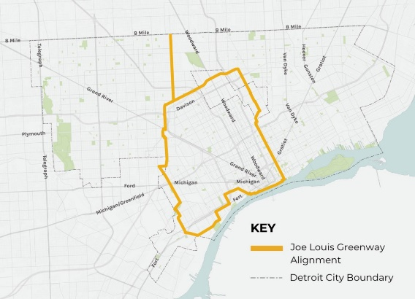

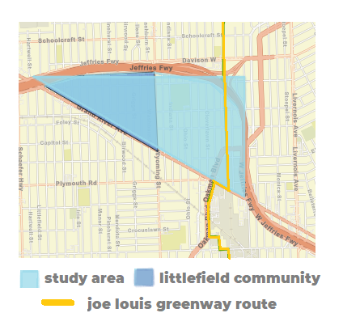

In this class students will prepare a focused neighborhood framework study, in partnership with local entities such as the Littlefield Community Association, as well as a plan to revitalize the study community, seeking to balance rehabilitation and retention of existing residents and businesses with, as appropriate, new housing, job-creating investments, an improved amenity base, new economic activity and a focus on environmentally just and equitable approaches to development and revitalization. The intent is to develop a plan and implementation program that:
- Seeks to retain strong community institutions and broadly benefits existing residents, businesses and others,
- Identifies zoning and land uses especially the potential for public ownership and property vacancies where there may opportunities for re-use or repositioning of these properties, and
- Identifies blighting influences and “hot spots” to be able to consider proposed planning responses
on behalf of our clients, departments of the City of Detroit, community-based development entities and the community itself.
Specific questions that can be answered include:
- How to design a street or streetscape to stimulate economic activity consistent with the plan and program discussed above,
- How to use streetscape and other urban design elements to support and reflect the specific community and its attributes,
- How to address light industrial uses along the Greenway in the study area, and
- What specific community projects might enhance the Greenway to move the community “from blight to beauty.”
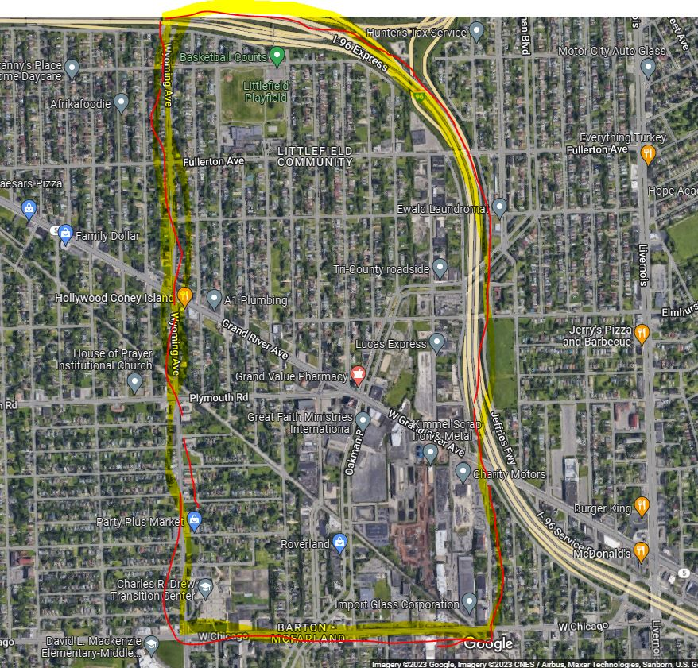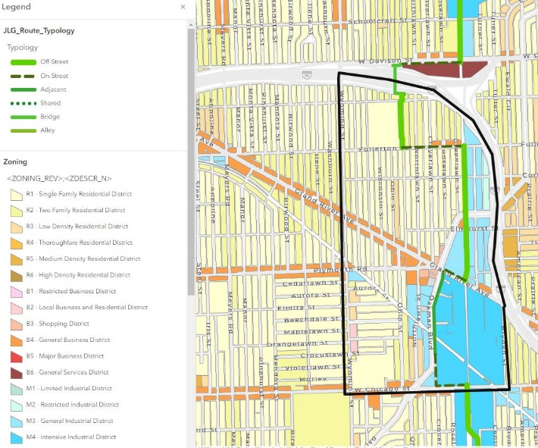

COURSE LEARNING OBJECTIVES
This course provides broad exposure to applying principles of planning and development, focused on (1) sustainable, mixed-use and program or project implementation and (2) building healthier and more resilient places. This course covers fundamental concepts and analytical methods used in making investment decisions from the perspectives of both private developers and a municipality, and how developers, investors, community organizations and the public sector can use land use and other policies to generate resources, address historic environmental and social justice issues and enhance health, livability and equity.
At the conclusion of the course, students should have a fuller understanding of:
- Methods for documenting, analyzing and evaluating physical, economic and regulatory processes and conditions of urban corridors/districts,
- Methods of preparing analyses of corridors/districts that assess their strengths, weaknesses and opportunities, along with assessing constraints or threats that may make repositioning of them difficult,
- Ways of assessing costs and benefits that accrue to different subsets of an affected population and steps to mitigate adverse impacts on some community members even if the community at large may benefit,
- Principles and best practices of:
  - Policy: land use, zoning and local ordinances,
  - Finance: real estate development and financing mechanisms, private and public, and
  - Design: place-making strategies and effective physical environments, and how the physical environment can affect public health,
- Ways to develop compelling visions and detailed implementation plans for neighborhood revitalization, and
- Professional practices such as public speaking, presenting work to clients and teamwork.

Prerequisite(s): Junior or Senior level
Co-Requisite(s): None
Concurrent Enrollment: None
Recommended Preparation: No special preparation is required

INSTRUCTOR AND COMMUNICATION POLICY
Donald R. Spivack, AICP, FRSA
Office: RGL 107 and (for online courses and virtual meeting options) Zoom
Phone: 213 740-0350 office 213 590-1600 cell
Email: spivack@usc.edu
Best way of contact is by email: spivack@usc.edu or text to 213 590-1600. Please note cell calls must provide caller ID or will not be answered, nor can calls be answered during meetings or other classes.

TEXTBOOKS AND MATERIALS
The preferred textbook is Blakely, Edward J. and Leigh Green, Nancey: Planning Local Economic Development, Fifth Edition, Sage Publications, Los Angeles, CA, 2013 or Sixth Edition, 2016. Other readings and useful background information will be on Blackboard. The Blackboard site is http://blackboard.usc.edu.
Additional material will be posted regularly on the Greenway web site www.detroitmi.gov/jlgplanning and it is suggested that the site be checked regularly.
Other reading and background data sources include selections from:
- Benner, Chris and Pastor, Manuel: Just Growth: Inclusion and Prosperity in America’s Metropolitan Regions, Rutledge, New York, NY, 2012.
- City of Detroit: “Blight to Beauty”, Detroit, MI, 2022.
- City of Detroit: Joe Louis Greenway Framework Plan (Volume 1 Vision, Volume 2, Design Standards, Appendices), Detroit General Services Department, Detroit, MI, 2021.
- City of Los Angeles Department of City Planning, “Walkability Checklist”, Los Angeles, CA, 2007.
- Gallagher, John: Reimagining Detroit, Wayne State University Press, Detroit, MI, 2010.
- Gallagher, John: Revolution Detroit, Wayne State University Press, Detroit, MI, 2013.
- Glaeser, Edward: Triumph of the City, The Penguin Press, New York, NY, 2011.
- Health Impact Partners: A Health Impact Assessment Toolkit, Oakland, CA 2011.
- Pollack, Stephanie, Bluestone, Barry and Billingham, Chase: Maintaining Diversity in America’s Transit Rich Neighborhoods, Dukakis Center for Urban and Regional Policy, Northeastern University, Boston, MA, 2010.
- Porter, Michael: “The Competitive Advantage of the Inner City,” Harvard Business Review 35, 1995.
- Prevention Institute: "Healthy Development without Displacement: Realizing the Vision of Healthy Communities for All," Prevention Institute, Oakland, CA, 2017.
- Urban Land Institute: Building Healthy Places Toolkit (National), Urban Land Institute, Washington, DC, 2014.
- Urban Land Institute: Unfound Opportunities: Investing in Underserved Communities, Urban Land Institute-Los Angeles, Los Angeles, CA, 2023.

GRADING AND COURSEWORK POLICIES

Grade Breakdown

This course uses a percent-base grading schema, as shown below.
Category | Percentage
In Class Discussion | 30%
Written Assignments | 10%
Final Project (Team) | 30%
Final Paper (Team) | 30%
Total | 100%

Grade Category Descriptions
Description and Assessment of Assignments
The focus of the class will be in-class discussions of readings and relevant current issues, along with participation in work sessions on site in Detroit, and final projects and papers (these constitute examples of the type of professional analyses and presentations required in planning and related professions). The final projects consist of a team power point presentation as described more below, and an accompanying document that sets forth the team’s analysis of the study area, data identified and analyzed, conclusions from the data analysis and a plan and implementation program recommendations for the study area.
Other assignments will be occasional short memoranda on particular topics covered in classes, some assigned and completed in class and others assigned for home completion.
Project grading will be based largely on (1) class participation, (2) how the final projects identify and address the conditions facing the chosen community as set forth in the team’s analysis. Grading will also consider how well the students have included creative, analytical and feasible solutions.
The following categories comprise the final grade:
In-Class Discussion (30%)
- The grade in this component of the course reflects the degree to which students actively participate in class discussions. Opportunities include responding to questions posed during class sessions, bringing issues to the class discussion based on their own work which is germane to the content of that session, and taking a lead in commenting on work of other students when peer review is indicated in the session description.
Witten Assignments (10%)
- In specific classes, students will complete an assignment, either in-class or take home. These are short responses to issues covered in those classes.
Final Project (30%)
- The final project consists of a 15-20-minute team power point, setting out the vision, relevant data that support the vision, conclusions and recommendations from field work and other analysis, and a proposed plan and implementation program for the area. The plan and program set forth a desired end state in more detail than the vision, means by which that end state might be achieved (including financing sources and, if needed, proposed changes to land use and zoning), and the identification of catalytic projects or actions that the team believes necessary to begin to evolve the target area and implement the plan – moving the community “from blight to beauty.”

Final Project Paper (30%)
- A supplemental document that explains the team’s thinking, elaborates on the planning process undertaken, sets forth how the team reached its conclusions and recommendations, and contains any additional data that cannot be covered in the 15-20 minute presentation.
Grading Description
- A – Work of excellent quality exceeding requirements and exceeding expectations
- B – Work of good quality meeting requirements and meeting expectations
- C – Work of fair quality
- D – Work of minimum passing quality
- F – Failure to adequately complete coursework
To receive an “A” grade, students must complete all work on time and submit work of superior quality at every stage. Work must address all aspects of the required assignments, exceed the minimum requirements and demonstrate critical and creative thinking. Students must consistently contribute to class discussion.
Assignment Submission Policy
- Assignments and the final project shall be submitted in electronic format by 4.00 pm Pacific time the day before the class sessions in which the presentations are scheduled (see schedule below). A member of the team should be responsible for uploading and screen sharing presentations. Outlines of oral presentations should also be emailed to the instructor by 5.00 pm the day prior to the presentation date. Understanding that 15-20 minutes provides for only an abbreviated presentation, supplemental materials should be submitted in addition to the final project power points. Homework and other assignments shall normally be submitted electronically.

Grading Timeline
Every effort will be made to provide feedback within 72 hours of the submission deadline. Feedback may be through annotations on the submittal or through a response email or document.

Assignment Submission Deadline
All assignments are due no later than 4.00pm Pacific Time on the indicated due date unless otherwise noted.

Late Work
Late assignments will be graded down. Assignments more than 72 hours late may not be accepted unless the lateness involves any of the excuses granted in the USC Student Handbook. A passing grade will not be assigned unless all assignments have been completed and submitted. While allowance will be made for medical or personal emergencies, unexcused absences will be penalized. Make-up work may be allowed on a case-by-case basis at the discretion of the instructor.

Class Sessions
Attendance at all sessions is expected. If you are unable to attend regular class sessions, your instructor may require an alternative assignment.
Students are expected to complete all readings and instructional materials prior to attending class meetings. Synchronous class meetings are regularly provided over Zoom and recorded for students’ review, or if students are unable to attend in person. If you miss a class you are urged to watch the recording prior to the subsequent class session. The final presentation will be a Zoom session from Los Angeles, with the clients in Detroit.
Please review the USC Price Zoom Etiquette Tips before attending your first session. You may find it helpful to periodically review this video throughout the semester.

Grading Ranges
USC’s grading system uses both numbers and letters, ranging from 1.9 to 4.1, with letter-grade equivalents ranging from F to A+. “CR” is assigned as the satisfactory passing grade in courses that are not graded numerically or when a student has elected to take a numerically graded course on a CR/D/F basis.

Percentage/Course Total | Numerical Grade | Letter Grade
100 | 4.1 | A+
95–99 | 4.0 | A
90–94 | 3.7 | A-
87–89 | 3.3 | B+
83–86 | 3.0 | B
80–82 | 2.7 | B-
77–79 | 2.5 | C+
73–76 | 2.4 | C
70-72 | 2.2 | C-
60–69 | 2.0 | D
59 and below | 1.9 | F
Course Notes
Student are expected to take notes in class. Selected materials will be posted on Blackboard.
Technological Proficiency and Hardware/Software Required
The class is expected to be live on campus except for the time spent in Detroit (roughly 19-25 May 2023) though it may also be conducted concurrently or partially on line using the USC Zoom platform. Students will need access to both Zoom and Blackboard. Basic maps, diagrams and written reports and occasional spread sheets will be prepared. Microsoft Word or other compatible word processing is required for written documents. Presentation materials should normally be prepared using Microsoft Power Point. Microsoft Excel is the preferred format for spread sheets. Most assignments are expected to be submitted electronically. Exhibits, selected reading assignments and supplemental materials will be posted in PDF, Word, Power Point or Excel format on Blackboard, usually organized by week for ease of access.

TECHNOLOGY REQUIREMENTS AND SUPPORT

Platforms Used in This Class
The class will be conducted on one or more of the following platforms:
Blackboard – Learning Management System
- This is the main course site, where you will find learning materials, assignments, Zoom links, and other class materials.
- All students are automatically enrolled in Blackboard courses before the start of the semester.
- If you are new to Blackboard, please review this introductory video to familiarize yourself with the platform.
Zoom – Video Conferencing
- Online synchronous sessions and virtual office hours will take place on Zoom.
- All students will access the Zoom meetings through our Blackboard course.
- Please review Zoom etiquette tips to be ready for our class sessions.
Perusall - Active reading and asynchronous discussion tool
- E-reader platform that allows users to annotate and comment to the assigned readings.
- All students will access the Perusall readings through our Blackboard course.

Technology Requirements
Before classes begin, students must be certain that the hardware, software, and internet capabilities being utilized for online classes and coursework meet the minimum standards to access Zoom and Blackboard, listed below.
Technology | Requirement
Computer | Mac or PC made within the last four years
Hardware | Webcam with microphone (headset with microphone recommended)
Operating System | Windows 7+ or OSX 10.6+
Memory | 4GB+ memory
Browser | Chrome/Firefox (current version of either)
Internet Speed | >1.5Mbps+ up/down for internet speed

Technology Support
Blackboard Support
Students can visit the USC Blackboard Help website as well as contact Blackboard Support via email and phone, (213) 740-5555 (select option 2).
NetID and Zoom
Students can contact the USC Customer Support Center at (213) 740-5555 to obtain help with NetID or Zoom.
USC Information Technology Services Student Page
Includes information about USC Student Computing Resources.

Course Calendar
Course calendar is subject to change.
Course Schedule: Weekly Breakdown
Period | Topic | Readings and Assignments; Key Deliverables
Week 00  10 May 2023  12.00noon-1.30pm | Welcome and Introduction. Orientation to class and course. Purpose, format of class. Discussion of class logistics.
Week 01  17 May 2023  8.30am-11.50am | Basics of applied planning. Natural forces of urban growth and decline. Natural distribution of land uses. Overview of city form. Overview of City of Detroit, history, evolution and current trends and conditions. Introduction to study area. | Joe Louis Greenway Framework Plan, Volume 1, skim Volume 2 and Appendices  Detroit Blight to Beauty Flyer  Glaeser, Introduction “Our Urban Species“ pages 1 to 15, Chapter 2, “Why Do Cities Decline“ pages 41 to 67  Benner and Pastor, Chapter 1 Pages 1 to 9, Chapter 6 Pages 185 to 186  Gallagher, Reimagining Detroit, Chapter 2, “Detroit Today” pages 21 to 32, Chapter 6 “Filling the Vacancy” pages 97 to 117  Gallagher, Revolution Detroit, Chapter 4, “Economics” pages 93 to 113, Chapter 5, “New Uses for Urban Land” pages 115 to 161
Week 02  19-25 May 2023  The bulk of this time period will be spent in Detroit | Analytical methods and evaluating development potential. Field reconnaissance. Strengths, weaknesses, opportunities and threats/constraints assessment. Market analysis, competitive and complementary uses. Development potential. Participants in the development process.  Exploration of the study area.  Meetings with client representatives and others in study area. | Blakely, Chapter 5, “The Local Economic Development Planning Process” pages 113 to 135  Blakely, Chapter 11, “Community Economic Development” pages 331 to 358  Blakely, Chapter 12, “Building the Implementation Plan” pages 361 to 381  Porter, “The Competitive Advantage of the Inner City” pages 55 to 71
Week 03  31 May 2023  8.30am-11.50am | Land use and zoning. General plans, building codes and other regulations. How regulations can facilitate or inhibit development.  Infrastructure, transportation and open space. Site development issues. Constraints of built form.  Housing and housing finance. Gentrification. Role of housing in economic development.  Resiliency and sustainability. | Prevention Institute, “Healthy Development without Displacement” pages 9 to 21  City of Los Angeles, “Walkability Checklist”  For reference:  Urban Land Institute, Building Healthy Places Toolkit  Health Impact Partners, A Health Impact Analysis Toolkit  Pollack, Stephanie, Bluestone, Barry and Billingham, Chase: Maintaining Diversity in America’s Transit Rich Neighborhoods
Week 04  07 June 2023  8.30am-11.50am | In class preparation of presentation and final report.
Week 04  09 June 2023  8:30am-2.00pm | Final presentation of analysis, findings and conclusions to client.  Preparation time 8.30am-10.30am  Presentation 11.00am-2.00pm

ACADEMIC POLICIES AND STUDENT CONDUCT CODE

Academic Conduct
Plagiarism – presenting someone else’s ideas as your own, either verbatim or recast in your own words – is a serious academic offense with serious consequences. Please familiarize yourself with the discussion of plagiarism in SCampus in Part B, Section 11, “Behavior Violating University Standards” policy.usc.edu/scampus-part-b. Other forms of academic dishonesty are equally unacceptable. See additional information in SCampus and university policies on Research and Scholarship Misconduct.

Copyright
The uploading to other websites or distribution of class materials outside the learning environment is explicitly prohibited per university policy (SCampus Part B § 11).

“Distribution or use of notes, recordings, exams, or other intellectual property, based on university classes or lectures without the express permission of the instructor for purposes other than individual or group study. This includes, but is not limited to, providing materials for distribution by services publishing course materials. This restriction on unauthorized use also applies to all information, which had been distributed to students or in any way had been displayed for use in relationship to the class, whether obtained in class, via email, on the Internet or via any other media.”

Student Conduct Code
Please review the Student Conduct Code for more information about expectations for student behavior and academic integrity.

Students and Disability Accommodations:
USC welcomes students with disabilities into all of the University’s educational programs. The Office of Student Accessibility Services (OSAS) is responsible for the determination of appropriate accommodations for students who encounter disability-related barriers. Once a student has completed the OSAS process (registration, initial appointment, and submitted documentation) and accommodations are determined to be reasonable and appropriate, a Letter of Accommodation (LOA) will be available to generate for each course. The LOA must be given to each course instructor by the student and followed up with a discussion. This should be done as early in the semester as possible as accommodations are not retroactive. More information can be found at osas.usc.edu. You may contact OSAS at (213) 740-0776 or via email at osasfrontdesk@usc.edu.

USC Policies on Accessibility for Online Courses
The University of Southern California is dedicated to maintaining an environment that ensures that all students with documented disabilities, including deafness, ADHD, dyslexia, visual impairments, learning disorders, physical/chronic health conditions and other disabilities, have equal access to its educational programs, activities and facilities. This policy covers all students at USC and in distance learning programs. The accommodations are designed to level the playing field for students with disabilities, while maintaining the integrity and standards of USC’s academic programs.
Accommodations are determined on a case-by-case basis. Examples of typical accommodations include assistance in providing note-takers, sign language interpreters, real-time captionists, readers, scribes, advocacy with faculty, accommodated exam proctoring, alternative text formats, adaptive technology, referrals to community resources, support groups and other support services for individual needs unique to a student’s disability.
Therefore, any student requesting academic accommodations based on a disability is required to register with the Office of Student Accessibility Services (OSAS) each semester. OSAS will review all complete files with documentation; however, please know that additional follow-up steps may be necessary prior to final accommodation decisions. Once a decision has been made, access your approved accommodations from the myOSAS Portal and generate accommodation letters to provide to your instructor.

USC Price Student Resources
Please see the comprehensive list of all resources available to students enrolled in the Price school.

SUPPORT SYSTEMS

Counseling and Mental Health - (213) 740-9355 – 24/7 on call
studenthealth.usc.edu/counseling
Free and confidential mental health treatment for students, including short-term psychotherapy, group counseling, stress fitness workshops, and crisis intervention.

National Suicide Prevention Lifeline - 1 (800) 273-8255 – 24/7 on call
suicidepreventionlifeline.org
Free and confidential emotional support to people in suicidal crisis or emotional distress 24 hours a day, 7 days a week.

Relationship and Sexual Violence Prevention Services (RSVP) - (213) 740-9355(WELL), press “0” after hours – 24/7 on call
studenthealth.usc.edu/sexual-assault
Free and confidential therapy services, workshops, and training for situations related to gender-based harm.

Office for Equity, Equal Opportunity, and Title IX (EEO-TIX) - (213) 740-5086
eeotix.usc.edu
Information about how to get help or help someone affected by harassment or discrimination, rights of protected classes, reporting options, and additional resources for students, faculty, staff, visitors, and applicants.

Reporting Incidents of Bias or Harassment - (213) 740-5086 or (213) 821-8298
usc-advocate.symplicity.com/care_report
Avenue to report incidents of bias, hate crimes, and microaggressions to the Office for Equity, Equal Opportunity, and Title for appropriate investigation, supportive measures, and response.

The Office of Student Accessibility Services (OSAS) - (213) 740-0776
osas.usc.edu
OSAS ensures equal access for students with disabilities through providing academic accommodations and auxiliary aids in accordance with federal laws and university policy.

USC Campus Support and Intervention - (213) 821-4710
campussupport.usc.edu
Assists students and families in resolving complex personal, financial, and academic issues adversely affecting their success as a student.

Diversity, Equity and Inclusion - (213) 740-2101
diversity.usc.edu
Information on events, programs and training, the Provost’s Diversity and Inclusion Council, Diversity Liaisons for each academic school, chronology, participation, and various resources for students.

USC Emergency - UPC: (213) 740-4321, HSC: (323) 442-1000 – 24/7 on call
dps.usc.edu, emergency.usc.edu
Emergency assistance and avenue to report a crime. Latest updates regarding safety, including ways in which instruction will be continued if an officially declared emergency makes travel to campus infeasible.

USC Department of Public Safety - UPC: (213) 740-6000, HSC: (323) 442-120 – 24/7 on call
dps.usc.edu
Non-emergency assistance or information.

Office of the Ombuds - (213) 821-9556 (UPC) / (323-442-0382 (HSC)
ombuds.usc.edu
A safe and confidential place to share your USC-related issues with a University Ombuds who will work with you to explore options or paths to manage your concern.

Occupational Therapy Faculty Practice - (323) 442-3340 or otfp@med.usc.edu
chan.usc.edu/otfp
​Confidential Lifestyle Redesign services for USC students to support health promoting habits and routines that enhance quality of life and academic performance.

