Department of French & Italian
Fall 2022
Dr. Béatrice Mousli Bennett
Office : THH 176
email : beatrice.mousli@usc.edu
Tue-Thurs. 2: 00 – 3:20 pm

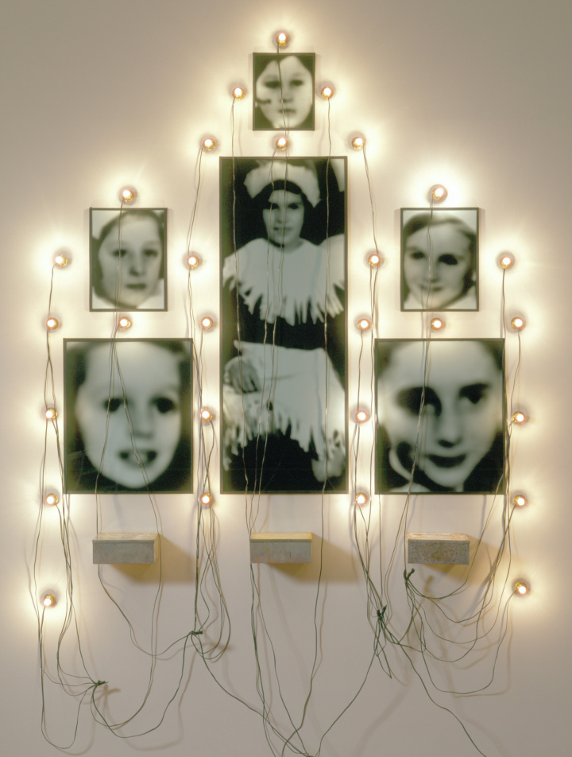
French 373g : Remembering Loss, Writing Memory

In this class, students will be asked to consider the different ways in which victims, survivors, their offspring and acquaintances, witnesses, public intellectuals, and writers have chosen to give voice and shape to the events that have marked them. Through careful reading and analysis of a wide range of Francophone literary texts and real life testimonies, students will also think about how writing, speaking or visually representing such events engages with past traumas and the extent to which it might constitute a form of resistance to future genocides.

The class is taught in English, and carries GE credits (Category B: Humanistic Inquiry). This class is intended for Majors and Minors in French, and open to all.

Required books :
Dora Bruder by Patrick Modiano
Charlotte: A Novel by David Foenkinos
The Safe House: A Novel by Christophe Boltanski

