Social Work 536
Section 60789
POLICY AND ADVOCACY IN PROFESSIONAL SOCIAL WORK
3 Units
It is easier to spend a few months and some money electing the right people, than to spend years and a lot of money trying to get the wrong people to do the right things.
—Senator Debbie Stabenow, MSW
FALL 2021
Instructor: Steve Gratwick, MSW, LCSW Course Day: Thursday
Email: gratwick@usc.edu Course Time: 1-3:50pm
Telephone: 323-371-5380
Office Hours: By Appointment

Course Pre-requisites, Co-requisites, and Concurrent Enrollment
Policy and Advocacy in Professional Social Work (SOWK 536) is built upon a liberal arts undergraduate foundation. Students are expected to have a basic understanding of how American government works at the local, state and national levels, and a rudimentary familiarity with the existence of social welfare policies.
Catalogue Description
Social workers practice within complex and interconnecting systems of policy, programs and communities that directly and indirectly impact their clients’ lives. This course studies and assesses the impact of anti-poverty programs, security-building insurance systems, and opportunity-creating public policies on clients seeking to navigate within and across these systems, and on the social worker’s role therein, at the programmatic, community and state-wide levels.
Course Description
This course provides a substantive understanding of the American social welfare policies and programs developed and implemented by all levels of government that seek to limit poverty, provide security and create opportunity for people, families and communities. These programs, systems, and policies will be assessed for their adequacy, effectiveness and fairness. Advocacy efforts – past and present – will be explored and even joined in some of these subject areas.
The course will also help develop students’ analytic, writing and presentation skills, which are crucial for successful social work practice across the systems, funding streams and communities that make up America. The course seeks to inspire students to develop a case-level, program-level and macro-level policy advocacy orientation, so that – regardless of their professional specialization – USC graduates will be motivated to redress social and economic injustice and empower less advantaged groups.
This course is divided into three modules: (1) the first module examines and assesses programs seeking to alleviate poverty, such as the Earned Income Tax Credit, TANF, food stamps, and Medicaid; (2) the second module studies how America uses various social insurances to create and reinforce family and community-level security, and includes focuses on Social Security, Unemployment and Disability insurances, and Medicare (including the impacts thereon of the Affordable Care Act); and (3) the third module examines how our society seeks to create opportunity through its education, progressive taxation, and other systems. Each of these modules focuses on understanding the policy decisions, financing, program implementation and advocacy interventions creating and impacting these various programs, and the role social workers have within and across them.
SOWK 536 provides a foundation for concentration-specific courses across the clinical and policy arenas, in which students can apply their knowledge, analysis and skill to develop specific improvements across sectors.
Course Objectives
Students in the Policy and Advocacy in Professional Social Work course (SOWK 536) will:
Objective # | Objectives
1 | Demonstrate understanding of the general provisions and current pivotal issues central to major social welfare policies in several key institutional sectors, and the impact these have on the local community; critically assess various substantive and advocacy-based options for improving / reforming these social welfare policies.
2 | Analyze the political, social, and economic histories that have shaped the delivery and financing of major social welfare policies, and assess the differing impacts (positive, neutral or negative) that these histories and delivery- and financing-regimes have on vulnerable populations in American society.
3 | Effectively advocate for services, rights, social justice, and equal protection for and with individuals, groups, and/or communities. In preparation for their advocacy work, students will also proactively identify common, repetitive and predictable problems across multiple practice settings and substantive issue areas that could trigger potential advocacy interventions.
4 | Distinguish, appraise, and attend to differences within and between communities, agency settings and budgets, scientific research, technological developments, and emerging societal trends in order to reform the financing and delivery of targeted services at the mezzo level.
5 | Demonstrate knowledge of the values, purpose and roles the social work profession practices within the contexts of policy systems and program administration at multiple levels of governmental (national, state, local); and understand how social workers intervene and engage in micro, mezzo and macro advocacy in each of these milieus.

Course Format / Instructional Methods
This class will include a variety of teaching/learning modalities. The instructor will provide lectures, with particular focus on faculty area of expertise; and classes will also be interactive, with students encouraged to discuss their ideas and experiences. Selected sessions will feature videos, in-class exercises, and/or speakers to illustrate the topics under examination. Material from the field and individual faculty-practitioner expertise will be used to integrate theory and intention with practice and impacts. As class discussion is an integral part of the learning process, students are expected to come to class ready to discuss the required readings, and its application to theory and practice.
Student Learning Outcomes
The following table lists the nine Social Work core competencies, as defined by the Council on Social Work Education’s 2015 Educational Policy and Accreditation Standards, which are the basis of the student learning outcomes in the MSW program:
Social Work Core Competencies
* | 1 | Demonstrate ethical and professional behavior
 | 2 | Engage in diversity and difference in practice
* | 3 | Advance human rights and social, economic, and environmental justice
 | 4 | Engage in practice-informed research and research-informed practice
* | 5 | Engage in policy practice
 | 6 | Engage with individuals, families, groups, organizations, and communities
 | 7 | Assess individuals, families, groups, organizations, and communities
* | 8 | Intervene with individuals, families, groups, organizations, and communities
 | 9 | Evaluate practice with individuals, families, groups, organizations, and communities
* Highlighted in this course
See Appendix A for an expanded table, which details the competencies and dimensions of competence highlighted in this course. The table also shows the course objective(s), behaviors/indicators of competence, and course content and assignments related to each competency highlighted in the course.
Course Assignments, Due Dates, and Grading
Assignment | Due Date | % of Final Grade
Assignment 1: Community Assessment | Class 4  Paper due on class day  by 11:59pm PST | 20%
Assignment 2: Collaborative Op-Ed to Address a Grand Challenge | Class 9  Submit paper by class time  ~  mini- presentations in class | 35%
Assignment 3: Advocacy to Impact a Grand Challenge: Lobbying | Class 14  Submit paper on class day by 11:59pm PST  ~  Presentation times assigned for both class 14 and 15 | 35%
Participation: In-class participation, preparation and engagement | Ongoing; faculty will check in during week 6 | 10%

Each of the major assignments is described below.
Assignment # 1: Community Assessment (20% of course grade, due class 4)
Assignment #1 is a five- to seven-page research-based assessment of a specific geographic community. The purpose of this assignment is for you to practice researching socio-economic and demographic data, assess the important aspects thereof as they interact with and impact the community, and demonstrate a distanced, professional understanding of a community and its strength and challenges.
The assignment is broken into the following sections in order to help guide students in sharing a professional perspective regarding the community: Demographics; Grand Challenges; Leadership and Decision-making; and Reflections. Grading criteria include compliance with the assignment, professional presentation (conforming to the basic rules of APA, English grammar, spelling and punctuation), and quality of content including evidence of critical thinking and basic understanding of concepts.
This assignment relates to course objective 1-5 and social work competency 1,3,5, and 8.
Assignment # 2: Collaborative Op-Ed to Address a Grand Challenge (35% of course grade, due class # 9)
Students will work in pairs for this assignment (editorials are rarely published with more than two authors). This assignment is for the two students to draft a publishable editorial on a substantive policy topic and specific policy that they have agreed upon, ideally identified in the students’ work in assignment 1. Each group will select a social welfare challenge facing a community (which they have identified as linked to the Grand Challenges). The students will research the policy and policy area together, write a professional and expert op-ed together, and submit the op-ed to the most appropriate media outlet the students choose, following the rules of that outlet; editorials are typically 500 to 750 words.
No submissions to the LA Times are allowed.
During class 9, there will be an in-class share/presentation. Each group will share their op-ed to their classmates. Then, the authors will briefly explain their topic, present relevant information for the classmates to fully understand their position, why they chose the issue they focused upon, why they chose that particular media outlet, and what that outlet’s rules are for submitting an editorial / guest commentary, and their experience submitting the writing.
The assignment is due and the share/presentation will occur during class # 9, and is worth 35% of the overall course grade. Grading of the assignment is not based on publication.
Grading criteria for this assignment will include responsiveness to the assignment; organization and clarity of the information presented; and demonstrated effort in creating an appropriate, evidenced editorial.
This assignment relates to course objective 1-5 and social work competency 1,3,5, and 8.
Assignment # 3: Advocacy to Impact a Grand Challenge: Lobbying (35% of grade, due class 14 (presentations in class 14 and 15)
Each student will conduct a lobby visit (virtual, telephonic, or in-person if appropriate due to COVID19) with a local or other elected official or their staff on a social welfare policy/challenge that impacts a geographic-based or interest-focused community. The lobby visit will describe the policy/issue, how it impacts the community, and offer a positive policy intervention/solution. Each student will also prepare a one to two-page memo describing and analyzing the substantive issue the student seeks to impact and the corresponding policy; the memo will serve as a leave-behind for your lobby visit. Scheduling a lobby visit is often most successful where the student is a constituent, however, a lobby visit may move beyond these geographic boundaries in the event COVID19 public health measures prevent an in-person visit. The student is encouraged to strategize the best person to lobby considering their chosen policy.
Each student will arrange and conduct a lobby visit on that policy issue with a local or other elected official of their choice. The leave-behind memo will be submitted to the professor, and will include sections on issue description, historical background, scope of issue and population impacted, policy and changes sought, rationale for your changes, and ethical implications.
Grading criteria will include responsiveness to the assignment; organization and clarity of the information presented; demonstrated effort in organizing the visit, overcoming unexpected issues, and conducting a visit; and critical thinking and use of evidence to support conclusions.
This assignment relates to course objective 1-5 and social work competency 1,3,5, and 8.
Class Participation (10% of Course Grade) -- Assessed in totality over 15 classes
Class grades will be based on the following:
Grade Points |  | Letter Grades
3.85 – 4.00 | A | 93 – 100 | A
3.60 – 3.84 | A- | 90 – 92 | A-
3.25 – 3.59 | B+ | 87 – 89 | B+
2.90 – 3.24 | B | 83 – 86 | B
2.60 – 2.89 | B- | 80 – 82 | B-
2.25 – 2.59 | C+ | 77 – 79 | C+
1.90 – 2.24 | C | 73 – 76 | C
 |  | 70 – 72 | C-
See Appendix B for additional details regarding the definitions of grades and standards established by faculty of the School.
Attendance and Participation
Students’ active involvement in the class is considered essential to their growth as practitioners. Consistent attendance, preparation for and participation in class discussions and activities, timely completion of coursework and assignments, and personal conduct that fosters a respectful, collegial, and professional learning environment are expected. Having more than 2 unexcused absences in class may result in the lowering of the grade. For VAC and remote/hybrid Ground courses, substantive participation includes maintaining an active screen in live sessions and completing all asynchronous content and activities prior to the scheduled live class discussion. Failure to complete 2 or more asynchronous units before the live class, without prior instructor permission, also may result in a lowered grade.
Class participation will be assessed according to the following criteria:
“A” grade range: Very Good to Outstanding Participation: Contributions in class reflect thorough preparation, and participation is substantial. Ideas offered are always substantive. Regularly provides one or more major insights and comments that provoke deeper thought. If this person were not a member of the class, the quality of discussion and class activities would be diminished markedly.
“B” grade range: Good Participation: Contributions in class reflect solid preparation. Ideas offered are usually substantive, and participation is regular. Provides generally useful insights and some comments that provoke thought. If this person were not a member of the class, the quality of discussion would be diminished somewhat.
“C+” or “C”: Adequate Participation: Contributions in class reflect some preparation. Ideas offered are somewhat substantive. Provides some insights, but seldom offers comments that provoke deeper thought. Participation is somewhat regular. If this person were not a member of the class, the quality of discussion would be diminished slightly. Please note: The minimum passing grade at the graduate level is “C”.
“C-” or “D”: Inadequate Participation: Says little in class and does not adequately participate in activities or present insights or ideas. Does not appear to be engaged. Submits late work. If this person were not a member of the class, the quality of discussion would not be affected.
“F”: Nonparticipant/Unsatisfactory Participation: Misses class. When present, contributions in class, if any, reflect inadequate preparation. Ideas offered are seldom substantive, and behavior may be inappropriate and/or disrespectful. Unable to work effectively on in-class assignments/activities and detracts from the learning process. Regularly misses assignment deadlines, if work is submitted at all.
Required Instructional Materials and Resources
Required Textbooks
- Jansson, B. (2020). Social welfare policy and advocacy: Advancing social justice through eight policy sectors, 2nd edition. Sage.

- Multiple readings, videos and on-line material will also be assigned and/or handed out on a class-by-class basis, based on daily-occurring current events and policy evolutions, as shared by the instructor. Many readings are available in ARES each week.
Notes:
- Additional required and recommended readings may be assigned by the instructor throughout the course.
- See Appendix C for additional recommended instructional materials and resources
Course Overview (Fall / Spring) –
Unit | Topics
1 | - Adequacy, Security and Justice  - Programs to alleviate poverty  - Insurances to create security  - Policies to create opportunity  - Charity vs. Professionalism  - The Grand Challenges for Social Work  First assignment is handed out: Community Assessment  Required readings include the importance of understanding and being able to assess communities as a foundation of social work practice.
2 | - Programs to Alleviate Poverty  - EITC, TANF, SNAP, Medicaid, Homeless services  - History  - Scope of need  - Adequacy of programs  - Role of social workers
3 | - Paying for Means-tested Programs  - EITC, TANF, SNAP, Medicaid  - Funding levels  - Fairness of financing compared with need  - Role of social workers
4 | - The Power of Advocacy: Writing, Speaking, and Activism  - Examples of activism  - Communication  - Supporting Your Assertions and Assessing Policy  1st assignment is due; 2nd assignment handed out  ** please also view asynchronous videos in unit 9.4 - 9.7 now as it relates to lobbying and writing for change.
5 | - Insurances and Programs to Create Security  - Social Security, SSI, Disability, Unemployment Insurance, Affordable Housing  - History: Security as the Goal  - The Creation of Poverty  - Why Income Disparity Matters  - Scope of need  - Adequacy of programs  - Role of social workers
6 | Paying for Security  - Social Security, SSI, Disability, UI, Minimum Wages  - How does Social Security Work?  - Funding levels  - Fairness of financing compared with need  - Role of social workers
7 | - Physical Health: Medicare, Affordable Care Act, and Getting on Agendas  - History  - Scope of need  - Adequacy of programs / ACA reforms  - What Does Our Health Care System Look Like?  - Unit 7.5 Video: Sicko  - Building Agendas with Bruce Jansson: Getting on the Agenda  - Role of social workers
8 | - Behavioral Health: Medicare, Affordable Care Act  - Historical Overview of Mental Health in the United States  - Mental Health Today with required readings presenting data through 2020  - Role of social workers
9 | - Fiscal Systems: Paying for Health  - Health Care Costs in America  - Medicare and Medicaid: How They Are Funded  - Unit 9.2 presents trends through 2015, required reading follows trends through 2020, and projections and options currently in discussions on possible future paths.  - Medicare and Medicaid: How They Are Funded  (units 9.4-9.7 are viewed during Unit 4, as stated above)  2nd assignment due, including peer-reviewed in-class group presentations  3rd assignment handed out
10 | - Power of Advocacy: Case Study of Making Change and Saving Lives  - Film: How to Survive a Plague
11 | - Programs: Education and Children Initiatives  - Creating Opportunity: Education  - K-12, charters, colleges, for-profits  - History and videos in unit 11.4 and 11.5 present data through 2015, required readings will present data and trends through 2020.  - Scope of need  - Adequacy of programs  - Unit 11.7 on the role of college “The College’s Life” – important historical reading from William Deresiewicz on “The Neoliberal Arts-- How College Sold Its Soul to the Market."  - Role of social workers
12 | - Programs: Education and Children Initiatives  - Creating Opportunity: Child Welfare Initiatives  - History  - Scope of need  - Adequacy of programs  - Historical 2006 Reading in Child Welfare Case: Her Most Difficult Call – The Case for Marie and Her Sons New York Times)  - Unit 12.5 Views on Agency Change by Professor Bruce Jansson  - Role of social workers
13 | - Taxation and Government Budget Priorities  - Basic government budgeting at the federal level, including a review of the sources of federal income and its disbursement, and aspects of tax expenditures and loopholes. State budgets may be used, depending on current events and relevance.  - Historical data through 2015 is explored in videos, current data through 2020 and trends presented in required readings.  - Describe tax policy at the individual level  - Examine the role between tax policy and social service funding, adequacy, and fairness  - Discuss special issues as per current events, possibly including the role of 501c3 nonprofits and 501c4 political groups, government contracting and privatization, and/or an examination of the flow of wealth and resources throughout society  - Examine whether and the extent to which social workers should focus on tax policy and budgets
14 | - The Power of Advocacy: American Society Doing Big Things  - Large-scale progress and reform  - How Social Workers Engage in Community Organizing  - Social Workers and Social Justice: Changing the Policy!  Assignment 3 uploaded to VAC today and mini-presentation in class today (and last day of class if more time needed).
15 | - Asynchronous discussion on Reforming Budgets – Impacting Agency Budgets  - Special Topics in Class  - In-depth exploration of a special topic currently in the news and relation to the 13 Grand Challenges for Social Work. Examples could include:  - Civil rights – justice for all  - Women’s issues – including violence against women  - Immigration  - Marriage equality  - Crime – and jail/prison decarceration  - The 2020 General Election  - Cultural issues - #BLM and the anti-racism movement
Course Schedule―Detailed Description
First Module Units 1- 4: Programs to Alleviate Poverty
Unit 1: Adequacy, Security and Justice

Topics Encompass:
- Conceptual framework: the ongoing effort to create Adequacy, Security and Justice.
- How our social safety net is structured: federal to local implementation; cross-system intersectionality
  - Programs to alleviate poverty: EITC, SNAP, Medicaid, TANF.
  - Insurances to create security: Social Security, Disability, Unemployment, Medicare & ACA.
  - Policies to create opportunity: education, child welfare, immigration, taxation
- Role of Social Work in developing and administering assistance: pre-New Deal to today’s disappearance
- Conceptual framework for role of Social Work: the difference between charity-giving and professionalism; cultural competence; the importance of context; non-traditional social work.
  - The Grand Challenges for Social Work
- Hope for the present and future: American society as flexible, empowered, and capable of vast change.
- USC & school resources / links shared
- First assignment is given out with regards to understanding community as a fundamental practice in professional social work: A Community Assessment
Required Readings:
Sherraden, M., Barth, R., Brekke, J., et al. (2015). Social is fundamental: Introduction and context for Grand Challenges for Social Work. American Academy of Social Work & Social Welfare.
Jansson, B (2020). Becoming a policy advocate in eight policy sectors. In Social welfare policy and advocacy: Advancing social justice through eight policy sectors (chapter 1, pp 1 – 21). Sage.
Jansson, B. (2020). Advancing social justice with seven core problems. In Social welfare policy and advocacy: Advancing social justice through eight policy sectors (chapter 2, pp 27 – 49). Sage.
Donnelly F. (2020). Placing the census in context. In Exploring the U.S. Census: Your guide to America’s data (pp.1-21). Thousand Oaks, CA: SAGE
Suggested Reading/Resources for Research on Community Analysis (in addition to Research Guide provided by the Library):
- For information on counties around the country: National Association of Counties - OVERVIEW of counties:
https://ce.naco.org/?dset=Gross%20Domestic%20Product%20(GDP)&ind=Gross%20Domestic%20Product
- For easy access to demographic information about the United States, providing interactive data maps going back to 1790:
Social Explorer https://www.socialexplorer.com/
Unit 2: Programs: Family Income, Nutrition and Health

Topics Encompass:
  - EITC, TANF, SNAP, and Medicaid
  - Examination of the scope of need in the community, on the aspects ostensibly covered by these programs (i.e. income, food security, health). Examine (i) the application process; (ii) the benefits available; (iii) the participation needed to receive benefits; and (iv) the best expected outcomes.
  - Examine the adequacy of the programs compared with the need, and the implementation thereof.
  - Examine and discuss the role that social workers do and should play in these safety-net programs.
Required Readings:
Jansson, B. (2020). Becoming policy advocates in the safety net sector. In Social welfare policy and advocacy: Advancing social justice through eight policy sectors (chapter 9, pp 239 – 283). Sage.

Warde, B. (2017). Social inequality. In Inequality in U.S. social policy: An historical analysis (Chap 3, pp. 66-105). Routledge.

Recommended Reading:

Politico (2017). The essential guide to legislation. https://www.politicopro.com/blog/guide-to-legislation

Jansson, B. (2020). How policy advocates advanced social justice through American history. In Social welfare policy and advocacy: Advancing social justice through eight policy sectors (chapter 3, pp 51-69) Sage.

Stiglitz, J.E. (2013). The price of inequality: How today’s divided society endangers our future. Norton.
Unit 3: Fiscal Systems: Means-tested Programs

Topics Encompass:
- EITC, TANF, SNAP, and Medicaid
- Explore historicity of how each program came about, and the resulting silos, politicization, and special interests.
- Explore how the programs are funded at the federal level, and other relevant levels.
- Discuss the justness (ie equality; fairness) of the programs’ financing, compared with the scope of need, as well as relevant larger social factors.
- Discuss the role of social workers: on the macro-level, to understand how the silos can be made to work together, and what would be needed to reform the silos; and at the mezzo-level, to fairly allocate limited resources to persons / families in need.

Required Readings:

DiNitto, D. & Johnson, D. (2016). Helping needy families: An end to welfare as we knew it. In Social Welfare Politics and Public Policy (Chap 7, pp. 237 – 271). Pearson.

Wehrnann, K., & McClain, A. (2018). Welfare reform. In Social work speaks: National Association of Social Workers policy statements, 2018-2020 (11th ed.) (pp. 337-340). NASW Press.
Unit 4: The Power of Advocacy: Writing, Speaking and Activism

Topics Encompass:
- This class will begin focusing on effectively communicating to different audiences your perspective about how to improve the programs.
- This class will focus on elements of persuasive oral and written communication; review examples thereof; introduce advocacy across different platforms, including lobbying and the effectiveness thereof.
- The first assignment is due
- The second graded assignment will be given out
Required Readings:
Jansson, Bruce (2020). Engaging in macro policy advocacy. In Social welfare policy and advocacy: Advancing social justice through eight policy sectors (chapter 6, pp 129 – 152). Sage.

Recommended Resources:
The Op-Ed Project: https://www.theopedproject.org/
NASW-CA Advocacy Tools, including tips for writing an op-ed: https://www.naswca.org/page/7

Second Module Units 5-11: Insurances to Create Security
Unit 5: Programs: Social Security, Unemployment, Disability, Affordable Housing

Topics Encompass:
- Social Security, SSI, Disability insurance, unemployment insurance, and affordable housing
- Examine the scope of need faced by Americans and/or residents living in the selected level of community (local, state, national) who are impacted by poverty in old age or as a survivor, who become or are already disabled, and/or who become unemployed. Assess (i) the resources which are available; (ii) the application process; (iii) the resulting benefits; and (iv) the best expected outcomes for participants.
- Discuss the adequacy (breadth and depth) of the programs’ services compared with the scope of need.
- Examine and discuss the role that social workers do and should play in these safety-net programs.
Required Readings:
Prime, H., Wade, M., & Browne, D. T. (2020). Risk and resilience in family well-being during the COVID-19 pandemic. American Psychologist, 75(5), 631-643.

McNutt, J.G. & Hoefer, R. (2016). Poverty, inequality, and income maintenance policy. In Social welfare policy: Responding to a changing world. (chapter 8, p. 160-181). Lyceum.

Wusinich, C., Bond, L., Nathanson, A., & Padgett, D. (2019). “If you’re gonna help me, help me”: Barriers to housing among unsheltered homeless adults. Evaluation and Program Planning, 76, 101673–. https://doi.org/10.1016/j.evalprogplan.2019.101673
Unit 6: Fiscal Systems: Paying for Security

Topics Encompass:
- Social Security, SSI, Disability insurance, unemployment insurance.
- Explore historicity/expansions/reductions of each program
- Explore how the programs are funded at the federal level, and other levels. Assess the scope of need intended to be impacted. Discuss recent issues (such as the social security Trust Fund “running out of money”).
- Assess the justness (i.e., equality; fairness) of programs’ financing, compared with larger social factors
- Discuss the role of social workers to understand these insurances can be made to work together, be sustainable, and be well-implemented.
Required Readings:
Jansson, B. (2020). Becoming policy advocates in the gerontology sector. In Social welfare policy and advocacy: Advancing social justice through eight policy sectors (chapter 8, p 197 – 233). Sage.
Wehrnann, K., & McClain, A. (2018). Aging and wellness. In Social work speaks: National Association of Social Workers policy statements, 2018-2020 (11th ed.) (pp. 20-24). NASW Press.
Video: The Atlantic: Social Security: The Greatest Government Policy of All Time? https://www.youtube.com/watch?v=aVQ7PIl3IDE
Lam, B. (2016). How can the U.S. salvage social security? The Atlantic Monthly. https://www.theatlantic.com/business/archive/2016/04/social-security/476331/
Unit 7: Programs: Medicare, and the Affordable Care Act: Physical Health

Topics Encompass:
- Medicare (Parts A thru D); Affordable Care Act & various state-level implementation thereof (ie Covered California); examples of successful health-delivery alternatives.
- Examine the scope of need faced by Americans, and/or residents in the local community, impacted by physical health issues. Assess (i) the existing program services / resources, (ii) the application process; (iii) the benefits; and (iv) compare what expected outcomes should be vs. actual health outcomes are.
- Describe the reforms and procedures and systems created by the Affordable Care Act; its implementation and results; ongoing attempts to roll it back
- Discuss the adequacy (breadth & depth) of the programs’ coverages, compared with the scope of need. Special cases may be explored, such as veterans’ access to quality medical care.
- Examine and discuss the increasing role social workers have, and should, play in health care systems.
Required Readings:
Berkowitz, E. (2017). Getting to the Affordable Care Act. Journal of Policy History, 29(4), 519-542. doi:10.1017/S0898030617000252

Jansson, B. (2020). Becoming policy advocates in the healthcare sector. In Social welfare policy and advocacy: Advancing social justice through eight policy sectors (chapter 7, pp 157 – 190). Sage.

Wehrnann, K., & McClain, A. (2018). Health care. In Social work speaks: National Association of Social Workers policy statements, 2018-2020 (11th ed.) (pp. 146-151). NASW Press.
Unit 8: Programs: Medicare, and the ACA: Behavioral Health

Topics Encompass:
- Medicare and the Affordable Care Act as they pertain to mental health issues and substance abuse; including discuss the Mental Health Parity & Addiction Equity Act of 2008, and the role of “integration.”
- Describe the scope of need faced by Americans, and/or residents in the local community, impacted by mental health issues, and substance abuse. Assess (i) the existing program services / resources; (ii) the application process; (iii) the benefits; and (iv) compare what expected outcomes should be vs. what actual health outcomes are…
- Special issues may be discussed, such as the role of police and prisons as de facto systems of care.
- Describe the reforms, procedures and systems created by the Affordable Care Act; the implementation thereof; and any results.
- Discuss the adequacy (breadth & depth) of the programs’ coverages, compared with the scope of need; including an assessment of innovative solutions impacting these problems
- Examine and discuss the role social workers have, and should, play in the mental health and substance abuse systems.

Required Readings:

Jansson, B. (2020). Becoming policy advocates in the mental health and substance abuse sector. In Social welfare policy and advocacy: Advancing social justice through eight policy sectors (chapter 10, pp 289 – 327). Sage.

Schuman, D., Cerel, J., & Praetorius, R. (2019). Suicide in U.S. women veterans: An interpersonal theory perspective on suicide prevention policies. Social Work in Public Health, 34(5), 418–429. https://doi.org/10.1080/19371918.2019.1616028

Wildgen, A. & Denny, K. (2020). Health equity’s missing substance: (Re)Engaging the normative in public health discourse and knowledge making. Public Health Ethics. https://doi.org/10.1093/phe/phaa019

National Alliance on Mental Illness [NAMI] (2020). Divert to what? Community services that enhance diversion. https://www.nami.org/Support-Education/Publications-Reports/Public-Policy-Reports/Divert-to-What-Community-Services-that-Enhance-Diversion/DiverttoWhat.pdf
Recommended Reading
Roth, Alisa. (2018). Insane: America’s Criminal Treatment of Mental Illness. New York, NY: Basic Books

Hilinski-Rosick, C. & Walsh, J. (eds.) (2018). Issues in corrections: Research, policy, and future prospects. Lexington Books

Unit 9: Fiscal System: Paying for Health

Topics Encompass:
- Medicare (Parts A through D) and the Affordable Care Act
- Explore historicity/expansions/reduction of each program; include as a case study the Bush administrations' expansion of part D, as well as the Obama creation of the ACA
- Explore how these programs are funded at the federal level, flowing through and among state, corporate, and local players
- Discuss the justness (i.e., equality, fairness) of the programs’ financing and priorities, compared with larger social factors and various populations’ health outcomes
- Discuss the role of social workers in interacting with the financing and payment systems for health care
Assignment 2 due this week: Collaborative Op-Ed to Address a Community Grand Challenge
Required Reading:
Bradley, E., Sipsma, H., & Taylor, L. (2016). American health care paradox - high spending on health care and poor health. QJM : Monthly Journal of the Association of Physicians, 110(2), hcw187–. https://doi.org/10.1093/qjmed/hcw187
The Commonwealth Fund (2020). International health care system profiles: The United States. https://www.commonwealthfund.org/international-health-policy-center/countries/united-states
Robert Wood Johnson Foundation (2020). Life Experiences and Income Inequality in the United States. Download full report here: https://www.rwjf.org/en/library/research/2019/12/life-experiences-and-income-inequality-in-the-united-states.html
Unit 10: Power of Advocacy: Case Study of Making Change and Saving Lives

Topics Encompass:
Screen and discuss the multiple aspects of the documentary How to Survive a Plague, including the following:
- How decisions are made and how they can be influenced
- “Inside” advocacy vs. direct-action “in-your-face” activism
- Treatment advocacy ("We want better drug treatment") vs. social advocacy ("We want equal rights")
- Role of personal empowerment, as well as collaborative empowerment, and how they mix
- Role of science as a driving force
Required Readings:

Bent-Goodley, T. (2015). A call for social work activism. Social Work, 60(2), 101–103. https://doi.org/10.1093/sw/swv005

Hartmann, D. (2019). The Olympic “Revolt” of 1968 and its lessons for contemporary African American athletic activism. European Journal of American Studies. 14 (1). Open Access Journal available here: https://journals.openedition.org/ejas/14335

France, D. (2020). The activists: How Act-Up forever changed patients’ rights, protests and American political organizing as it’s practiced today. https://www.nytimes.com/interactive/2020/04/13/t-magazine/act-up-aids.html

Unit 11: Programs: Education and Children Initiatives

Topics Encompass:

  - Head Start, public K–12 education and charter schools, child welfare and transitional youth programs, community & four-year colleges; discuss the American ideal in which education is the cornerstone of personal opportunity.
  - Describe the mechanisms and scope of the American public education system. Assess
  - The education programs that exist
  - History thereof
  - How the programs perform
  - What the best expected outcomes could (and should) be
  - Special issues to be discussed, depending on current events: the role of the family unit as a unit of opportunity creation; child welfare and transitional youth programs that promote (or hinder) educational success, measuring teaching and student success, charter schools, and/or the place of for-profit education
  - Examine and discuss the role that social workers do and should play in these various education arenas, from school social worker to creating your own school

Required Readings:

Gladwell, Malcom. (2009, May 11). How David beats Goliath: When underdogs break the rules. The New Yorker. https://www.newyorker.com/magazine/2009/05/11/how-david-beats-goliath

Jansson, B. (2020). Becoming policy advocates in the education sector. In Social welfare policy and advocacy: Advancing social justice through eight policy sectors (chapter 12, pp 379 - 420). Sage.

Stewart, M. (2018). The birth of the new aristocracy. The Atlantic Monthly. 322 (2) 8-12.
Third Module Units 12-15: Systems to Create Opportunity
Unit 12: Programs: Child and Family Sector

Topics Encompass:
- child welfare & transitional youth programs; child protective services
- Special issues to be discussed, depending on current events: the role of the family unit as a unit of opportunity creation; child welfare, foster care & transitional youth programs that promote (or hinder)
success; immigration policy; measuring teaching and student success; charter schools; and/or the place of for-profit education.
- Examine and discuss the role that social workers do and should play in the child welfare realm
Required Readings:

Jansson, B. (2020). Becoming policy advocates in the child and family sector. In Social welfare policy and advocacy: Advancing social justice through eight policy sectors (chapter 11, pp 333 – 371). Sage.

Doyle, J. J., Jr, & Aizer, A. (2018). Economics of child protection: Maltreatment, foster care, and intimate partner violence. Annual Review of Economics, 10, 87–108.
Open access available here: https://doi.org/10.1146/annurev-economics-080217-053237

Unit 13: Taxation and Government Budget Priorities
Topics Encompass:
- Basic government budgeting at the federal level, including a review of the sources of federal income and its disbursement, and aspects of tax expenditures and loopholes
- Describe tax policy at the individual level
- Examine the role between tax policy and social service funding, adequacy, and fairness
- Discuss special issues as per current events, possibly including the role of 501c3 nonprofits and 501c4 political groups, government contracting and privatization, and/or an examination of the flow of wealth and resources throughout society
- Examine whether and the extent to which social workers should focus on tax policy and budgets
Required Readings:
Jansson, B. (2001). On the magnitude of failed national priorities. In The sixteen-trillion-dollar mistake (chapter 15, pp 349 – 390). Columbia University Press. (For historical context)
Musell, R.M. (2020). Understanding government budgets: A guide to practices in the public services (2nd ed.) (chapters 2 and 3, pp 9-36). Routledge.
- Unit 14: The Power of Advocacy: American Society Doing Big Things

Topics Encompass:
- American society—of which government is only one part—is nimble in reforming certain often-extremely controversial issues to increase the security of and provide opportunity to people and communities.
- This class will explore a number of these successful efforts, most of which were led and advanced by different sectors of society working complementarily over time and accomplished through an interplay of activism, corporate efforts, government regulation, public education, and media coverage.
- Case studies will include civil rights, lowering the smoking rate, increasing car safety, reducing drunk driving, marriage equality, legalized medical marijuana, the creation of the Violence Against Women acts, the creation of the PTSD diagnosis, and/or the recent evolution of criminal justice policy.
- Assess the “new” issues that our society is focusing upon today, which could include, according to current events, climate change, reducing childhood obesity, gun control, and/or the availability of nutritious foods.

Required Readings:
Bird, M. (2016) Social justice advocacy in the belly of the beast. Journal of Women and Social Work.31 (2), 257-262.
Third assignment – lobbying memo – is due, along with a mini-presentation in class today (and last day of class if more time needed).
Unit 15: Special Topics | DATE

Topics Encompass:
- American society – of which government is only one part – is nimble in reforming certain often-extremely controversial issues in order to increase the security of and provide opportunity to people and communities.
- This class will explore a number of these issues, focusing on the topics currently dominating the current events locally, statewide, or nationally.
- Materials and case studies used will reflect current events and could include civil rights; issues impacting gender; immigration policy; marriage equality; cultural issues such as recreational marijuana; PTSD; and/or the recent evolution of criminal justice policy.
Required Readings/Audio file:

An oral history interview with Suzanne Dworak-Peck (2012). Open access link here: http://digitallibrary.usc.edu/cdm/singleitem/collection/p15799coll34/id/451/rec/43

List of Appendices
- Detailed Descriptions of Social Work Core Competencies Highlighted in this Course
- Definitions of Grades and Standards Established by Faculty of the School
- Recommended Instructional Materials and Resources
- Suzanne Dworak-Peck School of Social Work DEI Statement
- Statement on Academic Conduct and Support Systems
Appendix A: Detailed Description of Social Work Core Competencies Highlighted in this Course
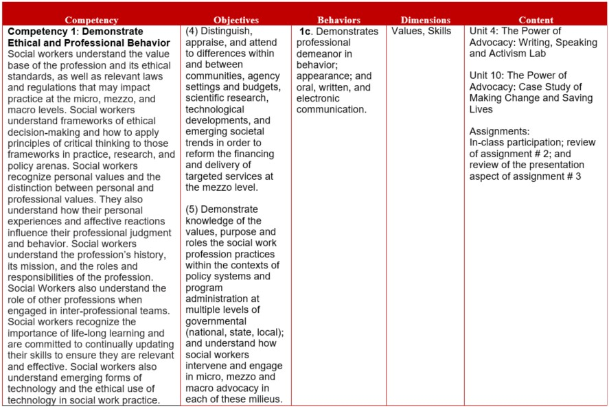
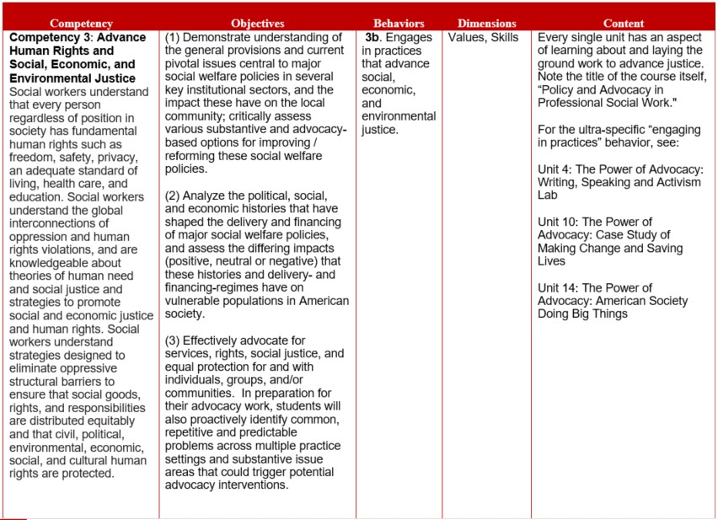
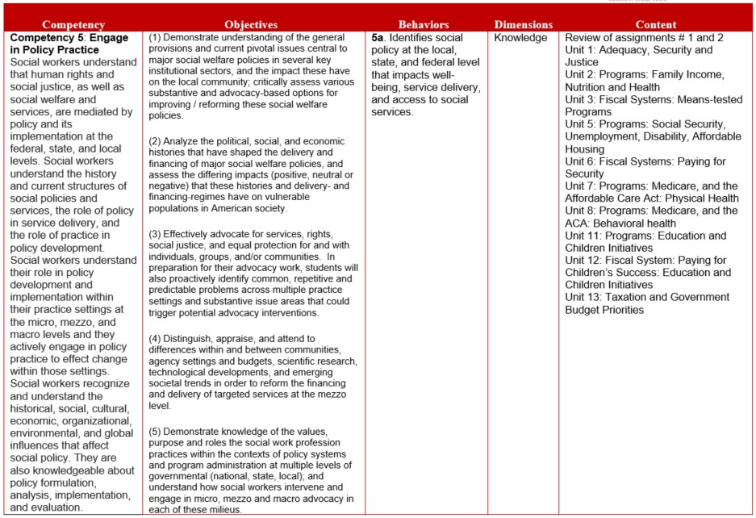
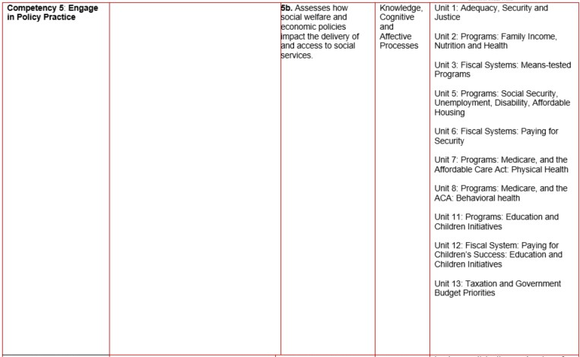

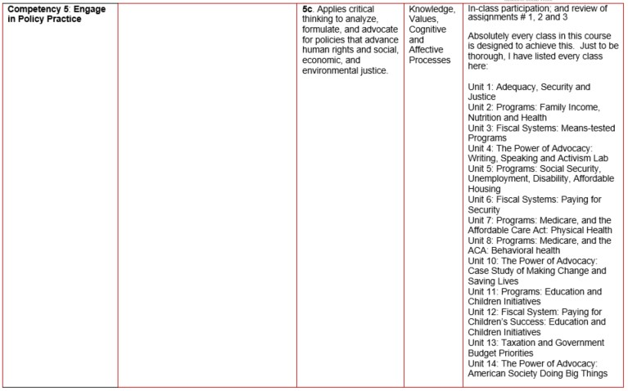
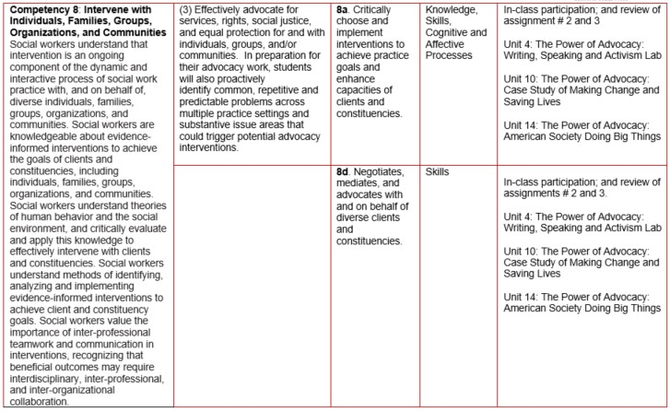

Appendix B: Definitions of Grades and Standards Established by Faculty of the School
Within the USC Suzanne Dworak-Peck School of Social Work, grades are determined in each class based on the following standards which have been established by the faculty of the School:
- Grades of A or A- are reserved for student work which not only demonstrates very good mastery of content but which also shows that the student has undertaken a complex task, has applied critical thinking skills to the assignment, and/or has demonstrated creativity in her or his approach to the assignment. The difference between these two grades would be determined by the degree to which these skills have been demonstrated by the student.
- A grade of B+ will be given to work which is judged to be very good. This grade denotes that a student has demonstrated a more-than-competent understanding of the material being tested in the assignment.
- A grade of B will be given to student work which meets the basic requirements of the assignment. It denotes that the student has done adequate work on the assignment and meets basic course expectations.
- A grade of B- will denote that a student’s performance was less than adequate on an assignment, reflecting only moderate grasp of content and/or expectations.
- A grade of C would reflect a minimal grasp of the assignments, poor organization of ideas and/or several significant areas requiring improvement.
- Grades between C- and F will be applied to denote a failure to meet minimum standards, reflecting serious deficiencies in all aspects of a student’s performance on the assignment.

Appendix C: Recommended Instructional Materials and Resources
Recommended Guidebook for APA Style Formatting
Publication manual of the American Psychological Association: The official guide to APA style. (7th ed.). (2020). American Psychological Association.
Additional Recommended Websites and their published descriptors:
Economic Policy Institute
The Economic Policy Institute (EPI), a non-profit, non-partisan think tank, was created in 1986 to broaden discussions about economic policy to include the needs of low- and middle-income workers.
​Center on Budget and Policy Priorities
The Center conducts research and analysis to help shape public debates over proposed budget and tax policies and to help ensure that policymakers consider the needs of low-income families and individuals in these debates. The Center also develops policy options to alleviate poverty.
Govtrack
Publishing the status of federal legislation, information about representatives and senators in Congress including voting records, and original research on legislation, and one of the oldest government transparency websites in the world.
Center for Economic and Policy Research
The Center for Economic and Policy Research (CEPR) was established in 1999 to promote democratic debate on the most important economic and social issues that affect people’s lives. In order for citizens to effectively exercise their voices in a democracy, they should be informed about the problems and choices that they face.
Council of Social Work Education - CSWE
Founded in 1952, the Council on Social Work Education (CSWE) is the national association representing social work education in the United States.
National Association of Social Workers - NASW –and state unit levels
Founded in 1955, the National Association of Social Workers (NASW) is the largest membership organization of professional social workers in the world.
International Federation of Social Workers –IFSW
The International Federation of Social Workers (IFSW) is the global body for the profession. The Federation and its national members strive for social justice, human rights and inclusive, sustainable social development through the promotion of social work best practice and engagement in international cooperation.
Social Progress Index
The Social Progress Imperative, through regional partnerships, promotes the formation of local networks which apply the Social Progress Index within countries to guide social investments.
Institute for Research on Poverty
IRP is a center for interdisciplinary research into the causes and consequences of poverty and social inequality in the United States. It is nonprofit and nonpartisan and based at the University of Wisconsin-Madison. It is one of three National Poverty Research Centers sponsored by the U.S. Department of Health and Human Services.
Center for American Progress
The Center for American Progress is an independent nonpartisan educational institute dedicated to improving the lives of Americans through progressive ideas and action.
Brookings Institution
The Brookings Institution is a nonprofit public policy organization based in Washington, DC whose mission is to conduct high-quality, independent research and, based on that research, to provide innovative, practical policy recommendations.
MDRC (originally Manpower Demonstration Research Corporation)
Created in 1974 by the Ford Foundation and a group of federal agencies, MDRC is a nonprofit, nonpartisan education and social policy research organization dedicated to learning what works to improve programs and policies that affect the poor.
Urban Institute
In the mid-1960s, President Johnson created a blue-ribbon commission of civic leaders who recommended chartering a center to provide independent nonpartisan analysis of the problems facing America’s cities and their residents. In 1968, the Urban Institute became that center.
Institute for Policy Research
The Institute for Policy Research (IPR) is an interdisciplinary public policy research institute founded in 1968 at Northwestern University whose mission is to stimulate and support social science research on significant public policy issues and to disseminate the findings widely — to students, scholars, policymakers, and the public at large.
National Poverty Center
The National Poverty Center (NPC) at the Gerald R. Ford School of Public Policy at the University of Michigan was established in the fall of 2002 as a university-based, nonpartisan research center. The center conducts and promotes multidisciplinary, policy-relevant research, mentors and trains emerging scholars, and informs public discourse on the causes and consequences of poverty.
Center for the Study of Social Policy
Established in 1979 as part of the University of Chicago, CSSP’s primary goal was to influence public policy affecting poor children and families, the elderly and the disabled. Founder Tom Joe, blind from early childhood, was a staunch advocate for federal and state policies that leveled the playing field for the disenfranchised and addressed the injustices that affected people’s lives.
Center for Law and Social Policy
The Center for Law and Social Policy develops and advocates for federal, state and local policies to strengthen families and create pathways to education and work.
Stanford Center on Poverty and Inequality
The Stanford Center on Poverty and Inequality (CPI), one of three National Poverty Centers, is a nonpartisan research center dedicated to monitoring trends in poverty and inequality, explaining what’s driving those trends, and developing science-based policy on poverty and inequality.
Inequality.org
Inequality.org is a new portal for data, analysis, and commentary on wealth and income disparity created by the Institute for Policy Studies
Heritage Foundation
Founded in 1973, The Heritage Foundation is a research and educational institution—a think tank—whose mission is to formulate and promote conservative public policies based on the principles of free enterprise, limited government, individual freedom, traditional American values, and a strong national defense.
Cato Institute
The Cato Institute is a public policy research organization — a think tank — dedicated to the principles of individual liberty, limited government, free markets and peace. Its scholars and analysts conduct independent, nonpartisan research on a wide range of policy issues guided by libertarian principles.
Joint Center for Political and Economic Studies
The Joint Center for Political and Economic Studies works to inform and illuminate the nation’s major public policy debates through research, analysis, and information dissemination, with the goal of improving the socioeconomic status of African Americans and other people of color.
Committee for a Responsible Federal Budget
The Committee for a Responsible Federal Budget is a bipartisan, non-profit organization committed to educating the public about issues that have significant fiscal policy impact. The Committee is made up of some of the nation’s leading budget experts including many of the past Chairmen and Directors of the Budget Committees, the Congressional Budget Office, the Office of Management and Budget, the Government Accountability Office, and the Federal Reserve Board.
Campaign for America’s Future
The Campaign for America’s Future views itself as “the strategy center for the progressive movement.” Their stated goal is to forge the enduring progressive majority needed to realize the America of shared prosperity and equal opportunity that our country was meant to be.
Institute for New Economic Thinking
The Institute for New Economic Thinking (INET) was created to broaden and accelerate the development of new economic thinking that can lead to solutions for the great challenges of the 21st century.
Vera Institute
The Vera Institute of Justice is an independent, nonpartisan, nonprofit center for justice policy and practice that combines expertise in research, demonstration projects, and technical assistance to help leaders in government and civil society improve the systems people rely on for justice and safety.
Drug Policy Alliance
The Drug Policy Alliance (DPA) is the nation’s leading organization promoting alternatives to current drug policy that are grounded in science, compassion, health and human rights.
The Sentencing Project
The Sentencing Project was founded in 1986 to provide defense lawyers with sentencing advocacy training and to reduce the reliance on incarceration. Since that time, The Sentencing Project has become a leader in the effort to bring national attention to disturbing trends and inequities in the criminal justice system with a successful formula that includes the publication of groundbreaking research, aggressive media campaigns and strategic advocacy for policy reform.
Justice Policy Institute
The Justice Policy Institute is a nonprofit organization that advances policies that promote well-being and justice for all people and communities. Their research and analyses identify effective programs and policies and they disseminate findings to the media, policymakers and advocates.
Brennan Center for Justice
The Brennan Center for Justice at New York University School of Law is a nonpartisan law and policy institute that seeks to improve U.S. systems of democracy and justice. They work to hold political institutions and laws accountable to the twin American ideals of democracy and equal justice for all.
Southern Poverty Law Center
The SPLC is a catalyst for racial justice in the South and beyond, working in partnership with communities to dismantle white supremacy, strengthen intersectional movements, and advance the human rights of all people.
RAND Corp
U.S Department of Education
CRISP- Congressional Research Inst Soc Policy
Green Peace
WHO
CDC
American Bar Association
Center for Work Life Law
The Network for Social Work Management
National Institute of Health
SAMHSA Substance Abuse and mental Health Services Association
AARP
Annie E Casey Family Foundation – Kids Count
Embrace Race
Anti Racism Daily
Government Accountability Office

Appendix D: Suzanne Dworak-Peck School of Social Work Diversity, Equity, and Inclusion Statement
At the USC Suzanne Dworak-Peck School of Social Work, we aspire to promote diversity, equity and inclusion in our courses and professional practice. We value the diverse backgrounds and perspectives that our students bring into the classroom as strengths and resources that enrich the academic and learning experience. We offer and value inclusive learning in the classroom and beyond. We integrate readings, materials and activities that are respectful of diversity in all forms, including race, ethnicity, culture, gender identity and expression, sexual orientation, age, ability and disability, socioeconomic status, religion, and political perspectives. Collectively, we aspire to co-create a brave space with students and instructors to critically examine individual and collective sources of bias, prejudice, discrimination, and systematic oppression that affect the ability of people and communities to thrive. In this way, we fulfill our professional responsibility to practice the NASW Code of Ethics, abide by the CSWE Educational Policy and Accreditation Standards, and address the American Academy of Social Work and Social Welfare, Grand Challenges for Social Work.

Appendix E: University Policies and Guidelines
Attendance Policy
Students are expected to attend every class and to remain in class for the duration of the unit. Failure to attend class or arriving late may impact your ability to achieve course objectives which could affect your course grade. Students are expected to notify the instructor by email (xxx@usc.edu) of any anticipated absence or reason for tardiness.
University of Southern California policy permits students to be excused from class for the observance of religious holy days. This policy also covers scheduled final examinations which conflict with students’ observance of a holy day. Students must make arrangements in advance to complete class work which will be missed, or to reschedule an examination, due to holy days observance.
Please refer to SCampus and to the USC School of Social Work Policies and Procedures for additional information on attendance policies.

Statement on Academic Conduct
Plagiarism – presenting someone else’s ideas as your own, either verbatim or recast in your own words – is a serious academic offense with serious consequences. Recording a university class without the express permission of the instructor and an announcement to the class, as well as distributing or using recordings of university lectures or classes without the express permission of the instructor, for purposes other than individual or group study, also constitute violations of the USC Student Conduct Code.
Please familiarize yourself with the discussion of plagiarism, unauthorized recording of university classes, and other forms of academic dishonesty and misconduct in SCampus, Part B, Section 11, “Behavior Violating University Standards,” as well as information in SCampus and in the university policies on scientific misconduct.

Statement about Incompletes
The Grade of Incomplete (IN) can be assigned only if there is work not completed because of a documented illness or some other emergency occurring after the 12th week of the semester. Students must NOT assume that the instructor will agree to the grade of IN. Removal of the grade of IN must be instituted by the student and agreed to be the instructor and reported on the official “Incomplete Completion Form.”

Policy on Late or Make-up Work
Papers are due on the day and time specified. Extensions may be granted, but depend on the extenuating circumstances. Any requests for consideration *must* be made in advance. If the paper is late without permission, the grade will be affected.

Policy on Changes to the Syllabus and/or Course Requirements
It may be necessary to make some adjustments in the syllabus during the semester in order to respond to unforeseen or extenuating circumstances. Adjustments that are made will be communicated to students both verbally and in writing.

Code of Ethics of the National Association of Social Workers (Optional)
Approved by the 1996 NASW Delegate Assembly and revised by the 2017 NASW Delegate Assembly https://www.socialworkers.org/About/Ethics/Code-of-Ethics/Code-of-Ethics-English
Preamble
The primary mission of the social work profession is to enhance human well-being and help meet the basic human needs of all people, with particular attention to the needs and empowerment of people who are vulnerable, oppressed, and living in poverty. A historic and defining feature of social work is the profession's focus on individual well-being in a social context and the well-being of society. Fundamental to social work is attention to the environmental forces that create, contribute to, and address problems in living.
Social workers promote social justice and social change with and on behalf of clients. "Clients" is used inclusively to refer to individuals, families, groups, organizations, and communities. Social workers are sensitive to cultural and ethnic diversity and strive to end discrimination, oppression, poverty, and other forms of social injustice. These activities may be in the form of direct practice, community organizing, supervision, consultation, administration, advocacy, social and political action, policy development and implementation, education, and research and evaluation. Social workers seek to enhance the capacity of people to address their own needs. Social workers also seek to promote the responsiveness of organizations, communities, and other social institutions to individuals' needs and social problems.
The mission of the social work profession is rooted in a set of core values. These core values, embraced by social workers throughout the profession's history, are the foundation of social work's unique purpose and perspective:
- Service
- Social justice
- Dignity and worth of the person
- Importance of human relationships
- Integrity
- Competence
This constellation of core values reflects what is unique to the social work profession. Core values, and the principles that flow from them, must be balanced within the context and complexity of the human experience.

Academic Dishonesty Sanction Guidelines
Some lecture slides, notes, or exercises used in this course may be the property of the textbook publisher or other third parties. All other course material, including but not limited to slides developed by the instructor(s), the syllabus, assignments, course notes, course recordings (whether audio or video) and examinations or quizzes are the property of the University or of the individual instructor who developed them. Students are free to use this material for study and learning, and for discussion with others, including those who may not be in this class, unless the instructor imposes more stringent requirements. Republishing or redistributing this material, including uploading it to web sites or linking to it through services like iTunes, violates the rights of the copyright holder and is prohibited. There are civil and criminal penalties for copyright violation. Publishing or redistributing this material in a way that might give others an unfair advantage in this or future courses may subject you to penalties for academic misconduct.

Complaints
Please direct any concerns about the course with the instructor first. If you are unable to discuss your concerns with the instructor, please contact the faculty course lead. Any concerns unresolved with the course instructor or faculty course lead may be directed to the student’s advisor and/or the Chair of your program.

Tips for Maximizing Your Learning Experience in this Course (Optional)
- Be mindful of getting proper nutrition, exercise, rest and sleep!
- Come to class.
- Complete required readings and assignments BEFORE coming to class.
- BEFORE coming to class, review the materials from the previous Unit AND the current Unit, AND scan the topics to be covered in the next Unit.
- Come to class prepared to ask any questions you might have.
- Participate actively in class discussions.
- AFTER you leave class, review the materials assigned for that unit again, along with your notes from that Unit.
- If you don't understand something, ask questions! Ask questions in class, during office hours, and/or through email.
- Keep up with the assigned readings.
Appendix F: Support Systems and Additional Resources
Counseling and Mental Health
https://studenthealth.usc.edu/counseling/
Phone number (213) 740-9355
On call 24/7
Free and confidential mental health treatment for students, including short-term psychotherapy, group counseling, stress fitness workshops, and crisis intervention.

National Suicide Prevention Lifeline
https://suicidepreventionlifeline.org/
Phone number 1 (800) 273-8255
On call 24/7
Free and confidential emotional support to people in suicidal crisis or emotional distress 24 hours a day, 7 days a week.

Relationship and Sexual Violence Prevention Services (RSVP)
https://studenthealth.usc.edu/sexual-assault/
Phone Number (213) 740-9355(WELL), press “0” after hours
On call 24/7
Free and confidential therapy services, workshops, and training for situations related to gender-based harm.

USC Office of Equity, Equal Opportunity, and Title IX
https://eeotix.usc.edu/
Phone number (213) 740-5086
Title IX Office (213) 821-8298
Information about how to get help or help someone affected by harassment or discrimination, rights of protected classes, reporting options, and additional resources for students, faculty, staff, visitors, and applicants.

Reporting Incidents of Bias or Harassment
https://usc-advocate.symplicity.com/care_report/index.php/pid422659?
Phone number (213) 740-5086 or (213) 821-8298
Avenue to report incidents of bias, hate crimes, and microaggressions to the Office of Equity, Equal Opportunity, and Title IX for appropriate investigation, supportive measures, and response.

The Office of Disability Services and Programs
https://dsp.usc.edu/
Phone number (213) 740-0776
Support and accommodations for students with disabilities. Services include assistance in providing readers/notetakers/interpreters, special accommodations for test taking needs, assistance with architectural barriers, assistive technology, and support for individual needs.

USC Campus Support and Intervention
https://campussupport.usc.edu/
Phone number (213) 821-4710
Assists students and families in resolving complex personal, financial, and academic issues adversely affecting their success as a student.

Diversity at USC
https://diversity.usc.edu/
Phone number (213) 740-2101
Information on events, programs and training, the Provost’s Diversity and Inclusion Council, Diversity Liaisons for each academic school, chronology, participation, and various resources for students.

USC Emergency
https://dps.usc.edu/
UPC phone number (213) 740-4321
HSC phone number (323) 442-1000
On call 24/7
Emergency assistance and avenue to report a crime. Latest updates regarding safety, including ways in which instruction will be continued if an officially declared emergency makes travel to campus infeasible.

USC Department of Public Safety
https://dps.usc.edu/
UPC phone number (213) 740-6000
HSC phone number (323) 442-120
On call 24/7
Non-emergency assistance or information.

Additional Resources
Students enrolled in the Virtual Academic Center can access support services for themselves and their families by contacting Perspectives, Ltd., an independent student assistance program offering crisis services, short-term counseling, and referral 24/7. To access Perspectives, Ltd., call 800-456-6327.

