ROSKI CRIT 440 – CURATORIAL ISSUES (4 units)
Curating Contemporary Performance: from Actions to Activism
Fall 2021 Monday, 3 – 6:20 pm Dr. Karen Moss

This course focuses on curating contemporary performance from actions, happenings and Fluxus events of the 1960s to recent socially engaged art, protests and activism. We will delve deeply into case studies of a diverse range of performances in traditional galleries and museums, experimental and artist-run spaces, festivals and biennials, and sites on screen, on-line and in the street. Including live events and exhibitions that document or re-present past programs, we will study how different curators collaborate with artists to conceptualize different frameworks to best present and contextualize their performative, ephemeral practices.

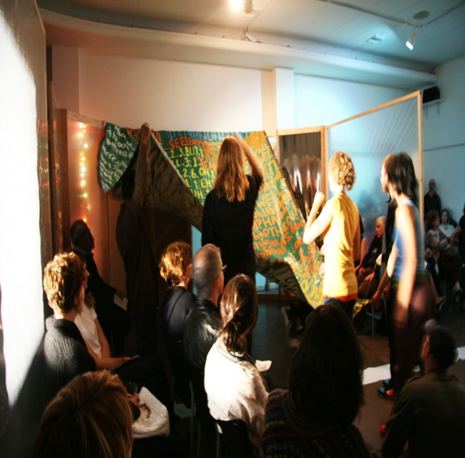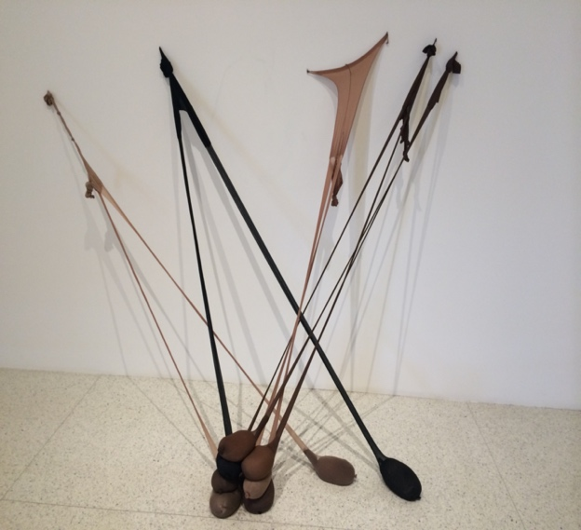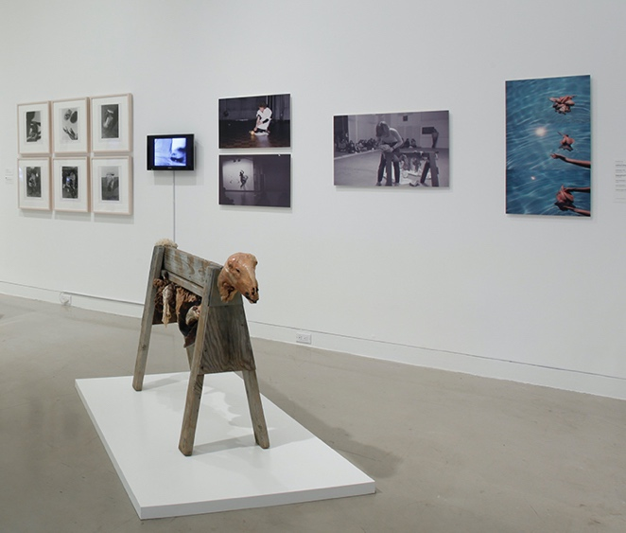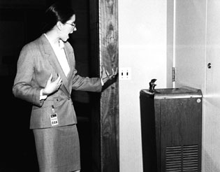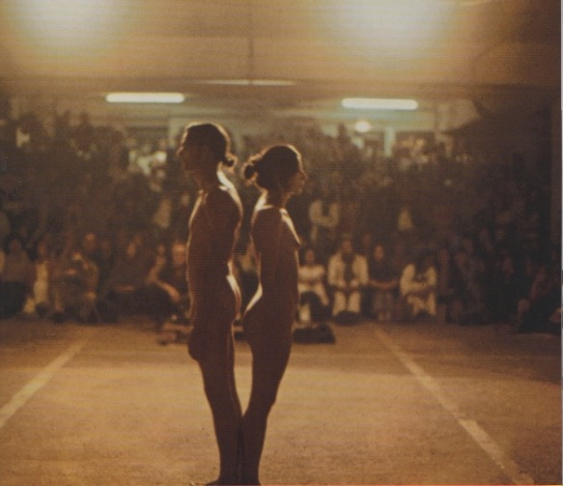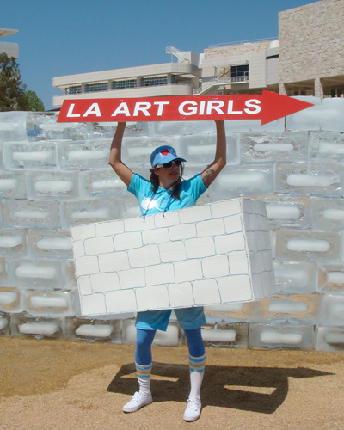

Open to Roski upper division undergrads and grads, other students by permission

For more information, please contact Karen Moss

moss@usc.edu & https://roski.usc.edu/community/faculty/karen-moss

