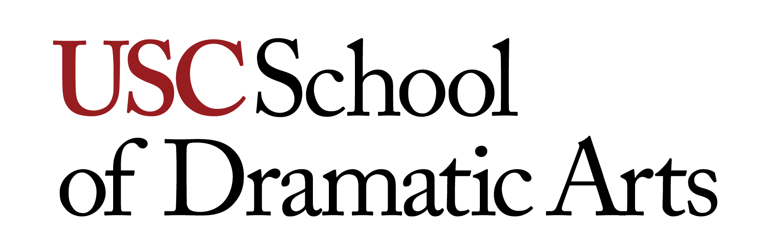
THTR 520A ADVANCED ACTING
Units: 4
FALL 2020—M/W—3:00pm – 5:50pm

Location: ONLINE

Instructor: David Warshofsky (He/Him)
Office: DRC 120 or Zoom
Office Hours: Available by appointment. Call or email as above. Mentorship is an essential element of the instructional technique in the MFA program; make it a point to make an appointment
Contact Info: warshofs@usc.edu (323) 646-9525 (mobile)

Course Description
“An actor’s tool is you, but this use of oneself is informed by all the things which inform one’s mind and body – your observations, your struggles, your nightmares, your prison, your patterns – yourself as a citizen of your times and your society. Technique is a means to free the artist.”
--Joseph Chaiken
The goal of this course is to begin the intellectual, physical, emotional and ritual understanding of what personalization is and how it applies to the text of a play and eventually transitioning the information into intensive formal scene study focusing on contemporary American playwrights.

Learning Objectives

- To begin the practical understanding and application of the craft of acting. What acting is and what it isn’t. How to break down a piece of text (i.e. “table work”) Objectives, Actions, Sub-text applied to the given circumstances of the play.

- Moving though personalization--making the connection between yourself, your story, the story of the play and the so-called “character” that you are attempting to portray.

- We will utilize active text analysis with particular focus on verbs (what you are doing) and objectives (what you want).

In this class we will explore the idea that the individual actor is infinitely more interesting and imaginative than any finite character that he, she, or they might play.

Recommended Preparation: Undergraduate Degree

Technological Proficiency and Hardware/Software Required
Highest speed internet available, most recent lap top available, external microphone and camera, uncluttered well-lit space to work in.

Required Readings and Supplementary Materials
The Empty Space by Peter Brook
Theatre of the Unimpressed by Jordan Tannahill

*Ordered for you and available at the USC Bookstore

Lab Section: Jeremy Kagan’s Directing for Cinema Class ONLINE TH 7-10:20pm
kagan@usc.edu

Description and Assessment of Assignments
Monologues and Scene Work

Grading Breakdown
A work of excellent quality
B work of good quality
C work of average quality
D work of below average quality

Your grade is assessed according to

Class Work – 50%
Midterm – 25%
Final – 25%

Additional Policies

Some of our classrooms are retrofitted with camera and micrphones that will enable myself to teach remotely from the studio while the students are at home, or vice versa once we can begin to re-introduce in person training. This also enables an actor who is sick and needing to stay at home (during COVID or in the future) to never have to miss class. The following will be discussed on the first day of class:
- Do you have discussion norms for communications in your class?
- Do you expect a certain type of professional attire and behavior for students during synchronous sessions? If so, do you provide an explanation of the expectations?
- Are students allowed to log-in to the class using their phone?
- Who should students contact if they have technical issues during the class?
- Do you require students to mute their microphones when they are not speaking?
- Do you require students to enable their webcam, so they are visible in the course?
- Do you allow students to eat during the class?
- Can students use technology other than their computers during the sessions?
- Do you recommend a certain physical environment for the student to take part in the synchronous session? Consider noise levels, background objects and artwork, pets, family members.
- Do you specify how/if the chat box will be used during the session?
- Have you identified a process for students taking turns speaking?
- How can students indicate they have something to say?
- Do you have a plan for managing and addressing conflict in a synchronous environment?

Course Schedule: A Weekly Breakdown

WEEK FIRST CLASS SECOND CLASS

1 Formal Orientation Exercises

2 Monologues Monologues

3 Monologues Monologues

4 Script Analysis Script Analysis

5 Show/work scene 1 Show/work scene 1

6 Show/work scene 1 Show/work scene 1

7 Show/work scene 1 Show/work scene 1

8 Show/work scene 1 Show/work scene 1

9 Show/work scene 1 Run-thru of Scene 1

10 Show/work scene 2 Show/work scene 2

11 Show/work scene 2 Show/work scene 2

12 Show/work scene 2 Show/work scene 2

13 Show/work scene 2 Show/work scene 2

14 Format Culmination Rehearse Culmination

15 Rehearse Culmination Rehearse Culmination

SDA PRODUCTIONS

SDA productions are courses and therefore do not supersede any other courses in which you are enrolled. When in an SDA production, students must not register for evening classes that conflict with regularly scheduled rehearsals. In short, being involved in an SDA production is a curricular assignment and must be treated as any other curricular assignment.

Statement on Academic Conduct and Support Systems

Academic Conduct:
Plagiarism – presenting someone else’s ideas as your own, either verbatim or recast in your own words – is a serious academic offense with serious consequences. Please familiarize yourself with the discussion of plagiarism in SCampus in Part B, Section 11, “Behavior Violating University Standards” policy.usc.edu/scampus-part-b. Other forms of academic dishonesty are equally unacceptable. See additional information in SCampus and university policies on scientific misconduct, http://policy.usc.edu/scientific-misconduct.

Statement for Students with Disabilities
Any student requesting academic accommodations based on a disability is required to register with Disability Services and Programs (DSP) each semester. A letter of verification for approved accommodations can be obtained from DSP. Please be sure the letter is delivered to me (or to TA) as early in the semester as possible. DSP is located in GFS 120 and is open 8:30 a.m.–5:00 p.m., Monday through Friday. Website for DSP and contact information: (213) 740-0776 (Phone), (213) 814-4618 (Vidoe Phone), (213) 740-8216 (FAX) ability@usc.edu.

Emergency Preparedness/Course Continuity in a Crisis
In case of a declared emergency if travel to campus is not feasible, USC executive leadership will announce an electronic way for instructors to teach students in their residence halls or homes using a combination of Blackboard, teleconferencing, and other technologies. See the university’s site on Campus Safety and Emergency Preparedness.

***

Support Systems:
Campus Support & Intervention (CSI) – (213) 740-0411
Campus Support & Intervention is an office within Campus Wellbeing and Crisis Intervention. We are a team of professionals here to assist students, faculty, and staff in navigating complex issues. Whether you are here seeking support for yourself or someone else, we are available to help you problem solve, understand options, and connect with resources. https://uscsa.usc.edu

Student Counseling Services (SCS) – (213) 740-7711 – 24/7 on call
Free and confidential mental health treatment for students, including short-term psychotherapy, group counseling, stress fitness workshops, and crisis intervention. engemannshc.usc.edu/counseling

National Suicide Prevention Lifeline – 1 (800) 273-8255
Provides free and confidential emotional support to people in suicidal crisis or emotional distress 24 hours a day, 7 days a week. www.suicidepreventionlifeline.org

Relationship and Sexual Violence Prevention Services (RSVP) – (213) 740-4900 – 24/7 on call
Free and confidential therapy services, workshops, and training for situations related to gender-based harm. engemannshc.usc.edu/rsvp

Sexual Assault Resource Center
For more information about how to get help or help a survivor, rights, reporting options, and additional resources, visit the website: https://titleix.usc.edu/

Office of Equity and Diversity (OED)/Title IX Compliance – (213) 740-5086
Works with faculty, staff, visitors, applicants, and students around issues of protected class. equity.usc.edu

Bias Assessment Response and Support
Incidents of bias, hate crimes and microaggressions need to be reported allowing for appropriate investigation and response. https://titleix.usc.edu/

The Office of Disability Services and Programs
Provides certification for students with disabilities and helps arrange relevant accommodations. dsp.usc.edu

Diversity at USC
Information on events, programs and training, the Diversity Task Force (including representatives for each school), chronology, participation, and various resources for students. diversity.usc.edu

USC Emergency Information
Provides safety and other updates, including ways in which instruction will be continued if an officially declared emergency makes travel to campus infeasible. emergency.usc.edu

USC Department of Public Safety – UPC: (213) 740-4321 – HSC: (323) 442-1000 – 24-hour emergency or to report a crime.
Provides overall safety to USC community. dps.usc.edu

