BUAD 304: Organizational Behavior and Leadership
Syllabus Fall 2020
Section 14735 – 4 Units, 8AM
Professor Maurice H Rahimi, Ph.D.
Office: Currently, given the Covid circumstances, my office is at home
Phone: (858) 775-8775
Email: mhrahimi@marshall.usc.edu
Office Hours: Mondays 10:15-11:30 AM (Please schedule meetings in advance) and by appointment

This class will be entirely online. Synchronous class sessions will be held Mondays and Wednesdays, Pacific Time via Zoom. The Zoom link is posted on the course Blackboard site.

Course Description

Organizational behavior addresses the human side of organizations—what people need and desire at work, how they use their time, talent, and energy for collective ends, and how they can work together effectively for a greater good. Leadership guides and influences others to engage in these collective endeavors.

BUAD 304 therefore has a dual focus on helping you: 1) learn evidence-based knowledge from the field of organizational behavior in order to identify and apply best organizational practices for leading teams and organizations, and 2) develop the interpersonal skills required to lead diverse groups and organizations effectively.

This combined focus on organizational knowledge and leadership behaviors will enable you to use sound judgment in making complex decisions, manage relationships with others, motivate and influence others without relying on formal authority, build and manage high performing teams, deploy social capital, negotiate effectively, lead organizational change, and generally make sense of today’s — and tomorrow’s — organizational world. Organizations place a high value on these leadership skills, so learning them will enable you to excel in today’s dynamic, competitive, and global marketplace.

Course Learning Objectives

After successfully completing BUAD 304, you will be able to:
- Utilize organizational behavior theories, frameworks, principles, and tactics to prevent OB problems from emerging and, when problems are identified, intervene to fix them.
- Evaluate the benefits and challenges of alternatives to achieve high performance at the individual, team and organizational levels.
- Develop greater confidence and dexterity with enacting a variety of leadership behaviors.
- Create a plan to improve your own personal leadership skills and to manage your career.

The course will place a special emphasis on developing your critical thinking skills. Cases will seek to develop your ability to uncover the various potential problems, challenges and opportunities faced by a business, sort and select the most important, develop alternative courses of action for addressing those issues, assess the different courses of action in light of multiple criteria, select the solutions that have the potential to be the most effective and develop an effective implementation plan.

The relationship between the course learning goals and the Marshall School of Business’ undergraduate business program learning goals is described in Appendix A.

Course Materials

You need the following resources for this course.

(1) Textbook & You will need the ONLINE version of Organizational Behavior: A
Connect/LearnSmart Practical, Problem-Solving Approach 3rd edition by Angelo Kinicki and Mel Fugate. 2018. McGraw Hill.
I recommend that you purchase through our Connect class link- for $80. If you want a printed version, it is an additional cost and takes time for delivery. This is the most cost-effective choice.
You can also purchase the text including the Connect code at the USC Bookstore (about $130).
Of course, you have other options, but make sure you have access to the online Connect/LearnSmart resources and the 3rd edition. Be mindful of what you are buying, if not through the recommended website, before you purchase and not be able to return.
NOTE: You can register for 2-week temporary access on Connect if you are still figuring out your courses for Fall. But buy full access before your temporary access expires to keep your assignments and scores in sync.
Please use the following steps to gain access to Connect through Blackboard and purchase the text as well as have access to other resources provided by Connect.
Please use the directions below to register for Connect through Blackboard:
- Sign into our school Blackboard
- Go to our course
- Go to “Tools” menu
- Click on McGraw-Hill Education link
- Below “My Connect Section”, click Go to My Connect Section
- Follow the on-screen instructions to register

To learn more about Connect/LearnSmart, please use the following link to gain access to instructions on using Connect: https://www.mheducation.com/highered/support/connect/first-day-of-class/blackboard.html.

(2) ARES The course reader is accessible for free on the USC Libraries ARES
Course Reader: system online. Go to https://reserves.usc.edu/ares/ and search for BUAD 304 for Fall 2020. Instructions for how to download the articles in Appendix B and posted on Blackboard.

(3) Case Reader: BUAD 304 Fall 2020 Organizational Behavior & Leadership Coursepack available for purchase ($25.50) at https://hbsp.harvard.edu/import/745052
If the link doesn’t work, cut & paste into your browser.

(4) Case for A link will be provided to purchase a specific case for the Module 1 Case
Module 1 Paper Analysis Paper. (approximate cost $4.25)

Additional Readings, Resources and Assessments
- Videos are available on the USC Marshall Critical Thinking Initiative website to help you better understand how to do case analysis and use the Marshall USC-CT framework. You will want to watch these before completing the first case analysis memo. http://info.marshall.usc.edu/faculty/critthink/Pages/default.aspx
- Personal assessments are listed in the class schedule with how to access them via a website or McGraw-Hill Connect.
- Any additional readings and/or assessments will be posted on Blackboard.

Course Notes

All course information is available through your Blackboard account. Blackboard is the primary channel of communication for this course so take note of announcements and other email messages you receive. Assignment and exam scores are posted here as well. You can also communicate directly with your Professor, your project team members, and other classmates from your section. To access Blackboard from your web browser, enter https://blackboard.usc.edu, and use your USC username and password to log in.

Grading

Individual Assignments 30%
Module 1 Case Analysis Paper 15
Final Reflection Paper 15
Team Project 30%
Proposal & Team Contract 3
Paper 15
Presentation 10
Self & Peer Evaluation 2
Final Exam 25%
Participation 15%
Active Class Participation
Team Engagement
Connect reading quizzes
Research studies

TOTAL 100%

Final grades for this course will reflect the weighted sum of your assignment grades and will adhere to the grading policy approved by Marshall. Three items are considered when assigning final grades:
- Your average weighted score as a percentage of the available points for all assignments (the points you receive divided by the number of points possible).
- The overall average percentage score within the class.
- Your ranking among all students in the class.

Course Requirements: Individual Assignments

Module 1 Case Analysis Paper: At the end of Module 1 (Week 6), you will complete a written case analysis paper based on a business case from Harvard or other source. You are expected to use the USC-CT framework to identify the key issues and provide relevant solutions utilizing the concepts, theories and frameworks from Module 1 (Individual level of Organizational Behavior). Further instructions will be provided in class and on Blackboard.

Final Reflection Paper: You will write a short personal reflection paper that describes how your team experience was influenced by different group properties and processes as well as reflect on your own behavior and learning. You will be assessed based on thoughtful, convincing, insightful, and exploratory writing and reflection, a strong connection between the experience and the learning or insights gained, and the use of specific detail and narrative accounts that convey an understanding of the experience supported by course material and personal assessment results. We strongly recommend that you maintain a learning journal or notes throughout the semester to aid in the writing at the end of the semester. Instructions and a grading rubric will be posted on Blackboard.

Course Requirements: Team Project Assignments

Team Project: You will work together as an intact project team throughout the semester to prepare for and complete the Team Project. Your team will demonstrate that you understand the major challenges and key success factors to perform effectively as an individual, on a functioning team, and as a leader in business and society today. The aims of the team project are (1) to enrich your understanding of organizations and leadership; (2) to provide you with an opportunity to apply what you have learned in the course; (3) to assess your ability to define and analyze an organization or organizations and come to insightful conclusions and (4) to help you develop critical interpersonal and teamwork skills.

Your team will have a choice of conducting either:

(a) Fieldwork study with a local organization such as a student organization, business unit on campus, or other local company. Your team will investigate and analyze some aspect of this organization that connects with themes in the course
such as the organization’s culture, the structure and functioning of groups within the organization, its reward systems, or its relation to its local or national environment. You will make recommendations or identify best practices based on your study.
(b) Issues analysis of an issue/topic connected to the themes in the course and of importance to multiple organizations; this issue may be inspired by something in the headlines of the business press or something in your own experience. You will need to examine the nature of this issue and analyze in detail how different companies have addressed and/or experienced the issue. You will make recommendations and/or identify best practices based on your study using archival sources (i.e. library research).

Your “deliverable” for this project has five components. Submitted assignments should use 12-point, Times-Roman font, double spaced, 1-inch margins on all sides.

1) Project proposal with team contract: A one-page memo with appendix (contract)
2) Detailed outline of paper based on the grading
3) Project paper: An 8-10 page analytical paper
4) In-class presentation: A 15-minute presentation, 5 minutes for Q&A
5) Self & peer evaluation feedback (online assessment explained in class).

Feedback helps you learn and improve your performance as well as the quality of your output as a team. As part of the team project, you will practice and develop skills in providing and receiving effective feedback through in-class exercises and a more formal peer evaluation survey. The criteria for the peer evaluation will be discussed in class and posted on Blackboard.

The final grade for this project is based upon four components - project proposal, project paper, presentation, and self/peer evaluation. The team project will be evaluated according to quality of analysis, appropriate use of course concepts, logic and substantiation of conclusions, and clarity and appeal of your class presentation. The detailed outline of the paper is not graded but you will receive feedback to help improve the final paper. Further instructions and grading rubrics will be posted on Blackboard.

Grades for individual student contributions to team projects are assigned by your Professor, based on my observations of the team’s working dynamics, my assessment of the team project quality, and thoughtful consideration of the information provided through your peer evaluations.

Course Requirements: Final Exam

Final Exam: The comprehensive final exam will contain a series of multiple-choice questions. Refer to the exam study guide that is posted on Blackboard for information on the format of the questions, topics covered, and sample questions

The final exam will take place on the date and time assigned based on the University final examination schedule. If you have another final exam scheduled for the same time as the final exam for this course, you must let me know about the conflict at least 2 weeks prior to the final exam.

If you need DSP accommodations for the final exam, please notify me early in the semester so we can make the necessary arrangements. If you wait until the day of the exam, it is highly unlikely that I will be able to accommodate extra time or any other accommodation. If you have any questions or concerns, please come and speak with me. I am eager to make every student successful in any way I can.

Course Requirements: Participation

Class Participation: This part of your grade will be based on consistent and effective contributions to class discussions and activities. Connect reading assignments and practice quizzes, in-class assignments and activities also contribute to this score. You are expected to attend every class session having read, thought about, and prepared any assigned material. You should also be prepared to share your ideas and to actively listen to and interpret the ideas presented by others.

Comments that are vague, repetitive, unrelated to the discussion, or disrespectful of others will be evaluated negatively. Quality comments possess one or more of the following attributes:
- Offer a relevant concept or personal experience;
- Provide careful analysis by applying theory and concepts from readings and lectures;
- Move the discussion forward by building on previous contributions with new insights;
- Ask thoughtful and challenging questions.

Our learning community operates in an environment of openness, respect, encouragement and engagement. Discussions will be richer if you share your unique perspective. There is rarely one right answer in organizational behavior! It may take courage or patience or imagination to engage with the course material, our classmates and our experiences. In our classroom, I aim to develop a psychologically safe space where we can all learn together and benefit from the diversity that leads to increased innovation, better problem solving and, in our case, what I hope will be new friends and a great semester!

A Note on Diversity, Equity and Inclusion: Our USC Principles of Community state “USC is a multicultural community of people from diverse racial, ethnic, gender, and class backgrounds, national origins, faith backgrounds, political beliefs, abilities, and sexual orientations. Our activities, programs, classes, workshops, lectures, and everyday interactions are enriched by our acceptance of one another, and we strive to learn from each other in an atmosphere of positive engagement and mutual respect.” https://diversity.usc.edu/usc-principles-of-community/

As Trojans, we understand the value of the perspectives of individuals from all backgrounds that reflect the rich diversity of our USC community and beyond. I strive to make this classroom an inclusive environment for all students and invite you to join me.

I commit to the following and request them from you as well:
- Respect the dignity and essential work of all individuals,
- Promote a culture of respect within the university community,
- Respect the privacy, property, and freedom of others,
- Reject bigotry, discrimination, violence or intimidation of any kind,
- Practice personal and academic integrity and expect it of others, and
- Promote the diversity of opinions, ideas and backgrounds which is the lifeblood of the university.

If you see ways I can improve, please let me know.

Case Analysis Preparation: To actively engage in case discussions, you will need to complete an analysis of the assigned case before attending class. Case analysis allows us to explore how what we learn applies to real world situations. This goes beyond simply reading the case. You are expected to use the USC-CT critical thinking framework to analyze the assigned case. You will identify critical problems or issues and develop alternative solutions based on a particular situation or scenario. These assignments provide scaffolding (i.e. analytical skill development) for your Module 1 Case Analysis paper, the team project as well as the final exam. Be sure to watch the assigned USC-CT videos as noted in Week 1. Additional instructions will be posted on Blackboard.

Research Studies Participation: Finally, another part of your participation grade for class is based on your involvement in research activities. The purpose of this research requirement is to expose you to how the scientific process works and to provide you with an opportunity to contribute to science and research. There are two components to the research participation requirement. You must complete both components in order to fulfill your research requirement.

1. Participate in Lab Studies
To do this, you will participate in studies outside of class (either online or in-person), conducted by researchers in MOR at the Marshall School of Business. You will earn 0.5 or 1.0 credit for each separate study you complete. The amount of credit earned depends upon the length and complexity of the research study; most studies take no longer than one hour to complete.

You will need to obtain 2.0 credits during the semester in order to fulfill this component of the research requirement. Students must be age 18 or older by Sunday, October 4, 2020 to participate in the research studies. If you will not be 18 by this date, please consult with your professor about an alternative assignment (details below).

Register for a SONA account to Participate in Research Studies at this link:
http://marshall-mor.sona-systems.com/.

Account Reactivation for Previous BUAD 304/497 Students:
If you previously took BUAD 304/497 and you already have a SONA account, you will need to email the SONA administrator (mor.sona@marshall.usc.edu) in order to request account reactivation. Past credits earned CANNOT be used for current courses. If you see past credits appearing in your profile, you should notify the SONA administrator immediately.

DEADLINE to Register: Friday, August 28, 2020. Those who do not register for an account (or reactivate a pre-existing account) by this date will be required to complete the alternative assignment (details below).

Participating in Research Studies: After you verify your SONA account, you will need to check the SONA site regularly to find open studies and sign up to participate in them. Sometimes email announcements regarding new studies are sent out, but please do not rely on announcements alone.

Studies are scheduled throughout the semester at various days and times (both online and in-person). For online studies, you must complete them in one sitting by the due date listed on the study webpage. If attending an in-person study, please make sure to arrive on time; otherwise, you may not receive credit. Please remember to cancel within 6 hours if you cannot attend a study.

While there are usually enough studies to accommodate all students, you may wish to complete your credits early for your own peace of mind and to ensure you are able to obtain all the credits you need. You are not guaranteed enough study spots.

Other Deadlines:
- Friday, October 2, 2020: To receive full participation credits, you must earn your first credit by this date.
- Friday, November 13, 2020 (last day of classes): The last day to complete all credits.

Note for Students Currently Enrolled in Marketing (MKT) BUAD 307:
Please make sure you can visit the Marketing research study website that your Marketing professor has given you (see your Marketing course syllabus). Each course has its own unique SONA Systems web address. Credits will NOT transfer from one course to another for credit fulfillment. No exceptions.

Where to Direct Questions: Please review the FAQs about Lab Studies for assistance. Additional questions regarding the completion of lab studies should be directed to the SONA administrator (mor.sona@marshall.usc.edu).

2. Contribute to Field Studies
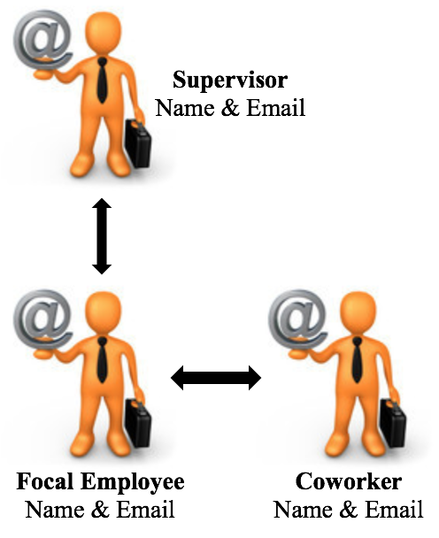
To do this, you will need to identify a full-time employee who would be willing to fill out an online survey about his/her work experiences. This might be a parent or guardian, a family friend, or anyone else who is currently a full-time employee. This (focal) employee must have a coworker and a supervisor who would be willing to fill out an online survey as well. Please note that the coworker and supervisor should know the focal employee. You will need to submit the information of all three employees.

Information Required:
The employee who agrees to participate should provide you with the following information:
- His/her own name and e-mail address (focal employee).
- The name and e-mail address of a coworker of theirs who is willing to participate in a survey.
- The name and email address of a supervisor of theirs who is willing to participate in a survey.

Submitting the Three Names and E-mail Addresses:
You will receive an e-mail with a link to submit the names and e-mail addresses of the three people you have recruited to participate. We will then e-mail survey links directly to the three employees within the following few weeks.

Deadlines:
You will receive an e-mail with a link. Friday, September 18, 2020 is the deadline for using that link to submit the names and e-mail addresses of the three people you recruited. Once you submit valid and accurate names and e-mail addresses, your participation in this portion of the research requirement is complete. There is no need to follow-up with your contacts to see if they received a survey.

Where to Direct Questions: Please review the FAQs about Field Studies for assistance (see Appendix C). Additional questions regarding the field data studies should be directed to the USC Marshall MOR Research Team (mor.research@usc.edu).

Alternative assignment:
If for any reason you do not wish to participate in the research requirements listed above, you can complete the research requirement of your participation grade by engaging in literature-based research on topics relevant to the course. To do so, you will need to write three short (3-page) research papers on topics pre-approved by your Professor. See your Professor for details. The deadline to submit papers is Friday, November 13, 2020 (last day of classes).

Online Class Expectations

- Class attendance and participation is important in developing a coherent view of the materials covered in the course. Because BUAD 304 is highly interactive and experiential, attendance and active participation is required at the synchronous Zoom class sessions.

  - Students are expected to have cameras on during the synchronous Zoom sessions. Headsets or earphones ensure the best audio quality but are not required. Please advise me if you have circumstances under which you will not be able to meet these expectations. We will see if there can be any accommodation or if you will want to register for a different section that better fits your time zone.

  - In addition, for any student who does not attend the Zoom session live, you will be required to complete an assignment as an alternate method of contribution to the class. You must contact me prior to the session.

- During synchronous Zoom sessions, the following netiquette is expected, as if you were in a physical classroom.
  - Please DO:
    - Log into class early or promptly.
    - Arrange to attend class where there is a reliable internet connection and without distractions.
    - Dress respectfully. Video conference business meetings are and will be the norm, so practice your professional telepresence.
    - If you use a virtual background, please keep it respectfully professional.
    - Display both your first and last name during video conferencing and synchronous class meetings. You may choose to rename with a nickname (i.e. Thomas Trojan -> Tommy Trojan).
    - Respectfully minimize distractions by muting and or turning off video if necessary and when appropriate.
    - Engage in appropriate tone and language with instructors and classmates.
  - Please DON’T:
    - Engage in a simultaneous activity not related to the class.
    - Interact with persons who are not part of the class during the class session.
    - Leave frequently or not be on camera for extended periods of time.
    - Have other persons or pets in view of the camera.

- All Zoom sessions will be recorded and posted in the Blackboard Course pages.

Online Technology Requirements

The following equipment and system requirements are recommended to successfully participate in this online course:
- Computer with webcam
- Earphones or headset
- Reliable (preferably high speed) Internet connection
- Current operating system for Windows or Mac
- Current browser
  - Google Chrome
  - Firefox
  - Internet Explorer (not recommended)
  - Safari (Mac)

For technical support please see:
- USC Systems (Blackboard, USC Login, MyUSC, USC Gmail, GoogleApps)
For assistance with your USC login or other USC systems, please call +1 (213) 740-5555 or email Consult@usc.edu. They are open Mon – Fri, 9:30am – 5pm and weekends from 8am - 5pm (all Pacific time).

- Zoom Video Web Conferencing System
For assistance using Zoom, go to Zoom Support Page. You may also call +1 (888) 799-9666 ext. 2. They are available 24/7.

- Marshall Systems (MyMarshall, Marshall Outlook email)
For assistance with Marshall systems you can call +1 (213) 740-3000 Mon-Fri 8am-6pm (Pacific), email HelpDesk@marshall.usc,edu, or use our self-help service portal as shown below. The portal allows you to get immediate assistance by searching for the information you need. You can also use it to chat with a technician or input a request. To access the service portal, follow these steps:
  - On a computer or mobile device, go to MyMarshall Home Page and click the “Help” link on the upper right.
  - Log in using your Marshall username and password.
(If you don’t know your Marshall login please follow the onscreen instructions pertaining to login issues)

If your computer does not have Microsoft Word, Office 365 package is available to you free of charge and allows you to install Word, Excel, PowerPoint, Outlook, OneNote, Publisher, and Access on up to 5 PCs or Macs and Office apps on other mobile devices including tablets. Office 365 also includes unlimited cloud storage on OneDrive. To download Office 365 log into your student (University) email through a web browser, choose Settings (top right corner), and select software. If you have further questions or need help with the software, please contact the USC ITS service portal (https://itservices.usc.edu/).

Review of Grades

Feedback and reflection are critical to learning, and especially for learning from our mistakes. I am happy to discuss how you are performing on assignments or in class participation to help you improve and/or correct your mistakes. This has to happen BEFORE your final grade is posted. So, I invite you to contact me within a week of when an assignment is returned to discuss so I can clarify my comments – which I assume you have read and reflected on your own first. Additionally, I do hold extra office hours for students to review exams. In the event that assignments are graded by a Teaching Assistant, you will meet with the TA first since s/he will be in the best position to provide useful feedback. I am happy to me with you after you meet with the TA if you have any additional questions or concerns.

Weekly Schedule

Weekly Class Schedule is available as a separate document on Blackboard
which is easier to read

Additional Information

USC Marshall Critical Thinking Initiative
The USC Marshall Critical Thinking Initiative is a school-wide effort to improve your critical thinking skills in order to be more successful problem solvers in class and ultimately in the workplace. This means that you will engage in a variety of learning activities in your courses which are aimed at developing and applying your critical thinking skills in a disciplined manner so that you can outperform others to get your desired job and to further excel in your career. Your ability to think critically is an important part of the evaluation/grading process in this course. The centerpiece of Marshall’s critical thinking knowledge is a website that contains instructional materials and videos. We utilize these resources to prepare you to do the case analysis assignments as noted in Course Materials. Website: http://info.marshall.usc.edu/faculty/critthink/Pages/default.aspx

Academic Integrity & Conduct
USC seeks to maintain an optimal learning environment. General principles of academic honesty include the concept of respect for the intellectual property of others, the expectation that individual work will be submitted unless otherwise allowed by an instructor, and the obligations both to protect one’s own academic work from misuse by others as well as to avoid using another’s work as one’s own. All students are expected to understand and abide by these principles. SCampus, the Student Guidebook, (www.usc.edu/scampus) contains the University Student Conduct Code (see University Governance, Section 11.00), while the recommended sanctions are located in Appendix A in the SCampus document online.
Should there be any suspicion of academic dishonesty, students will be referred to the Office of Student Judicial Affairs and Community Standards for further review. The Review process can be found at: http://www.usc.edu/student-affairs/SJACS/ . Failure to adhere to the academic conduct standards set forth by these guidelines and our programs will not be tolerated by the USC Marshall community and can lead to dismissal.
Plagiarism – presenting someone else’s ideas as your own, either verbatim or recast in your own words – is a serious academic offense with serious consequences. The use of unauthorized material or technology, communication with fellow students during an examination, attempting to benefit from the work of another student, and similar behavior that defeats the intent of an examination or other course work is unacceptable and will be treated accordingly. Other integrity violations include handing in someone else’s homework assignment for them when they did not attend class, or claiming credit for words or thoughts that are not your own, which includes having your name appear on a team project/paper when you did not fully participate in completion of the project/paper. These actions will have significant impact such as failing the course. Not only is it your responsibility to abide by these standards, it is also your responsibility to notify the instructor if you observe any violations of academic integrity in this course.
You are expected to familiarize yourself with the discussion of plagiarism in SCampus in Part B, Section 11, “Behavior Violating University Standards” https://policy.usc.edu/scampus-part-b/. Other forms of academic dishonesty are equally unacceptable. See additional information in SCampus and university policies on scientific misconduct, http://policy.usc.edu/scientific-misconduct.

Add/Drop Process

Most Marshall classes are open enrollment (R-clearance) through the Add deadline. If there is an open seat, you can add the class using Web Registration. If the class is full, you will need to continue checking Web Registration or the Schedule of Classes (classes.usc.edu) to see if a space becomes available. Students who do not attend the first two class sessions (for classes that meet twice per week) or the first class meeting (for classes that meet once per week) may be dropped from the course. Therefore, let me know if you have any conflicts in Week 1 like visa or health issues so you aren’t dropped. There are no formal wait lists for Marshall undergraduate courses, and professors cannot add students or increase the course capacity. If all sections of the course are full, you can add your name to an interest list by contacting the Office of Undergraduate Advising & Student Affairs; if new seats or sections are added, students on the interest list will be notified.

Students with Disabilities

USC is committed to making reasonable accommodations to assist individuals with disabilities in reaching their academic potential. If you have a disability which may impact your performance, attendance, or grades in this course and require accommodations, you must first register with the Office of Disability Services and Programs (www.usc.edu/disability). DSP provides certification for students with disabilities and helps arrange the relevant accommodations. Any student requesting academic accommodations based on a disability is required to register with Disability Services and Programs (DSP) each semester. A letter of verification for approved accommodations can be obtained from DSP. DSP is located in GFS (Grace Ford Salvatori Hall) 120 and is open 8:30 a.m.–5:00 p.m., Monday through Friday. The phone number for DSP is (213) 740-0776. Email: ability@usc.edu. Please be sure the letter is delivered to your Professor as early in the semester as possible.

Retention of Graded Coursework
Final exams and all other graded work, which affects the course grade, will be retained for one year after the end of the course if the graded work has not been returned to the student (i.e., if we returned a graded paper to you, it is your responsibility to file it, not ours). We recommend that you keep returned work in a folder or other safe place in the event you need to reference it.

Statement on Technology Use
Please note that you will need to use your computer laptop or tablet for this course to log into Zoom and access other digital tools as instructed by your Professor. It is far more important to participate than to take detailed notes. Course PPT slides and Zoom recordings will be posted on Blackboard. After each class session, you may want to take some time to reflect on the learning experience and type up whatever notes seem useful. You should turn off your mobile phone and kept off throughout the class session unless you are using it to access the class session. Participation/Contribution points will be deducted for students misusing technology during class. We invite you to “Be Here, Be Present!” to create an engaging learning community.

Religious/Cultural Observance
Persons who have religious or cultural observances that coincide with class should let me know by email as soon as possible so we can make accommodations for any missed work or participation. I strongly encourage you to honor your cultural and religious holidays! However, if I do not hear from you before the holiday, I will assume that you plan to attend all class meetings.

Emergency Preparedness/Course Continuity
In case of a declared emergency (i.e. earthquake or fire), the USC Emergency Information web site (http://emergency.usc.edu/) will provide safety and other information, including electronic means by which instructors will conduct class using a combination of USC’s Blackboard learning management system (blackboard.usc.edu), teleconferencing, and other technologies.

Student Well-being Support Systems
Counseling and Mental Health - (213) 740-9355– 24/7 on call
https://studenthealth.usc.edu/counseling/
Free and confidential mental health treatment for students, including short-term psychotherapy, group counseling, stress fitness workshops, and crisis intervention.

National Suicide Prevention Lifeline - 1 (800) 273-8255 – 24/7 on call
suicidepreventionlifeline.org
Free and confidential emotional support to people in suicidal crisis or emotional distress 24 hours a day, 7 days a week.

Relationship and Sexual Violence Prevention Services (RSVP) - (213) 740-9355(WELL), press “0” after hours – 24/7 on call
https://studenthealth.usc.edu/sexual-assault/
Free and confidential therapy services, workshops, and training for situations related to gender-based harm.

Office of Equity and Diversity (OED)- (213) 740-5086 | Title IX – (213) 821-8298
equity.usc.edu, titleix.usc.edu
Information about how to get help or help someone affected by harassment or discrimination, rights of protected classes, reporting options, and additional resources for students, faculty, staff, visitors, and applicants.

Reporting Incidents of Bias or Harassment - (213) 740-5086 or (213) 821-8298
https://usc-advocate.symplicity.com/care_report/
Avenue to report incidents of bias, hate crimes, and microaggressions to the Office of Equity and Diversity |Title IX for appropriate investigation, supportive measures, and response.

The Office of Disability Services and Programs - (213) 740-0776
dsp.usc.edu
Support and accommodations for students with disabilities. Services include assistance in providing readers/notetakers/interpreters, special accommodations for test taking needs, assistance with architectural barriers, assistive technology, and support for individual needs.

USC Campus Support and Intervention - (213) 821-4710
https://uscsa.usc.edu/
Assists students and families in resolving complex personal, financial, and academic issues adversely affecting their success as a student.

Diversity at USC - (213) 740-2101
diversity.usc.edu
Information on events, programs and training, the Provost’s Diversity and Inclusion Council, Diversity Liaisons for each academic school, chronology, participation, and various resources for students.

USC Emergency - UPC: (213) 740-4321, HSC: (323) 442-1000 – 24/7 on call
dps.usc.edu, emergency.usc.edu
Emergency assistance and avenue to report a crime. Latest updates regarding safety, including ways in which instruction will be continued if an officially declared emergency makes travel to campus infeasible.

USC Department of Public Safety - UPC: (213) 740-6000, HSC: (323) 442-120 – 24/7 on call
dps.usc.edu Non-emergency assistance or information.

Trojans Care for Trojans – (213) 740-0411; https://campussupport.usc.edu/trojans-care-4-trojans/
USC Trojans Care for Trojans (TC4T) is an initiative within the Office of Campus Wellbeing and Crisis Intervention that empowers USC students, faculty and staff to take action when they are concerned about a fellow Trojan challenged with personal difficulties. This private and anonymous request form provides an opportunity for Trojans to help a member of our Trojan Family.

Appendix A

Undergraduate Program Learning Goals and Objectives
BUAD 304 Coverage of Learning Goals

Learning goal 1: Our graduates will demonstrate critical thinking skills so as to become future-oriented problem solvers, innovators and decision makers in diverse and rapidly changing business environments.  - Students will demonstrate the ability to anticipate, identify and solve business problems. They will be able to identify and assess central problems, identify and evaluate potential solutions, and translate a chosen solution to an implementation plan that considers future contingencies  - Students will demonstrate the ability to be accurate, clear, expansive (thorough, detailed) and fair-minded in their thinking  - Students will critically analyze concepts, theories and processes by stating them in their own words, understanding key components, identifying assumptions, indicating how they are similar to and different from others and translating them to the real world  - Students will be effective at gathering, storing, and using qualitative and quantitative data and at using analytical tools and frameworks to understand and solve business problems  - Students will understand the concepts of critical thinking, entrepreneurial thinking and creative thinking as drivers of innovative ideas | High
Learning Goal 2: Our graduates will develop people and leadership skills to promote their effectiveness as business managers and leaders in the 21st century’s evolving work and organizational structures.  - Students will recognize, understand and analyze the roles, responsibilities and behaviors of effective managers and leaders in diverse business contexts e.g., functionally diverse, culturally diverse, geographically diverse, etc.  - Students will understand factors that contribute to effective teamwork including how to elicit, manage and leverage diverse perspectives and competencies.  - Students will recognize, understand, and analyze the motivations and behaviors of stakeholders inside and outside organizations (e.g., teams, departments, consumers, investors, auditors) | High
Learning Goal 3: Our graduates will be effective communicators to facilitate information flow in organizational, social, and intercultural contexts.  - Students will identify and assess diverse personal and organizational communication goals and audience information needs  - Students will demonstrate an ability to gather and disseminate information and communicate it clearly, logically, and persuasively in professional contexts  - Students will understand individual and group communications patterns and dynamics in organizations and other professional contexts | Medium
Learning goal 4: Our graduates will demonstrate ethical reasoning skills, understand social, civic, and professional responsibilities and aspire to add value to society.  - Students will recognize ethical challenges in business situations and assess appropriate courses of action  - Students will understand professional codes of conduct | High
Learning goal 5: Our graduates will develop a global business perspective. They will understand how local, regional, and international markets, and economic, social and cultural issues impact business decisions so as to anticipate new opportunities in any marketplace.  - Students will understand that stakeholders, stakeholder interests, business environments (legal, regulatory, competitor) and business practices vary across regions of the world  Students will understand how local, regional and global markets interact and are impacted by economic, social and cultural factors. | Medium

Learning goal 6: Our graduates will understand types of markets and key business areas and their interaction to effectively manage different types of enterprises.  - Students will demonstrate foundational knowledge of core business disciplines, including business analytics and business economics  - Students will understand the interrelationships between functional areas of business so as to develop a general perspective on business management  - Students will apply theories, models, and frameworks to analyze relevant markets (e.g. product, capital, commodity, factor and labor markets)  - Students will be able to use technologies (e.g., spreadsheets, databases, software) relevant to contemporary business practices | Low

Appendix B
How to Access ARES Course Reader

Automated Reserves System (ARES) manages course reserves including electronic reserves and physical reserve requests. Maintained and operated by the Integrated Document Delivery (IDD) department, the ARES database differs from Blackboard as it is supported by USC Libraries staff to manage physical and electronic reserve requests obtainable and available from library resources.
You can access ARES at: https://reserves.usc.edu
Students can find a quick introduction and guide on how to add courses to their ARES profile at:
http://libguides.usc.edu/distancelearning/coursereserves
You will be able to search courses by Instructor Name, Department, and Course Number (SEARCH BUAD 304 (all sections) for Spring 2019 - not by instructor name). On-line students can find their courses by searching by Department since most courses are under a Lead Instructor. Please note, although your course may not be listed under your individual instructor name, the core reserve material posted is the same across all sections of a course number.

How to Access Harvard Business Review Articles on ARES

When you click on the link in ARES for Harvard Business Review articles, it will take you to this page. You want to select EBSCOhost Business Source Complete. There are only a few steps but if you find yourself getting frustrated, remember this is saving you about $120! Plus, this is an important research skill.

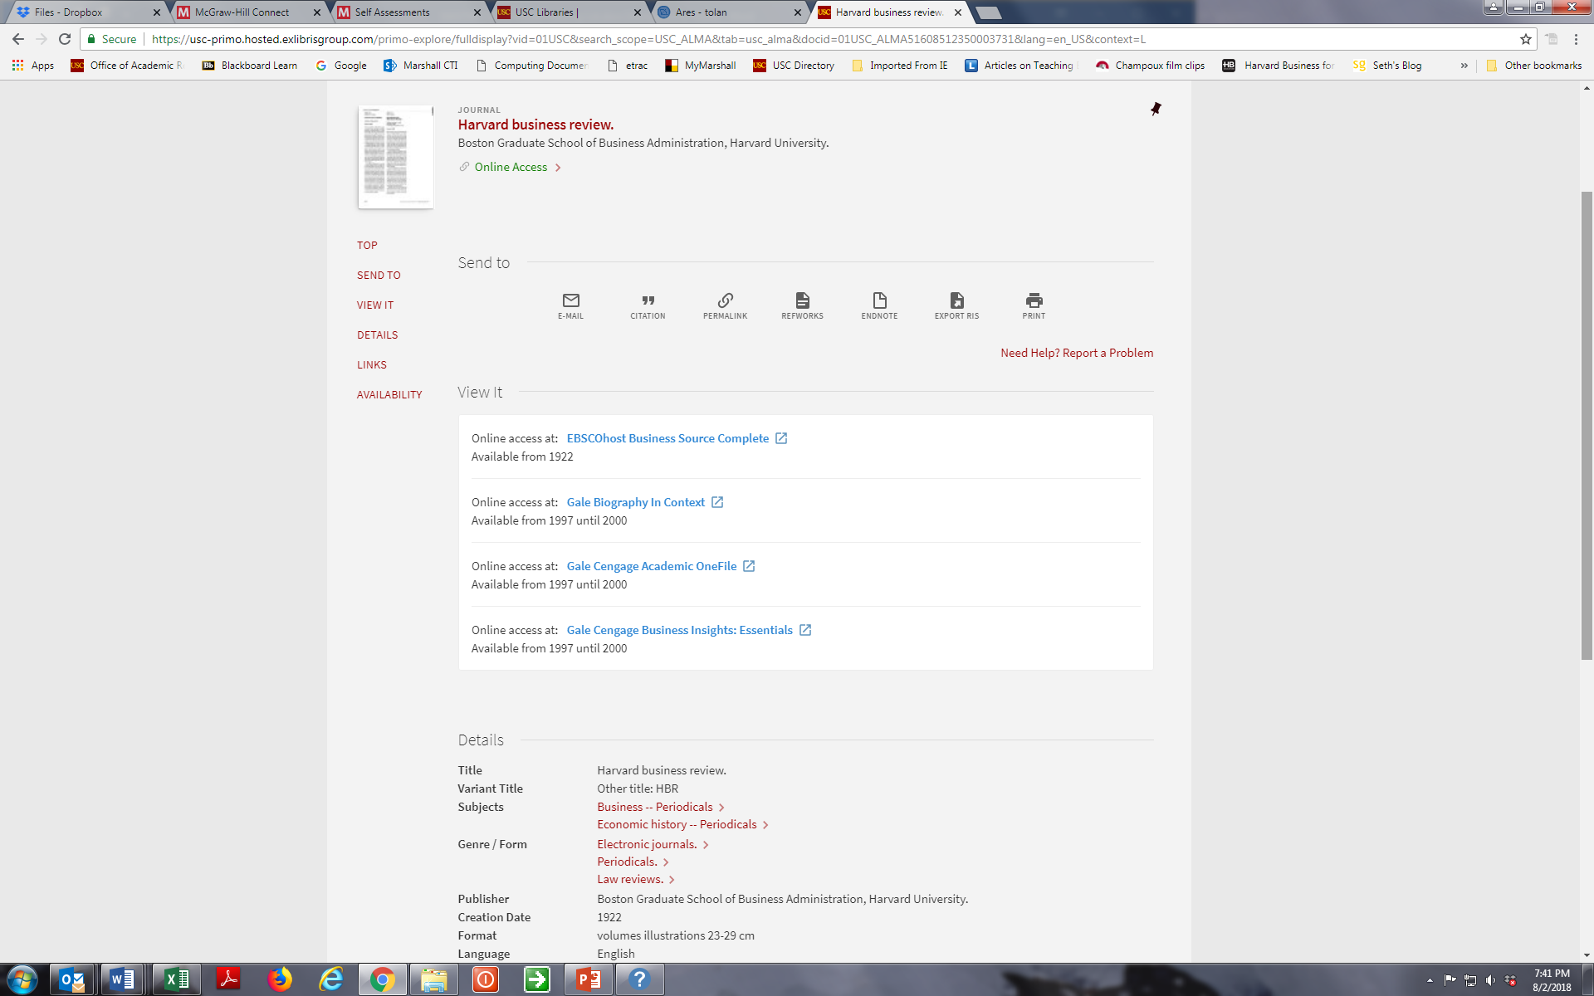

The following page will appear. You will need to select the Year, Volume and Date for the article. This is included on the Master Reading Reference List posted in Blackboard/Course Documents.

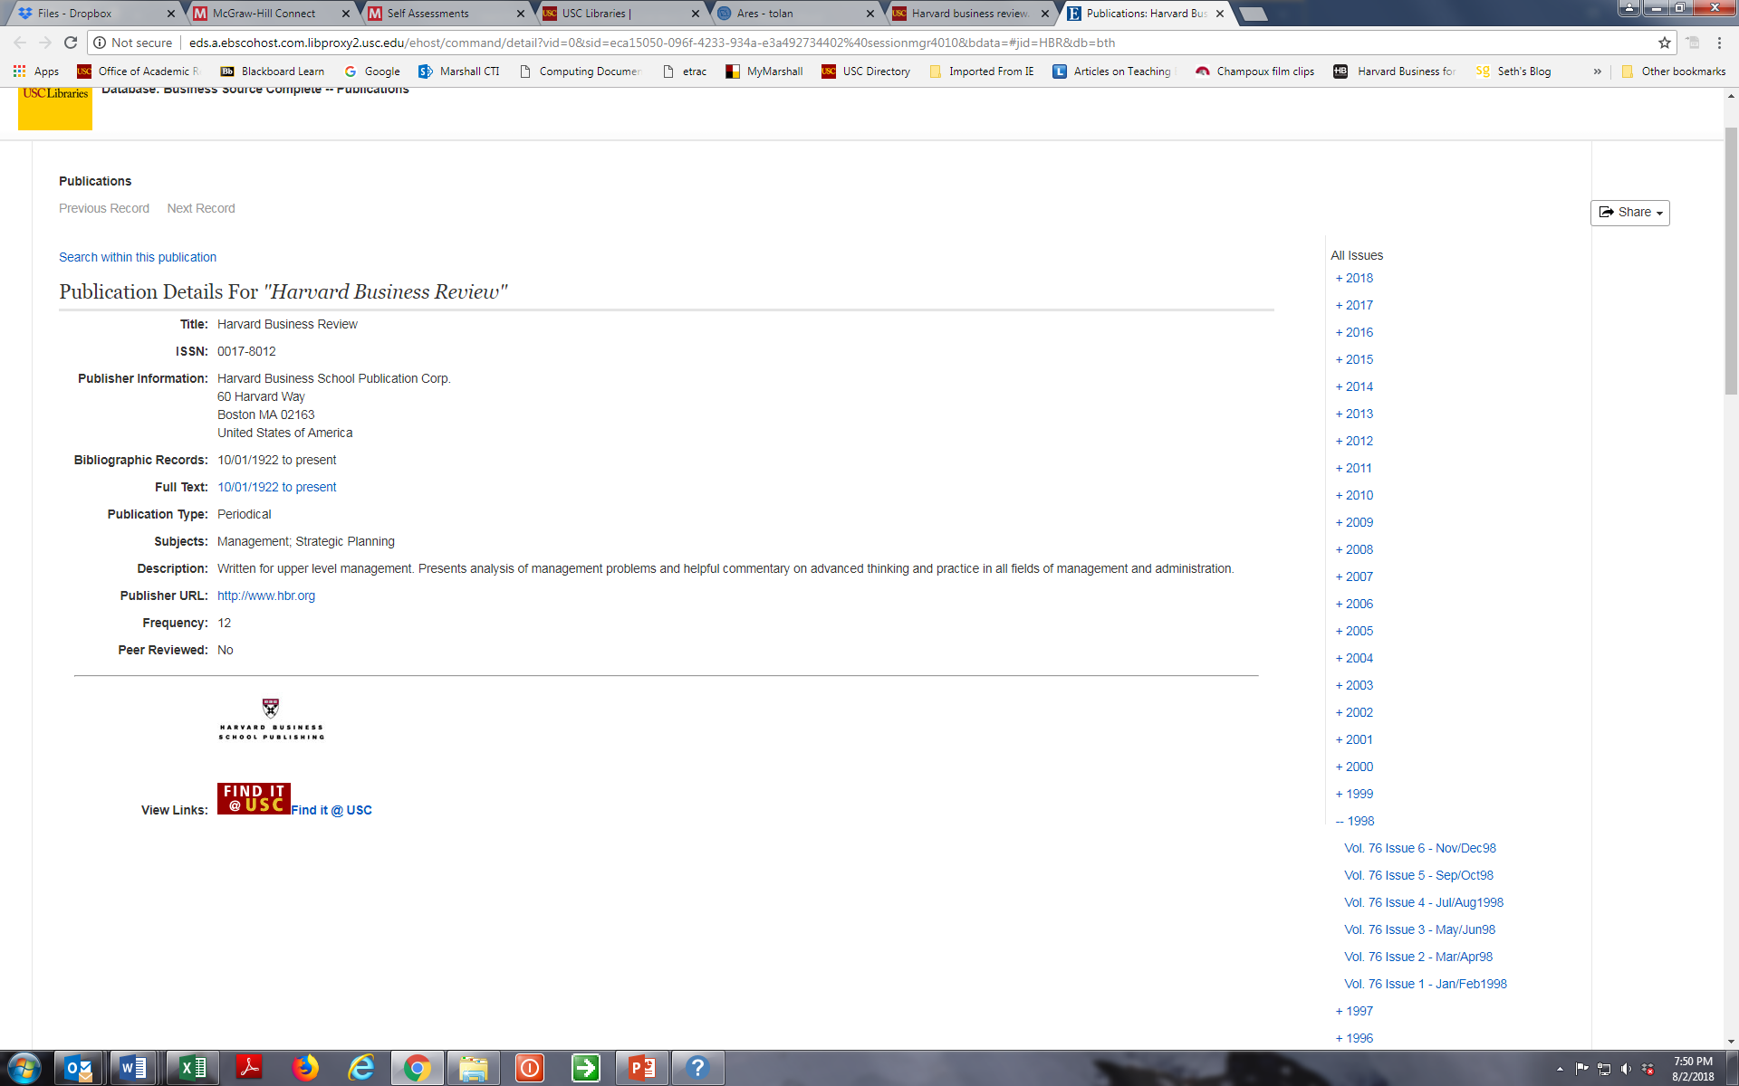

This will take you to the online issue where you will find the article. You may need to scroll down to find the article you are looking for as shown below.

LANDING PAGE:
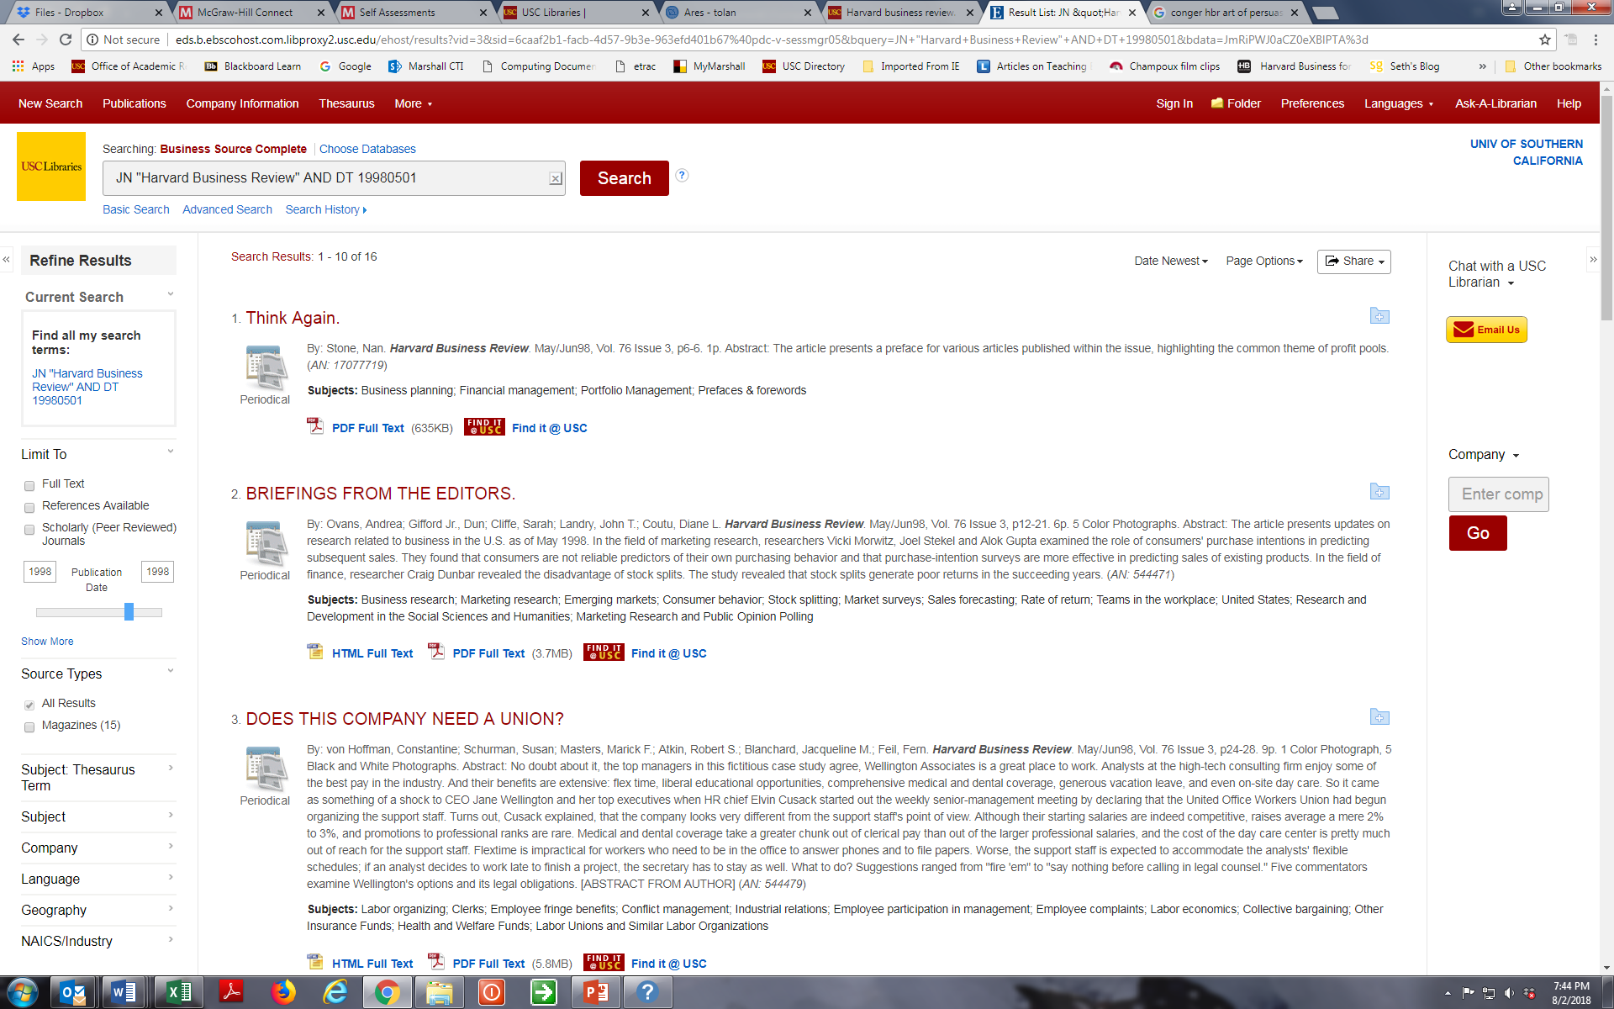

SCROLL DOWN TO FIND ARTICLE (if necessary):
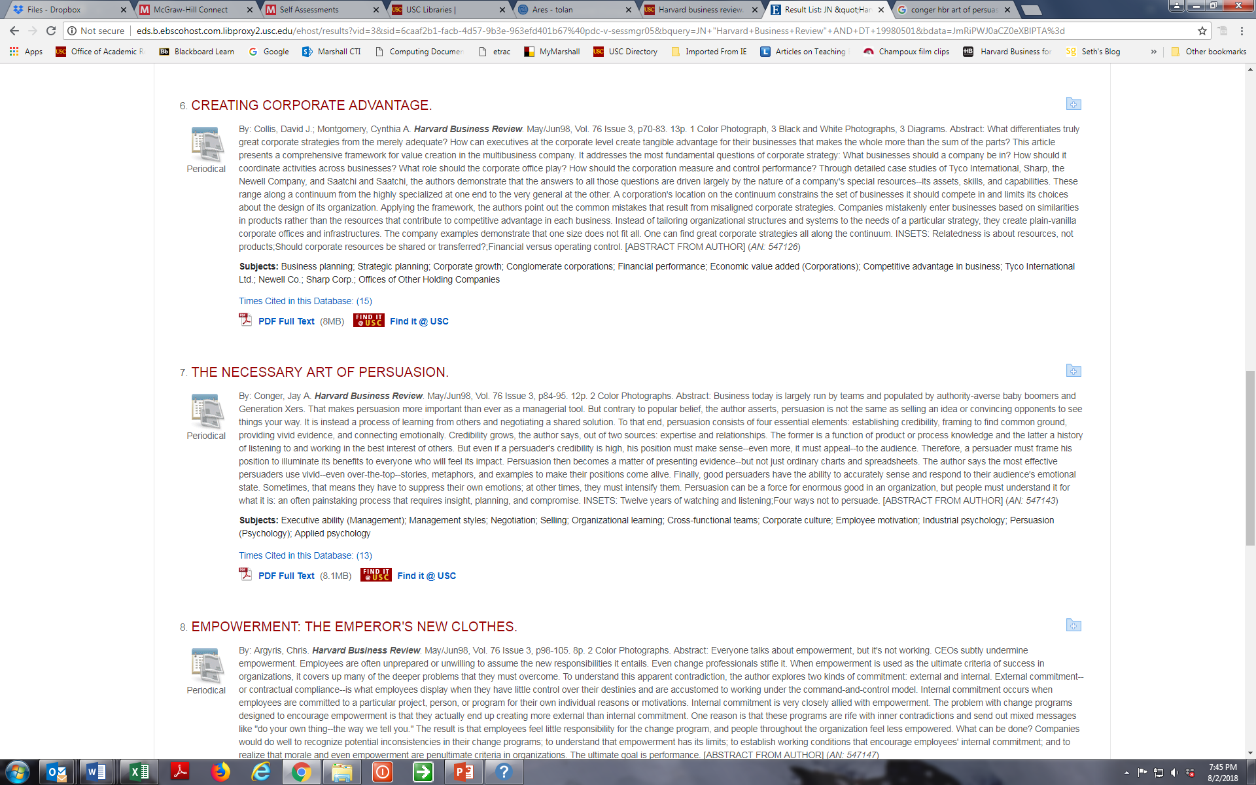

You will then be able to Select FULL TEXT PDF and download the article for your own personal use. Please respect and observe all copyright regulations.

If you need additional help, you can email the Reserves Librarian using the Contact Reserves link on the ARES course page.

MASTER LIST of Readings for BUAD 304 Fall 2020

This list of course readings is provided to help you find the Harvard Business Review (HBR) articles using EBSCOHost Business Source Complete database via USC Libraries ARES online course reserves. Note that you will need the Year and Month for the HBR articles. Other journal articles, newspaper articles, blog postings and chapters are accessible directly from the BUAD 304 ARES page. All cases are in the BUAD 304 Coursepack available for purchase on the Harvard Business Publishing website.

Week 1 Introduction & Values, Attitudes and Ethics
- Vermeulen, F. (2013). Beware the Sirens of Management Pseudo Science. Harvard Business Review Blog, direct link on ARES
- Pfeffer, J. & Sutton, R. (2011). Trust the Evidence, Not Your Instincts. New York Times, September 3, 2011, Op Ed
- Park, N. & Peterson, C. (2009) Character Strengths: Research and Practice. Journal of College and Character, Volume 10, No. 4, April 2009

Week 2 Motivation
- Kerr, S. (1995). On the folly of rewarding A, while hoping for B. Academy of Management Executive, Volume 9, No. 1 February, pp. 7-14.
- Staw, B. (1995). The self-perception of motivation. In B. Staw (Ed.), Psychological Dimensions of Organizational Behavior (2nd edition). Englewood Cliffs, NJ: Prentice Hall. (Chapter posted in ARES)
- Pfeffer, J. (1998). Six dangerous myths about pay. Harvard Business Review, 1998, May/June issue, pp. 109-119.
- SkillsforTomorrow case, (HBR Online Coursepack)

Week 3 Perception & Decision Making,
- Polzer, J. (2018). Trust the Algorithm or Your Gut case, (HBR Online Coursepack)

Week 4 Power, Politics & Influence
- Conger, J. (1998). The necessary art of persuasion. Harvard Business Review, 1998, May/June issue
- Cialdini, R. (2001). Harnessing the science of persuasion. Harvard Business Review, 2001, October issue
- Thomas Green case, (HBR Online Coursepack)

Week 5 Communication, Negotiation & Conflict
- The Portrait on My Wall, John Rutledge, Forbes, December 1996. (from Google search: http://www.rutledgecapital.com/Articles/19961220_portrait_on_my_office-wall.html)

Week 8 Teams
- Coutu, D., & Beschloss, M. (2009). Why teams don’t work. Harvard Business Review, 1987, May issue, pp. 98-105.
- Duhigg, C. (2016). What Google Learned from its Quest to Build the Perfect Team. The New York Times, February 28, 2016
- Ferrazzi, K. (2014). Getting virtual teams right. Harvard Business Review, 2014, December issue
- Katzenbach, J. & Smith, D. (1993). The discipline of teams. Harvard Business Review, 1993, March/April issue

Week 9 Cross-Cultural Teams & Diversity & Inclusion
- Earley, P.C. & Mosakowski, E. (2004). Cultural Intelligence. Harvard Business Review, 2004, October issue
- Meyer, E. (2014). Navigating the Cultural Minefield. Harvard Business Review, 2014, May issue
- Managing Diversity and Inclusion at Yelp case, (HBR Online Coursepack)

Week 11 Networks
- Baker, W. (2000) - What is social capital and why should you care about it? Chapter 1 in Achieving Success Through Social Capital: Tapping Hidden Resources in Your Personal and Business Networks.

Week 12 Creativity
- Chamorro-Premuzi, T. (2015) Why Brainstorming Works Better Online. Harvard Business Review Online, https://hbr.org/2015/04/why-brainstorming-works-better-online
- OPTIONAL: Sutton, R. (2006). Eight tips for better brainstorming. Online Bloomberg Business News.

Weeks 12-13 Organizational DNA: Culture & Structure & Organizational Change
- The Congruence Model: A Roadmap for Understanding Organizational Performance. Mercer Delta Group, 2004.
- Greiner, L. (1998). Evolution and Revolution as Organizations Grow.
- Cummings, T. (1995). From Programmed Change to Self-Design: Learning How to Change Organizations.
- Wildfire Entertainment, (HBR Online Coursepack)

Week 14 Personal Leadership
- Any additional reading assignments will be posted on Blackboard.

Appendix C
Research Participation and Requirements – Frequently Asked Questions – Fall 2020

FAQs about Lab Studies

Q: I have questions, comments, or concerns regarding lab studies. Who can I talk to?
A: Please email all questions and concerns related to research participation, requirements, and technical issues to the SONA administrator (mor.sona@marshall.usc.edu). We will reply to your email within 2 business days.

Q: How do I set up a SONA account?
A: You can create an account on the MOR SONA website (http://marshall-mor.sona-systems.com/) in order to participate in research studies. Click on the blue “Request Account” button on the homepage. Note: You must create an account only using your USC email address; any other personal emails such as gmail, yahoo, etc. will not be accepted/activated. Do NOT enter your student ID# as the user ID.

Q: What if I already had a SONA account from a past course?
A: All accounts are automatically deactivated at the end of each semester. If you previously had an account for your BUAD 304 or BUAD 497 course, you will have to email the SONA administrator (mor.sona@marshall.usc.edu) to request reactivation of your account using your USC email address. Please note the deadlines for reactivation.

Q: All the timeslots are full. What can I do?
A: Timeslots tend to fill up quickly, especially early in the semester, because there are over 1000 other students looking for credits. Our advice is to check the study postings once a week. New credits will be posted weekly, starting in early September, so if you don’t get a spot one week, just check the next.

Q: I switched sections. How do I update it so my credits are routed to the right Professor?
A: You can update this by logging into your account (https://marshall-mor.sona-systems.com), then clicking on “My Profile” at the top right corner of the web page. Here you can check and/or change the section as necessary.

Q: If the study is in-person, where are they located?
A: The majority of studies this semester will be held online. In-person studies will be held in Verna and Peter Dauterive Hall (VPD). All rooms are on the Lower Level (LL). Depending on your study, the study may be in one of three rooms: LL102, LL110, or LL112. After you enter the building, take the wooden stairs or elevator down and follow the signs. VPD is located across from the Law School and Popovich Hall. Google Maps link: https://goo.gl/maps/tsF1JmV9MP62.

Q: Can I meet the full requirement in a single week?
A: It’s possible, but it’s very unlikely. The available studies will be spread across the semester, so it is quite unlikely that there will be enough new credits in a single week for you to cover the requirement fully.

Q: Why are some studies worth 1.5 and others worth 0.5?
A: The amount of credit per study is based on the amount of time required for participation. Studies that are expected to take 15-30 minutes are assigned 0.5 credits. Studies that take 35 min to an hour receive 1 credit, and so forth.

FAQs about Field Studies

Q: What exactly will these employees be asked to do?
A: In early to mid-October, the employees will receive an email with a link to a survey. All they will be asked to do is to click on the link and respond to the survey questions.

Q: What email address will the survey link be sent from?
A: The survey will be sent from the USC Marshall MOR Research Team at mor.research@usc.edu.

Q: How long will the survey take?
A: For focal employees, about 20-25 minutes. For coworkers and supervisors, less than 20 minutes.

Q: What type of questions will they be asked?
A: The questions are focused on the employees’ work experiences. For example, there may be questions about the workplace culture, common workplace behaviors and tasks, thoughts and feelings about the workplace, workplace social interactions, and attitudes toward coworkers. We will NOT ask the participants to identify themselves or their companies.

Q: Is participation anonymous?
A: Yes, participation is anonymous! We will NOT store the participants’ names or email addresses with their survey responses. We will NOT ask them to identify themselves, nor will we ask them to identify their company or employer. The survey is completely confidential, and all data will be stored anonymously.

Q: Will participants’ responses be shared with their coworker, supervisor, or company?
A: No! In addition to all participants’ responses being anonymous, we will NOT share the survey responses with anyone within the participants’ company.

Q: What will happen to the data?
A: The faculty and doctoral students in the MOR Department will use the data to generate new knowledge about organizational behavior. Research in our department addresses important business questions related to effective decision making, leadership, team performance, organizational change, and social issues in the workplace. Participation in this data collection process can help to advance knowledge in these areas and also helps to support the Marshall mission of continuing to be at the leading edge of research insights.

Q: What if the employees never receive an email?
A: Please ask the employees to check their spam folder for an email from the USC Marshall MOR Research Team (mor.research@usc.edu). If they still have not received the email, there is nothing they need to do. Please rest assured that you will receive credit for your field study research requirement as long as you successfully submitted the employee contact information. Please note that employees should never forward their emails to one another since each employee receives a unique survey link! In the event that email bounce backs occur due to inaccurate email addresses, we will contact you for updated contact information.

Q: Do I need to check whether the employees completed the survey?
A: No, you do not need to check whether they completed the survey. Please rest assured that you will receive credit for your field study research requirement as long as you successfully submitted the employee contact information.

Q: Will I receive a confirmation that my field study research requirement has been completed?
A: Yes! After you submit the employee contact information on the submission survey, you will receive an email confirmation that you have fulfilled your research requirement for the field study once we have verified the employee emails. You will receive the confirmation email no later than Friday, October 30th.

Q: What if I or the employees have additional questions?
A: Please contact the USC Marshall MOR Research Team at mor.research@usc.edu.

Q: What if I cannot find three employees willing to participate in the survey?
A: If you are unable to find three employees willing to participate in the survey, you will need to complete 1 additional credit of lab studies instead. Please contact the USC Marshall MOR Research Team (mor.research@usc.edu) to let us know this is how you will complete your field data research requirement. Please make sure to complete this additional credit by November 13th, the deadline to complete all lab study credits. The MOR Research Team will coordinate with the SONA administrator to confirm that you have fulfilled the additional lab study credit.

