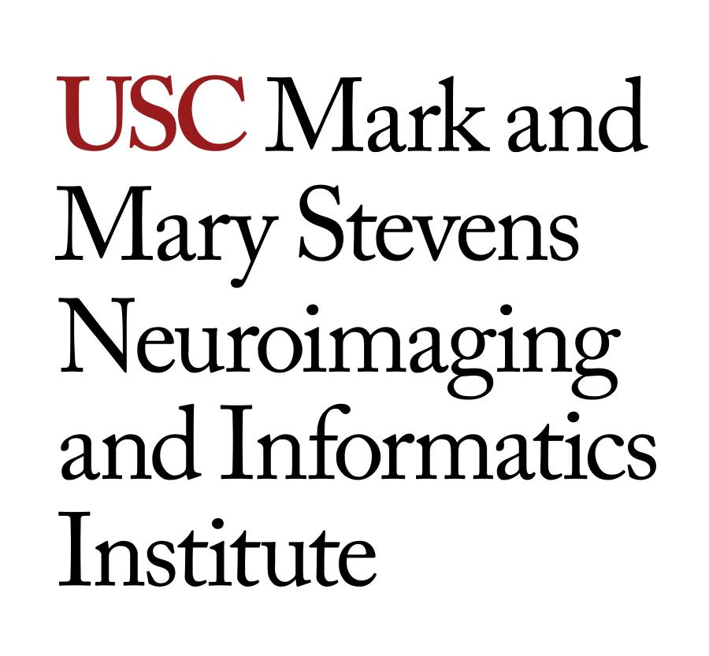
NIIN 530: Neuroimaging Data Acquisition with Magnetic Resonance Imaging
Units: 3
Fall2018—Time: Tues. 9‐10 AM, Thurs. 1‐3 PM
Location: Hastings Auditorium, Hoffman Building, Keck School of Medicine

Instructor: Danny JJ Wang, Ph.D.
Lirong Yan, Ph.D.
Office: Hastings Auditorium
Office Hours: Tues 11 AM – 12 PM
Contact Info: jj.wang@loni.usc.edu, (323) 865‐1730

Course Description
This course introduces the principals and various MRI techniques which can be used to image the structure and function of a living brain. The course covers neuroimaging scanning technologies, pulse sequence design, and sources of image artifact, along with a lab session on MRI scans.

Learning Objectives
By thoroughly exploring data acquisition methods for human neuroimaging using MRI, students should acquire knowledge and understanding of:
- Basic principles (atomic structure, alignment, precession, the Larmor equation, resonance, relaxation, T1 recovery, T2 and T2* decay)
- Image weighting and contrast (contrast mechanisms, relaxation in various tissues, T1 and T2 contrast, PD contrast)
- Encoding and image formation (gradients, slice selection, frequency and phase encoding, sampling, k space description and filling, the FFT, k space traversal)
- Parameters and trade‐offs (SNR, CNR, spatial resolution, scan time, trade‐offs)
- Pulse sequences (SE sequences, conventional vs. turbo SE, inversion recovery, STIR, FLAIR, GE sequences, coherent vs. incoherent, steady‐state, balanced and fast GE, single‐shot and parallel imaging techniques)
- Artifacts and compensation (phase mis‐mapping, aliasing, chemical shift, truncation, magnetic susceptibility, cross‐excitation and crosstalk, zipper and shading artifacts, etc.)
- Instrumentation and equipment (superconducting electromagnets, fringe fields, shim and gradient coils, MR computer systems)
- Contrast agents (mechanisms of action, molecular tumbling, dipole‐dipole interactions, magnetic susceptibility, relaxivity, gadolinium safety and applications)
- Functional imaging (functional MRI, diffusion weighted imaging, perfusion imaging, magnetic resonance spectroscopy, MR microscopy)

Attendance and reading of the assigned materials prior to each class are both expected and recommended.

Prerequisite(s) and Co-Requisite(s): All available fall term program classes are required as co‐requisites. Familiarity with modern physics (atomic and nuclear structure, in particular) and electromagnetism is useful but not required as these topics will be covered in class to the extent necessary for understanding the material in the course. Students who desire assistance to improve on their quantitative sciences background are encouraged to contact the USC Center for Academic Support, which provides free tutoring. For more information, please consult http://sait.usc.edu/academicsupport.

Course Notes:
Examinations
Students are expected to read assigned sections of textbooks or supplemental materials in advance of class. Midterm and final examinations will each consist of a comprehensive, written, closed‐book test aimed at assessing conceptual understanding and knowledge of the material covered in class, in the course slides as well as in the textbook. There will also be two homeworks during the semester. Their solutions will be posted on Blackboard (https://blackboard.usc.edu). The midterm and final examinations will each be two hours long. The final examination will be comprehensive. Performing well on examinations will require knowledge of the material covered in the textbook and on lecture slides. Review sessions will be held in advance of the midterm and final examination.
Grading Disputes
On occasion, objections may arise with regard to grading. To promote fairness to all students, on each examination (with the exception of the final), each student will receive 5% worth of extra credit on condition that the assigned grade is not disputed by the student. If the student chooses to dispute the assigned grade, the 5% of extra credit will be deducted from the assigned grade and the entire examination will be re‐graded. Students are advised that such a course of action may or may not result in a higher grade.

Required Readings and Supplementary Materials
MRI in Practice, 4th Edition by Catherine Westbrook et al.: Wiley‐Blackwell.
ISBN: 97‐1444337433
Any supplementary reading material assigned throughout the course will be posted on Blackboard. If such material is assigned, students are expected to read it prior to class based on a schedule indicated by the instructor.

Virtual MRI simulator (PC and Java) http://iftm.de/index.php/e-learning/virtual-mri

Description and Assessment of Assignments
Presentation Assignments
In the second half of the semester, students will be assigned a course‐related topic. Students will then be assigned to specific teams, critically review instructor‐assigned literature on the assigned topic. Each student team will prepare a presentation on the topic of their review before the entire class. The presentation will be graded based on the speakers’ ability to convey information clearly, succinctly and accessibly to the audience. Each presentation will be followed by a questions & answers session before the entire class.

Midterm and Final Examinations
The midterm examination will be administered on Thursday, Sept 25, 2018 during class time 9-10AM. At USC, final examinations are held as indicated on the USC Schedule of Classes (http://www.usc.edu/soc). For Fall 2018, the date and time of the final examination for NIIN 530 are Friday, December 6, 2018 between 11 AM and 1 PM. The key to the final examination will be posted on Blackboard.

Grading Breakdown

Assignment | Points | % of Grade
HW 1 | 10 | 10
HW 2 | 10 | 10
Presentation | 10 | 10
Lab | 10 | 10
Midterm examination | 20 | 20
Final examination | 35 | 35
Extra | 5 | 5
Total | 100 | 100

Grading Scale
Per program policy, only letter grades can be assigned for this course. In other words, students do not have the option to take the course for Pass/Fail. NIIN 530 is a corequisite for all courses in the spring semester.

Course final grades will be determined using the following scale
A 95-100
A- 90-94
B+ 87-89
B 83-86
B- 80-82
C+ 77-79
C 73-76
C- 70-72
D+ 67-69
D 63-66
D- 60-62
F 59 and below

Course Schedule: A Weekly Breakdown
 | Topics/Daily Activities | Readings and Homework | Deliverable/ Due Dates
Week 1 (8/20) | Course overview; basic principles | Chapter 1
Week 2 (8/27) | Image weighting and contrast and MR safety | Chapter 2 and 10
Week 3 (9/3) | Encoding and image formation | Chapter 3 | HW 1
Week 4  (9/10) | Parameters and trade‐offs | Chapter 4
Week 5  (9/17) | MR Instrumentation and midterm review | Chapter 9, Dr. Jin Jin lecture on MR hardware
Week 6  (9/24) | Midterm and MR safety | Dr. Sherllock lecture on MRI safety 9/27 | Midterm (Sept 25 9-10pm)
Week 7  (10/1) | Pulse sequences –  spin echo | Chapter 5, pp. 140‐163
Week 8  (10/8) | Pulse sequences –gradient echo | Chapter 5, pp. 164‐197
Week 9  (10/15) | Artifacts and compensation | Chapter 7 | HW 2
Week 10  (10/22) | Contrast agents | Chapter 11
Week 11  (10/29) | Function imaging techniques | Chapter 12
Week 12  (11/5) | MRI lab (3 and 7T) and MRS | Dr. Albert Thomas guest lecture on MRS 11/8
Week 13  (11/12) | MRI lab (3 and 7T) and ASL | Dr. Jia Guo guest lecture on ASL 11/13
Week 14  (11/19) | Course review (thanksgiving)
Week 15  (11/26) | Student presentations
Week 16 | Final Examination |  | December 6, 2018 between 11 AM and 1 PM

Statement on Academic Conduct and Support Systems

Academic Conduct
Plagiarism – presenting someone else’s ideas as your own, either verbatim or recast in your own words – is a serious academic offense with serious consequences. Please familiarize yourself with the discussion of plagiarism in SCampus in Part B, Section 11, “Behavior Violating University Standards” https://policy.usc.edu/student/scampus/part-b. Other forms of academic dishonesty are equally unacceptable. See additional information in SCampus and university policies on scientific misconduct, http://policy.usc.edu/scientific-misconduct.

Discrimination, sexual assault, intimate partner violence, stalking, and harassment are prohibited by the university. You are encouraged to report all incidents to the Office of Equity and Diversity/Title IX Office http://equity.usc.edu and/or to the Department of Public Safety http://dps.usc.edu. This is important for the health and safety of the whole USC community. Faculty and staff must report any information regarding an incident to the Title IX Coordinator who will provide outreach and information to the affected party. The sexual assault resource center webpage http://sarc.usc.edu fully describes reporting options. Relationship and Sexual Violence Services https://engemannshc.usc.edu/rsvp provides 24/7 confidential support.

Support Systems
A number of USC’s schools provide support for students who need help with scholarly writing. Check with your advisor or program staff to find out more. Students whose primary language is not English should check with the American Language Institute http://ali.usc.edu, which sponsors courses and workshops specifically for international graduate students. The Office of Disability Services and Programs http://dsp.usc.edu provides certification for students with disabilities and helps arrange the relevant accommodations. If an officially declared emergency makes travel to campus infeasible, USC Emergency Information http://emergency.usc.edu will provide safety and other updates, including ways in which instruction will be continued by means of Blackboard, teleconferencing, and other technology.

