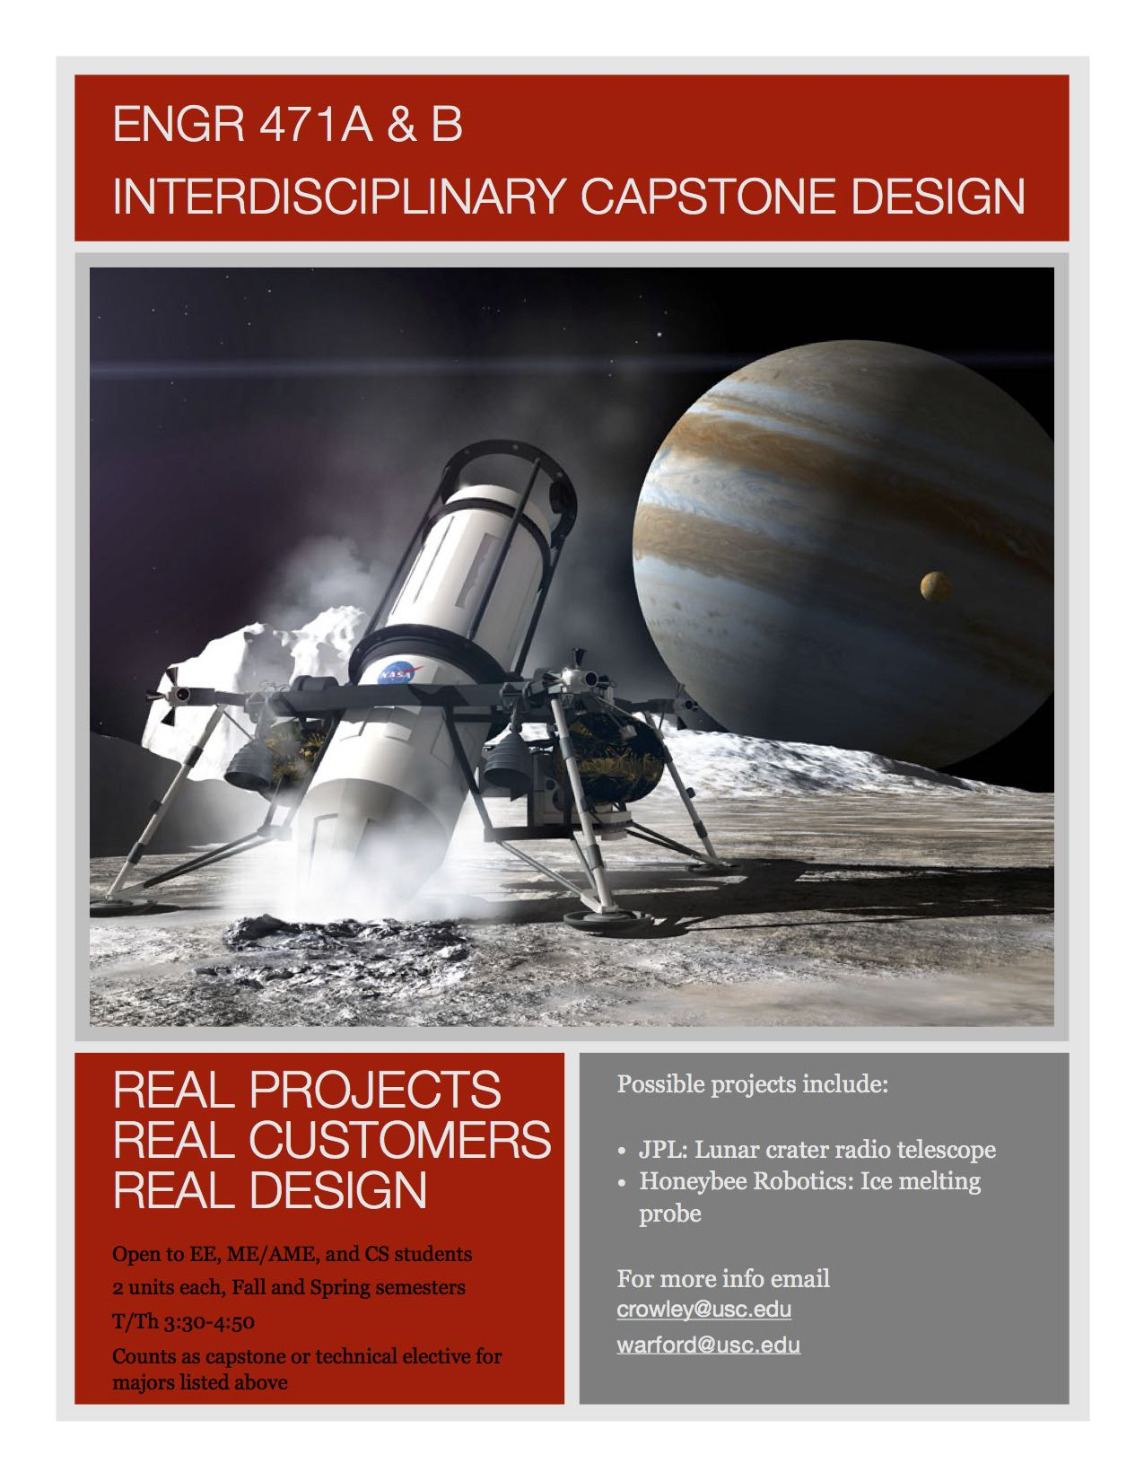

|  |  |  |  |  |
| --- | --- | --- | --- | --- |
|  | Interdisciplinary Capstone DesignENGR 471a (2 Units)   **Fall 2018** | |  | |
|  | Description This course provides students a culminating experience in applying the technical skills they have acquired in their engineering coursework to solve a design problem sponsored by an external customer. The students will begin with a problem statement provided by the customer, develop a specifications report, investigate similar existing technologies, and design their own solution. The course will also afford students practice in communicating their design process, both orally and in written form, to multiple audiences. Students will work in interdisciplinary teams to develop their design. The course includes lectures on the engineering design process, communication skills, and ethical and sustainability design considerations. Students will write accompanying documents and present oral progress reports in support of their final design proposal to the sponsor and/or faculty advisors.  This course is the first part of a two-semester design sequence. In the first semester, students will develop the design and present it to the customer. In the second semester, students will build and test the design or a prototype of the design. The course is co-taught by a computer science professor and an engineering communications professor. Prerequisites No prerequisites but departmental approval is required. At the discretion of the department, this course may substitute for a department capstone course, a design course, or a technical elective. To Register for the Course: Departmental approval and D-clearance are required to register for the course. See project descriptions for eligible departments. To obtain approval for the D-clearance, please email [Elisa Warford and Michael Crowley](mailto:warford@usc.edu,%20crowley@usc.edu?subject=Interdisciplinary%20capstone%20design). In your email, include the project you are interested in (see project descriptions below), your major, your areas of technical knowledge as related to the project, and why you are interested in the project. Sample Project Description **Background:** Future missions to Europa, Enceladus, and Mars consider using melt probes to penetrate ice layers and reach subglacial lakes and oceans. Even terrestrial applications (Antarctic, Greenland) require deployment of sensors and data collection in ice and reaching subglacial lakes at 4 km depth.  **Goal:** Since energy (not power) is the main limiting parameter in space exploration, the goal would be to design and fabricate the most efficient melt probe possible. Students will work with the customer and faculty to: (1) perform thermal analysis to select heater power, (2) design and fabricate probe with independent heater elements, (3) design and fabricate probe with optimal cone shape and body shape, (4) design and fabricate control system for monitoring and optimizing heater temperature and power to maximize penetration rate. The minimum probe diameter and length should be 1 inch and 6 inch, respectively.  **Test:** The melt probe will be tested in a block of clear ice (at room temperature). Power and penetration time will be measured and energy computed. | | | |
|  | Course Outcomes Upon successful completion of the course, students should be able to   * Work in interdisciplinary teams “to set goals, plan tasks, meet deadlines, and create a collaborative and inclusive environment” (ABET requirement). * Apply the engineering design process to produce solutions that “meet the specified needs with consideration for public health and safety, and global, cultural, social, environmental, and economic factors” (ABET requirement). * Write accurate, precise technical prose with an awareness of the rhetorical conventions of engineering writing * Use data visualization effectively in both oral and written communication * Give effective oral presentations | | | |
|  |  | | | |
|  | Instructors | Elisa Warford and Michael Crowley | | |
|  | Office Hours | Professor Warford: MW 12-2 and by appointment  [warford@usc.edu](mailto:warford@usc.edu)  Professor Crowley: TTh 1-3pm and by appointment  [crowley@usc.edu](mailto:crowley@usc.edu) | | |
|  | Lecture / Lab | Monday and Wednesday, 3:30 - 4:50pm | | |
|  | Required Textbooks None | | | |
|  | Optional References None | | | |
|  | Course website All course material will be on Blackboard (<http://blackboard.usc.edu)>. We will also Edusourced.com for materials and submissions. | | | |
|  | Grading and Assignments Grades for each assignment will include a technical component and a communications component. Grades are generally given as group grades, but the instructors reserve the right to raise or lower individuals’ grades based on the value of the individual’s contributions.  **Project management document**  The team will submit a project management document that sets milestones, interim goals, and team member responsibilities for the semester. The document will include a Gantt chart with a timeline for the project.  **Requirements document and presentation**  The team will submit a requirements document that provides a project overview, product description (including product context, user scenarios/use case, user characteristics, assumptions, constraints and dependencies), functional requirements, user interface requirements, and performance requirements. This document will be submitted and orally presented to the customer for their approval.  **Preliminary and final design reports**  The team will submit a preliminary design report that provides a project overview and a description of the architectural and component-level design concepts. The final design report will build upon the preliminary design report and will include additional details about the design.  **Weekly meetings and status reports**  Students are required to meet at least one hour per week outside of class to work on the project. Each week, a different team member will take attendance and notes at the meetings. This person will submit a status report on Tuesday of the following week (unless indicated otherwise) that summarizes the work accomplished by each subgroup for the week, tasks left unaccomplished, and problems encountered. The status report will also list the action items for each subgroup for the upcoming week. The planning document will also be updated weekly by this person to reflect actual progress and plans for the project.  Class sessions will be used to discuss upcoming action items and for technical and communications guidance from the instructors.   |  |  | | --- | --- | | **Assignment** | **Points** | | Project management document | 100 | | Requirements document and presentation | 100 | | Weekly status reports (12) | 100 | | Preliminary design report and presentation | 200 | | Final design report | 300 | | Final presentation | 100 | | Teamwork and participation, based on peer evaluations and instructors’ observations | 100 | | **Total** | 1000 | | | | |
|  | PoliciesHomework assignments Each assignment will include instructions, a due date, and a link for electronic submission.  It is the team’s responsibility to submit all assignments on or before the due date. Homework assignments turned in one day late will have 20% of the total points deducted from the graded score. Homework assignments turned in two days late will have 50% of the total points deducted from the graded score. After two days, submissions will not be accepted and you will receive a 0.  All assignments must be digitally submitted through Blackboard except when otherwise specified by the course staff. Do not email assignments. | | | |
|  | Incomplete and Missing Grades Excerpts for this section have been taken from the University Grading Handbook, located at  <http://www.usc.edu/dept/ARR/grades/gradinghandbook/index.html>. Please see the link for more details on this and any other grading concerns.  A grade of Missing Grade (MG) “should only be assigned in unique or unusual situations… for those cases in which a student does not complete work for the course before the semester ends. All missing grades must be resolved by the instructor through the Correction of Grade Process. One calendar year is allowed to resolve a MG. If an MG is not resolved [within] one year the grade is changed to [Unofficial Withdrawal] UW and will be calculated into the grade point average a zero grade points.”  A grade of Incomplete (IN) “is assigned when work is no completed because of documented illness or other ‘emergency’ **occurring after the twelfth week** of the semester (or 12th week equivalency for any course scheduled for less than 15 weeks).” | | | |
|  |  | | | |
| Academic Conduct and Academic Support SystemsAcademic Conduct Plagiarism – presenting someone else’s ideas as your own, either verbatim or recast in your own words – is a serious academic offense with serious consequences. Please familiarize yourself with the discussion of plagiarism in SCampus in Section 11, Behavior Violating University Standards <https://scampus.usc.edu/1100-behavior-violating-university-standards-and-appropriate-sanctions/>. Other forms of academic dishonesty are equally unacceptable. See additional information in SCampus and university policies on scientific misconduct, <http://policy.usc.edu/scientific-misconduct/>.  Discrimination, sexual assault, and harassment are not tolerated by the university. You are encouraged to report any incidents to the Office of Equity and Diversity <http://equity.usc.edu/> or to the Department of Public Safety <http://capsnet.usc.edu/department/department-public-safety/online-forms/contact-us>. This is important for the safety whole USC community. Another member of the university community – such as a friend, classmate, advisor, or faculty member – can help initiate the report, or can initiate the report on behalf of another person. The Center for Women and Men <http://www.usc.edu/student-affairs/cwm/> provides 24/7 confidential support, and the sexual assault resource center webpage [sarc@usc.edu](mailto:sarc@usc.edu) describes reporting options and other resources. Support Systems A number of USC’s schools provide support for students who need help with scholarly writing. Check with your advisor or program staff to find out more. Students whose primary language is not English should check with the American Language Institute <http://dornsife.usc.edu/ali>, which sponsors courses and workshops specifically for international graduate students. The Office of Disability Services and Programs <http://sait.usc.edu/academicsupport/centerprograms/dsp/home_index.html> provides certification for students with disabilities and helps arrange the relevant accommodations. If an officially declared emergency makes travel to campus infeasible, USC Emergency Information <http://emergency.usc.edu/> will provide safety and other updates, including ways in which instruction will be continued by means of blackboard, teleconferencing, and other technology. | | | |
| Course Outline (Subject to change) | | | | | |

**Week 1 Project management and teamwork**

M 8/21 Course introduction. Show Edusourced software. Introduce the projects and customers.

Introduction to workplace communication and teamwork.

W 8/23 Improv team-building session

**Week 2 Project management and teamwork/Introduction to report writing**

M 8/28 Lecture and class activity topics*:* Interfacing with customer—email, Skype, phone

Introduction to project management plan and Gantt charts

**Homework:** Contact customer via appropriate channel before Wednesday to arrange site visit site and/or interview

*Due on Edusourced Tuesday at 5:00 p.m.: Status report and action items for upcoming week*

W 8/30 Lecture: Concepts of requirements for engineers

Lecture and class activity: Identifying customer needs/interview techniques

Introduction to specifications/requirements report

Work on project management plans

**Deliverable due at end of class:** Set of questions for customer; meet with customer by Friday

F 9/1 **Deliverable due electronically at 11:59 p.m.:** Project management plan with initial ideas, timeframe, team member roles, Gantt chart (3 pp. single-spaced)

**Week 3 Specifications/requirements plan, presentation techniques**

M 9/4 **Labor Day holiday**

*Due on Edusourced Tuesday at 5:00 p.m.: Status report and action items for upcoming week*

W 9/6 Specifications and requirements, continued

Work on specifications/requirements report

**Deliverable due at beginning of class:** Write-up of customer interview

**Week 4** **Work week**

M 9/11 Work on specifications/requirements report in class

Lecture and class activity: Brainstorming and problem solving (Brockman, *Introduction to Engineering: Modeling and Problem Solving*)

*Due on Edusourced Tuesday at 5:00 p.m.: Status report and action items for upcoming week; updated planning document*

W 9/13 Work on specifications/requirements report in class

**Week 5** **Work week**

M 9/18 Work on specifications/requirements report in class

*Due on Edusourced Tuesday at 5:00 p.m.: Status report and action items for upcoming week; updated planning document*

W 9/20 Work on specifications/requirements report in class

**Week 6** **Presentation techniques and slide design**

M 9/25 Lecture: Presentation techniques

*Due on Edusourced Tuesday at 5:00 p.m.: Status report and action items for upcoming week; updated planning document*

W 9/27 Lecture: Slide design

F 9/29 **Deliverable due electronically by 11:59 p.m.:** Specifications/requirements report developed from statement of work and customer interviews. This may include analysis of customer’s needs, project system requirements, literature review, risks to the project (7 pp. single-spaced).

**Week 7 Specifications presentations to customers and class**

M 10/2 Presentations

*Due on Edusourced Tuesday at 5:00 p.m.: Status report and action items for upcoming week; updated planning document*

W 10/4 Presentations

**Week 8 Engineering design process**

M 10/9 Lecture: Engineering design concepts

Lecture: Literature review/technology review (to be included in preliminary design report)

*Due on Edusourced Tuesday at 5:00 p.m.: Status report and action items for upcoming week; updated planning document*

W 10/11 Lecture: Ethical design considerations

**Week 9** **Work week**

M 10/16 Work on projects

*Due on Edusourced Tuesday at 5:00 p.m.: Status report and action items for upcoming week; updated planning document*

W 10/18 Deliverable: Midterm oral progress reports and slides (requirements creep? What has changed in the requirements? What have they learned in last two weeks? What do they still not know/technical risks)

F 10/20 **Deliverable due electronically by 11:59 p.m.:** Preliminary design report (at least 10 pp. single-spaced)

**Week 10 Preliminary design presentations to customer**

M 10/23 Presentations

*Due on Edusourced Tuesday at 5:00 p.m.: Status report and action items for upcoming week; updated planning document*

W 10/25 Presentations

**Week 11 Work week**

M 10/30 Work on final design reports

*Due on Edusourced Tuesday at 5:00 p.m.: Status report and action items for upcoming week; updated planning document*

W 11/1 Lecture and class activity topics: Clarity and concision, draft workshops

**Week 12** **Work week**

M 11/6 Work on final design reports in class

*Due on Edusourced Tuesday at 5:00 p.m.: Status report and action items for upcoming week; updated planning document*

W 11/8 Work on final design reports in class

**Week 13** **Progress report slides and presentations**

M 11/13 Work on final design reports and presentations in class

*Due on Edusourced Tuesday at 5:00 p.m.: Status report and action items for upcoming week; updated planning document*

W 11/15 Work on final design reports and presentations in class

**Week 14** **Work week**

M 11/20 Work on projects

*Due on Edusourced Tuesday at 5:00 p.m.: Status report and action items for upcoming week; updated planning document*

W 11/22 **Thanksgiving holiday**

**Week 15**  **Draft workshops and presentations**

M 11/27 Draft workshop: Rough drafts of final reports due

W 11/29 Deliverable: Final design proposal due to Professors Crowley and Warford

Presentation workshop

**Final exam Monday, December 11, 2-4:00: Final design proposal presentations to customer and faculty advisory**