Seminar in Humanistic Inquiry
Sites of Memory in Modern Arabic Letters
GESM 120g, 35381, Fall 2017, Mondays & Wednesdays, 3:30-4:50 p.m., VKC 255
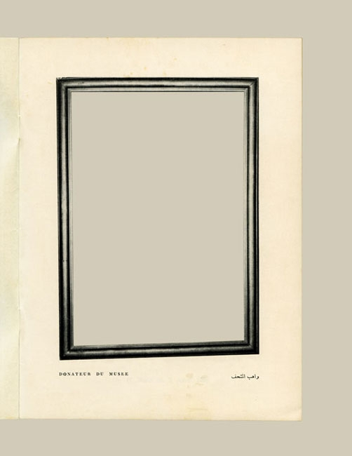
“The days when people knew, really knew how to tell stories must have been before my time.” Thus declared German-language author Rainer Maria Rilke in an emblematic sentence from a novel that largely concerns the relation between death and the work of writing. Nevertheless, with the hindsight of the disasters of the twentieth century and the literatures to which these disasters have given rise, the human penchant for telling stories seems as universal and inexhaustible as the human proclivity for producing death.
What can literary works tell us about the past? What falls upon literature from historical experience, or what befalls literature in the wake of experiences of collective catastrophe? This course turns to memoirs and novels from the modern Arab world to examine the relationship between historical events and literature. Specifically, by focusing on the difference of literature, as a site of memory, from historiographical accounts, we will explore the unexpressed—perhaps unrelatable—dimensions of historical experience that leave traces in literary writing during war time, in the context of political conflict, and in the aftermath of collective catastrophe. Our sustained focus on contentious pasts and their contemporary resonances will help us attend to the work of writing in and after the so-called Arab Spring—and beyond. Themes include nostalgia, loss, mourning, melancholia, war, trauma, imperialism, colonialism, and revolution. There are no prerequisites. All works are available in English translation; no prior knowledge of Arabic necessary.

Professor Veli N. Yashin
veli.yashin@dornsife.usc.edu THH 172

