Writing 340: Advanced Writing for Arts and Humanities
The Rhetoric of the Outlaw

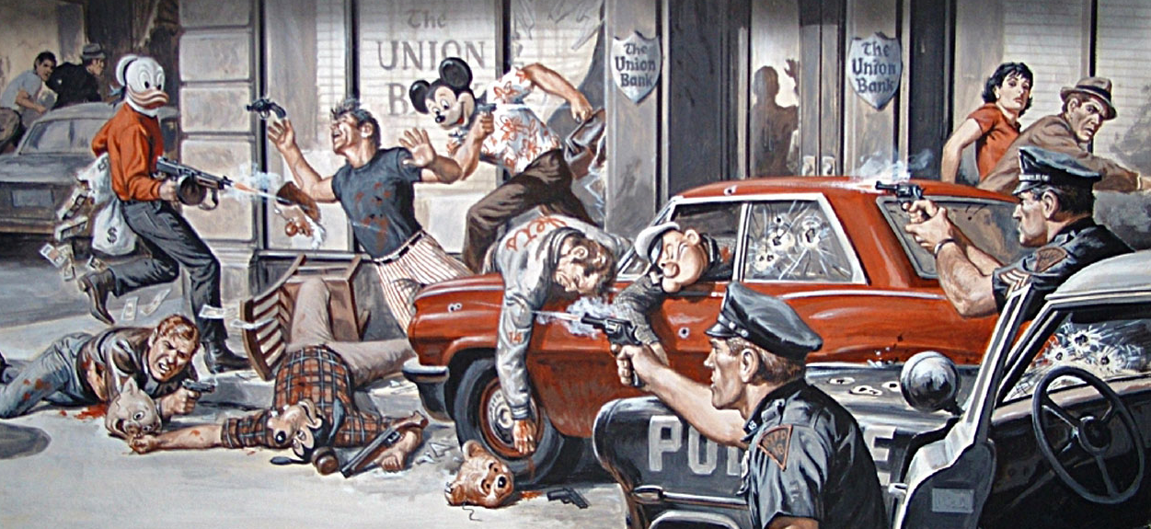

Matt Manson, Ph.D. Spring 2017
Office: JEF 254 Office Hours: TBD

Email: mmanson@usc.edu; mansonwriting@gmail.com

Course Description

As the other shoe falling in USC’s undergraduate writing curriculum, Writing 340 builds upon the foundation of critical thinking, reading and writing you have already cultivated in Writing 130, Writing 140, or Writing 150. More specifically, Writing 340 offers you the opportunity to critically explore issues in your chosen field while developing a sound writing process that incorporates, among other things, prewriting, drafting, revision and workshop-style peer review. Thoughtful, focused, even compelling, the written assignments you complete in this course are intended to further contribute to the discourses you have explored as arts and humanities students and expand the writing and thinking proficiencies that will make you successful in your future aspirations, be they academic or professional.

Course Texts

Kaufman Alan (Ed.), The Outlaw Bible of American Literature.
Others TBA (see Blackboard for updates)

I will also be uploading relevant course materials to Blackboard or providing it via your USC Email account.

A note on the reading: a central theme of the course will be the role of outlaw or “outsider” perspectives in American society, art, and culture. We will be reading excerpts from critical and literary texts and considering the uniquely (?) American fascination with the rebel, the criminal, the deviant. I have found that such material provides excellent occasions for the kind of thoughtful analytical writing you are expected to be able to do as Arts and Humanities students, but this material also presents some challenging content, language and points of view that, however relevant to our exploration of American cultural discourse, is not always everyone’s cup of tea. If you are adverse to rough language and adult themes, then this class might not be for you.

Course Requirements, Evaluation, and Grading

Class Schedule: in lieu of presenting a comprehensive schedule of dates and requirements at the start, I will be including a timeline with each assignment. This will give us more leeway to alter course or shift focus as exigencies dictate. For those of you who need a clear picture beforehand, suffice to say that each assignment will occupy three to four weeks of instruction, which will ideally leave us time at the end of the semester to focus our energies on revision for the final portfolio.

Attendance and Participation (10%): Get your reading and any assigned/required materials prepared before the designated class meeting. Given the heavy discussion component and workshop nature of this course, conscientious attendance is a must. Your participation grade also includes your preparation for and participation in in-class exercises such as impromptu essays and peer review workshops. Late work will be graded down a half grade each class meeting it is overdue. If you miss more than two full weeks of class meetings (including conferences) without a legitimate medical excuse, you will be asked to drop the class.

Individual Conferences: There will be mandatory one-on-one and then group conferences for each writing assignment. These are often held instead of class.

Written Assignments (60%): Four (4) out-of-class assignments covering a variety of themes and rhetorical approaches, including a research paper. These assignments will focus on critical reading and writing, social and cultural analysis, and emphasize the practice of writing as a recursive process. Please note that in order to receive full credit for each written assignment, you need to have participated in the workshop exercises that went into it.

Class Presentation : Towards the end of the term, you will be required to present your research paper to the rest of the class. This will be evaluated as part of your final portoflio grade.

Final Portfolio (30%): Your final portfolio will include revised versions of two of your four assignments.

