University of Southern California
School of Architecture Spring 2016, 2:00pm – 3:20pm
Arch 315: Design of the Luminous and Sonic Environment Course Syllabus
Faculty:
Lauren Dandridge Gaines
Elizabeth Valmont
Tony Cocea
Architects deal with a broad spectrum of constraints and opportunities when designing or thinking about design. Much of the way that a building is experienced relates to the Environment created by the building, both within and without. This is especially true in terms of light and sound. The interaction between occupant and building is almost entirely filtered through those two sensory media. This course deals with those channels, their perception, their effect, and how the designer controls or manipulates those experiences. It is necessary to understand the processes, the perceptions, and the materials and tools with which we work.
Certain similarities exist in the behavior of these systems and the behavior of thermal systems which we discussed last semester, simply because they are natural physical functions.
Near the end of the semester, we will also consider topics that have a less direct impact on perception, such as mechanical and plumbing systems, designing for fire safety, and building accessibility. These systems are also critical performance issues for the building .They can be less form determinate and normally set limits, they are still critical in the performance of each building, both for life safety reasons and as a necessary part of our professional responsibilities to the building users.
NAAB Student Performance Criteria Covered in this Course:
A.11 Applied Research
B.2 Accessibility
B.3 Sustainability
B.5 Life Safety
B.8 Environmental Systems
B.10 Building Engineering Systems
B.11 Building Service Systems
C.2 Human Behavior

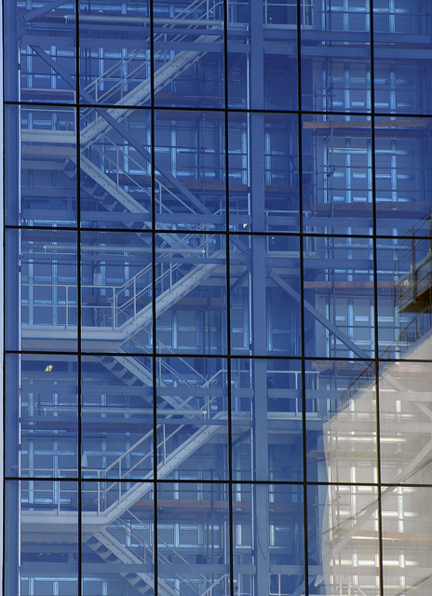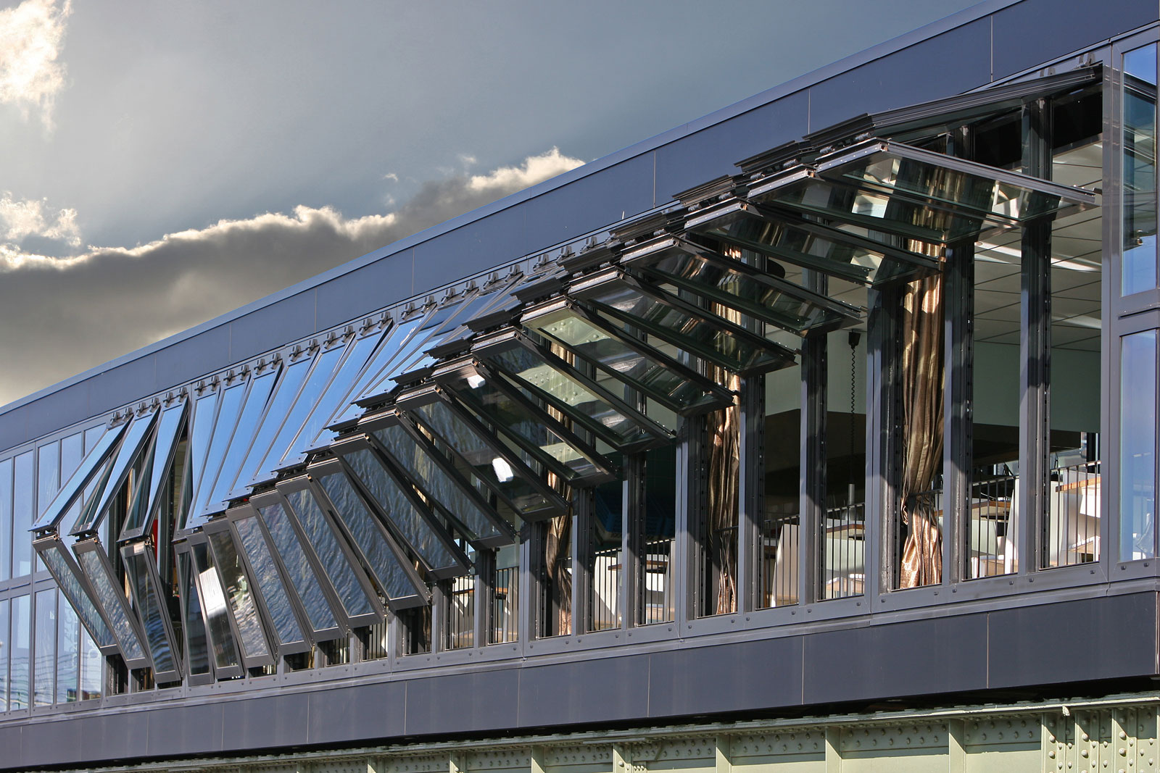
The material will be divided into three basic segments:
I. Lighting
II. Acoustics
III. Building Engineering Systems
The class will be primarily a series of lectures, guest lectures, demonstrations, assignments and quizzes or tests to determine what is being comprehended and what needs more work.
The homework assignments are graded. It is beneficial to have done the homework because the quizzes and prelims will be similar in content. Remember, doing and understanding the material will be much more beneficial than just having copied it into your notes.
Copies of the syllabus, homework, and other announcements may be found on the class blackboard website. We hope to be able to maintain this address throughout the semester.

There will be a quiz during the lighting and building system segments, the dates are listed in the syllabus. There will be a preliminary examination at the end of each of the first two segments. The dates will be announced in class. It is your responsibility to attend each class and to know what those dates are. There will be a comprehensive final at the end of the semester. All of these will be "open book." This means that books and notes may be brought into the exam, but copies of previous exams or quizzes are not allowed, nor are printouts of the web pages. You may bring a homework which you have done, but not an answer sheet from the web. Too many students have counted on these in the past, instead of doing the homework, and the result has been a drop in the average grades! Your exam may be disqualified.
The grading will be based on the following percentages:
Homework and Attendance 10% subtotal
Quizzes (2) 10% each 20% subtotal
Prelim (2) 20% each 40% subtotal
Final 30% each 30% subtotal
There will be several guest lecturers throughout the semester, and you will be responsible for all of the information presented in all lectures, including the guests' materials. There are recommended texts, and one required handout. The handout will be made available in class; the texts should be available at the bookstore. Please keep an active notebook with all of the materials handed out, and all homework. Again, tests will be open book and open notes, and you should have that material available. Keep it when you go on to practice architecture. It is not our intention to have you memorize things which you will then forget, but rather to understand information and concepts which you can access at a future date.
If you are interested in material which you do not find on the course outline, please let us know, and we will attempt to include it.
Recommended Texts
Mechanical and Electrical Equipment in Buildings; by Stein, Reynolds. Kwok, Grondzik- this is the same text as for ARCH 215.
Simplified Design of Building Lighting; by Marc Schiler - for advanced interest, also used in ARCH 515.
Architectural Acoustics; by M. David Egan - for advanced interest, not required.
NAAB Conditions for Accreditation
The USC School of Architecture’s five year BARCH degree and the two year M.ARCH degree are accredited professional architectural degree programs. All students can access and review the NAAB Conditions of Accreditation (including the Student Performance Criteria) on the NAAB Website, http://www.naab.org/accreditation/2004_Conditions.aspx.
Disabilities
Any student requesting academic accommodations based on a disability is required to register with Disability Services and Programs (DSP) each semester. A letter of verification for approved accommodations can be obtained from DSP. Please be sure the letter is delivered to me (or to my GRS students) as early in the semester as possible. DPS is located in STU 301 and is open 8:30AM-5PM, Monday through Friday. The phone number for DSP is (213) 740-0776
Academic Integrity
USC seeks to maintain an optimal learning environment. General principles of academic honesty include the concept of respect for the intellectual property of others, the expectation that individual work will be submitted unless otherwise allowed by an instructor, and the obligations both to protect one’s own academic work from misuse by others as well as to avoid using another’s work as one’s own. All students are expected to understand and abide by these principles.
Scampus, the Student Guidebook, contains the Student Conduct Code in Section 11.00, while the recommended sanctions are located in Appendix A:http://www.usc.edu/dept/publications/SCAMPUS/gov/
Students will be referred to the Office of Student Judicial Affairs and Community Standards for further review, should there be any suspicion of academic dishonesty. The Review process can be found at: http://www.usc.edu/student-affairs/SJACS/
Disruptive Behavior
Behavior that persistently or grossly interferes with classroom activities is considered disruptive behavior and may be subject to disciplinary action. Such behavior inhibits other students’ ability to learn and an instructor’s ability to teach. A student responsible for disruptive behavior may be required to leave class pending discussion and resolution of the problem and may be reported to the Office of Student Judicial Affairs for disciplinary action.
Critical Dates and Religious Observances
The university recognizes the diversity of our community and the potential for conflicts involving academic activities and personal religious observation. The university provides a guide to such observances for reference and suggests that any concerns about lack of attendance or inability to participate fully in the course activity be fully aired at the start of the term. As a general principle students should be excused from class for these events if properly documented and if provisions can be made to accommodate the absence and make up the lost work. Constraints on participation that conflict with adequate participation in the course and cannot be resolved to the satisfaction of the faculty and the student need to be identified prior to the drop add date for registration. After the drop-add date the University and the School of Architecture shall be the sole arbiter of what constitutes appropriate attendance and participation in a given course.
School of Architecture Policy on Attendance
Attending classes is a basic responsibility of every USC student who is enrolled in courses at the School of Architecture. Regular and punctual class attendance is considered an essential part of satisfying the NAAB accreditation requirements therefore attendance will be taken at every class session. A student may miss up to two class sessions without directly affecting their grade and ability to complete the course if they provide an excused absence for any confirmed personal illness/family emergency/religious observance. For each absence over that allowed number, the student’s letter grade is in danger of being lowered up to one full letter grade. Any student not in class within the first 10 minutes is considered tardy, and any student absent for more than 1/3 of the class time can be considered fully absent. If arriving late, a student must be respectful of a class in session and do everything possible to minimize the disruption caused by a late arrival. It is always the student’s responsibility to seek means to make up work missed due to absences. Being absent on the day of a quiz or exam results in a 0 for that quiz or exam.
2010 Imperative Statement:
The Architecture Faculty have voted to accept the 2010 Imperative-- to improvement of ecological literacy among the students and faculty and to achieve a carbon-neutral design school campus by 2010. To that end, this class will address issues of carbon neutrality and supports the following goal for all designs produced in the USC School of Architecture:
“The design should engage the environment in a way that dramatically reduces or eliminates the need for fossil fuel.”
This does not mean that no other issues are to be addressed. Precisely to the contrary, all design issues are fair game, but in the background, all will be considered within the generalized goal of reducing or eliminating the need for fossil fuel.
Instructor Contact Information
Lauren Dandridge Gaines, ldandrid@usc.edu
Elizabeth Valmont, evalmont@usc.edu
Tony Cocea, cocea@usc.edu

COURSE SCHEDULE
 | ARCH 315 |  |  |  |  | Design for the Luminous and Sonic Environment
 | Section 11286D |  |  |  |  | Ideas, problems and computations related to the design
 | Tues,Thurs 2:00PM-3:20PM |  |  |  |  | of buildings in response to the luminous and the sonic
 | HAR 101 |  |  | Environment and other building engineering systems.
 | Text : Mechanical and Electrical Equipment
 |  |  |  |  |  |  | Eleventh Edition
 |  |  |  |  |  |  | by Grondzik, Kwok, Stein and Reynolds
 | Recommended Text: Architectural Acoustics
 |  |  |  |  |  |  | by M. David Egan

Section 1: Lauren Dandridge Gaines

1 Lighting Fundamentals and Basic Perception
January 12, 2016 Tuesday

Lecture Introduction

Recommended Reading Chapter 11.15-11.29

Homework Due Today None

2 Physics of Light and Color
January 14, 2016 Thursday

Lecture Physics of Light and Color

Recommended Reading Chapter 11.34-11.39

Homework Homework #1

Lighting Sources
3. January 19, 2016 Tuesday

Lecture Lamps and Artificial Light Sources

Recommended Reading Chapter 12

Homework Homework #2

4 Designing with Artificial Light, Equipment, Point Grid
January 21, 2016 Thursday

Lecture Artificial Light and Equipment

Recommended Reading Chapter 15.1-15.12 and 16.1-16.30

Homework Homework #3

5 Calculating Light-Lumen Method/ Applications
January 26, 2016 Tuesday

Lecture Lighting Calculations

Recommended Reading Chapter 15.18-15.32

Homework Homework #4

6 Quiz #1
January 28, 2016 Thursday

Lecture None

Recommended Reading TBD

Homework None

7 Basic Electricity and Dimming
February 2, 2016 Tuesday

Lecture Electricity and Dimming

Recommended Reading TBD

Homework None

8 Designing with Daylight
February 4, 2016 Thursday

Lecture Designing with Daylight

Recommended Reading Chapter 14

Homework Homework #5

9 Lighting Applications and Review
February 9, 2016 Tuesday

Lecture Guest Lecture

Recommended Reading TBD

Homework Prepare for prelim exam

10 Preliminary Exam #1
February 11, 2016 Thursday

Lecture None

Recommended Reading Section 1 Recap

Homework None

Section 2: Acoustics Elizabeth Valmont

11 Acoustic Basic Theory and Perception
February 16, 2016 Tuesday

Lecture Introduction

Recommended Reading Egan- Chapter1, pp 1-11

Homework None

12 Acoustic Physics and Calculations
February 18, 2016 Thursday

Lecture Sound Levels and Propagation

Recommended Reading Egan- Chapter 1, pp 12-36

Homework Homework #6

13 Architectural Acoustics – Sound Absorption
February 23, 2016 Tuesday

Lecture Sound Absorption and Calculations

Recommended Reading Egan – Chapter 2

Homework Homework #7

14 Architectural Acoustics – Sound Isolation
February 25, 2016 Thursday

Lecture Sound Isolation and Calculations

Recommended Reading Egan – Chapter 4

Homework Homework #8

15 Acoustics in Assembly Spaces
March 1, 2016 Tuesday

Lecture Principles of Performance Acoustics

Recommended Reading Egan – Chapter 3

Homework Homework #9

16 Field Trip to Music Center
March 3, 2016 Thursday

Lecture Performing Arts Field Trip

Recommended Reading None

Homework None

17 Guest Lecture
March 8, 2016 Tuesday

Lecture Acoustic Technology and Auralization

Recommended Reading None

Homework None

18 Architectural Field Trip
March 10, 2016 Thursday

Lecture Architectural Field Trip Date

Recommended Reading None

Homework None

SPRING RECESS (March 14-20)

20 Acoustic Applications / Prelim Review
March 22, 2016 Tuesday

Lecture Acoustic Applications and Review

Recommended Reading Recap

Homework None

21 Preliminary Exam #2
March 24, 2016 Thursday

Lecture None

Recommended Reading Section 2 Recap

Homework None

Section 3: Building Systems (Mechanical, Electrical, Plumbing) Tony Cocea

21 Building Systems: Introduction to HVAC
March 29, 2016 Tuesday

Lecture HVAC (Heating, Ventilation, Air Cooling)

Recommended Reading Stein, Reynolds - Chapter 4

Homework None

22 Building Systems: Introduction to Electrical Engineering
March 31, 2016 Thursday

Lecture Electrical Engineering

Recommended Reading Stein, Reynolds Chapter 14

Homework Homework #10

23 Building Systems: Introduction to Plumbing Engineering
April 5, 2016 Tuesday

Lecture Gravity and Pressurized Piping Systems

Recommended Reading Stein, Reynolds – Chapter 10

Homework Homework #11

24 Architectural Field Trip
April 7, 2016 Thursday

Lecture Architectural Field Trip Date

Recommended Reading None

Homework None

25 Building Systems: Rainwater Harvesting Systems
April 12, 2016 Tuesday

Lecture Rainwater Harvesting/ Graywater

Recommended Reading Stein, Reynolds – Chapter 8, 9

Homework Homework #12

26 Building Systems: Basic Water Systems Design
April 14, 2016 Thursday

Lecture Water Piping Systems Design

Recommended Reading Stein, Reynolds – Chapter 13

Homework Homework #13

27 Building Systems: Water Reclamation Systems
April 19, 2016 Tuesday

Lecture Water reclamation design concepts

Recommended Reading Stein, Reynolds – Chapter 13

Homework Homework #14

28 Building Systems: Building Codes and Fire Safety
April 21, 2016 Thursday

Lecture Building Codes/ Life Safety

Recommended Reading TBD

Homework None

29 Building Systems: Fire Protection Systems Design
April 26, 2016 Tuesday

Lecture Automatic Sprinkler Systems

Recommended Reading Stein, Reynolds – Chapter 9

Homework Homework #15

30 Quiz #2
April 28, 2016 Thursday

Lecture None

Recommended Reading Session 3 Recap

Homework None

31 FINAL EXAM
May 5, 2016 TBC Thursday

