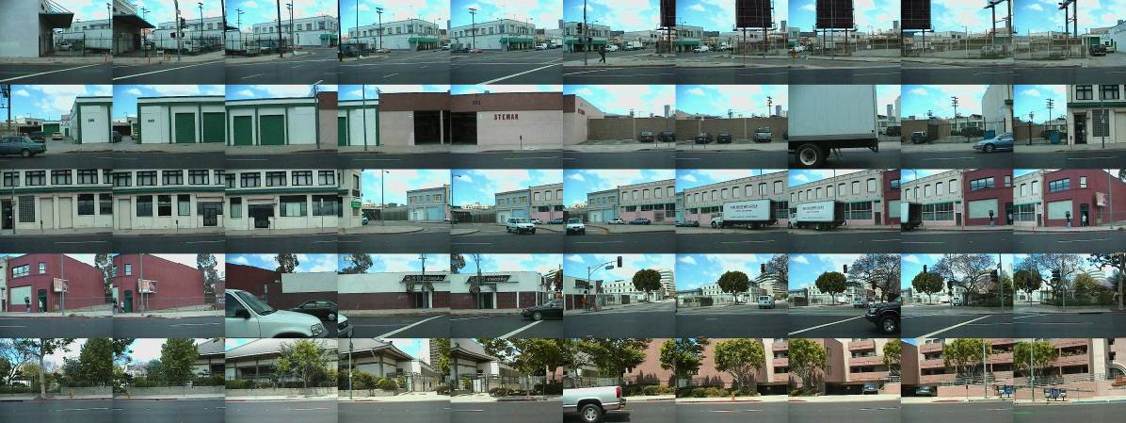
Photo by Robbert Flick
Writing 340/Special Topics
For the Common Good: Writing in the Community and Visual Storytelling

“This Writing 340 course has honestly invigorated my spirits and taught me so much more already than I could even begin to put in words.”

“Hands down, the proudest I have been of my work for any class.”

Description
This course places writing in a real-world context by partnering USC students with community groups to identify local problems and to use rhetorical tools for addressing these problems. Our class is premised on the model of writing with the community, which engages community members as partners rather than subjects or clients, each partner bringing something to learn and something to teach. By recognizing the value of different kinds of knowledge, this course asks all its participants to engage with perspectives outside their realm of experience.

This is an alternatively structured course in terms of contexts of learning and design of assignments. Although the tenets of good writing remain the central focus of the course, the semester will culminate in a media-driven, documentary-style final project, which will use writing, research, and personal experience to communicate these issues in a way meaningful to a broader public audience.

Our class will appeal to students with a desire to be active participants in their courses and who are interested in innovative approaches to learning. Given its community-based/real-world component, this course would interest students wishing to have a more intimate understanding of those people and issues that are so often the subjects of academic research. Disciplined and open-minded students who are willing to explore creative approaches to fulfilling course requirements should find this curriculum a challenging yet satisfying alternative to more traditional offerings.
For a recent article about the class: http://dornsife.usc.edu/news/stories/2357/writing-class-brings-together-writing-film-and-community-engagem/
For more information about the class, see https://dornsifecms.usc.edu/writing-in-the-community/
For D-Clearance, please fill out the form on the next page and send it to Stephanie Bower (sbower@usc.edu) or John Murray (johnrmur@usc.edu)
Request for D-Clearance: Writing 340 for “Writing in the Community” Spring 2018

Note:
1. In order to receive D-clearance for this section, please ensure that this is the only WRIT 340 class that you are enrolling in.

2. Transfer students should ensure that they have received credit for Writing 130/140 on their STARS report. If you have not, please bring a copy of your unofficial transcripts to JEF 150.

For Official Use Only

Date:

Comments:

Please email your completed form to John Murray (johnrmur@usc.edu) or Stephanie Bower (sbower@usc.edu)
Student ID number: __ __ __ __ - __ __ __ __ - __ __

Name: ________________________________________________

Contact Number: _______________________________________

Email: ________________________________________________

Declared Major: _______________________________________

Declared Minor: ________________________________________

Class Standing: _________________________________________

In a paragraph or two, please explain in detail why you would like to take a community-based WRIT340 class. Consider that we have more applicants than spaces, so the more we know about you, the better!

