OPEN TO ALL MAJORS!

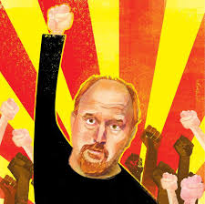

WRIT 440 – Writing in Practical Contexts:

Writing Comedy as Social Commentary

Fall 2017 Section: 65515D Tuesday/Thursday 2:00 – 3:50pm

Comics and comedic writers constantly address social issues in their material by critiquing aspects of society in ways intended to get a laugh. Various types of comedy approach their subjects in different ways: Trevor Noah critiques politics in a manner distinct from Steven Colbert, for instance, just as Family Guy differs in tone and approach from South Park. These “comedic critiques” have the potential to reach a large audience and address topics that might otherwise seem off limits, but they also run the risk of seeming frivolous or being disregarded as merely funny.

In this course, we will attempt to understand how being humorous allows authors and comics to tackle subjects in their work that might otherwise seem taboo, and how this freedom provides a unique opportunity for social commentary and critique. We will pay particular attention to how comedic authors balance the need to entertain an audience with their efforts to provide insight on controversial issues. We will devote time to discussing humorous texts that you want to talk about, and you will also have the opportunity to produce your own work in a variety of genres (such as reviews, rants, scripts, stories) on a number of social issues that you find compelling, culminating in a capstone project.

For a D-Clearance application or more information, please email Professor Mike Bunn at bunnm@usc.edu.

[NOTE: students must have completed or currently be enrolled in either WRIT 340 or CORE 112 as a prerequisite for WRIT 440.]

