CORE 104 – THIRD WORLD DOCUMENTS

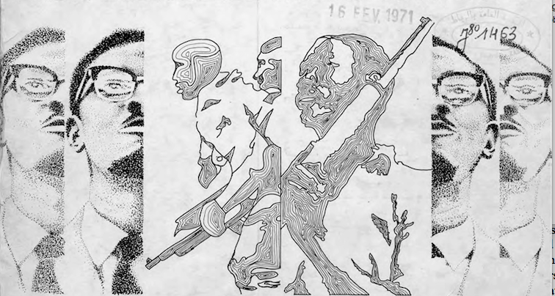

Instructor: Dr. Olivia C. Harrison
Contact: oharriso@usc.edu

What we now call the developing world, the poorer nations, or the Global South used to be known under a much loftier title: the Third World. This course explores the Third World as a political project of transnational solidarity, social justice, and cultural independence that continues to have resonance today. We will travel back to the 1950s, 60s and 70s to examine a trove of documents that attest to the aspirations and inspirations of the formerly and still colonized world, from Cuba to Africa, Vietnam, and the Americas. Far from studying this period in isolation, we will draw connections to contemporaneous movements like the Black Panther Party, as well as more recent ones like Standing Rock and Black Lives Matter. We will analyze a wide range of documents: journals and magazines such as Souffles-Anfas, Lotus, and Tricontinentale; films by Gillo Pontecorvo and Ousmane Sembene; essays and manifestos by Frantz Fanon and Che Guevara; plays by Kateb Yacine and Aimé Césaire; and new media documenting contemporary social movements, from Tahrir Square to North Dakota. The course will culminate in individualized research projects exploring little known archives that document global struggles for social justice in our recent past and present.

Texts available for purchase:
Césaire, Aimé. A Season in the Congo. ISBN 9781905422944
Harrison, Olivia C. and Teresa Villa-Ignacio, eds. Souffles-Anfas: A Critical Anthology from the Moroccan Journal of Culture and Politics. ISBN 9780804796231
Kateb, Yacine. Intelligence Powder. ISBN 0913745200
McKay, Claude. Banjo. ISBN 1902934040.

