FREN 330 CRITICAL WRITING IN FRENCH

Fall 2017

M/W 10 – 11h20 AM

Étrangers / Étrangères

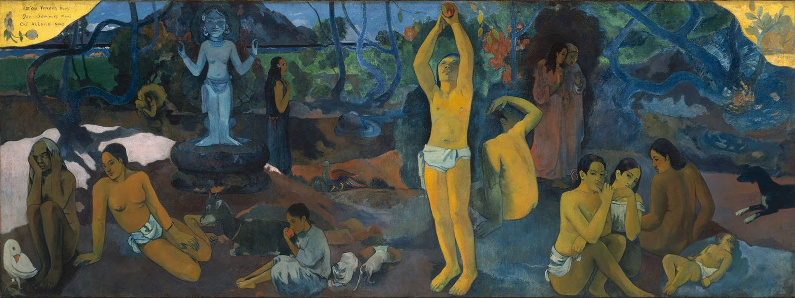

Paul Gauguin, “D’où venons-nous? Que sommes-nous? Où allons-nous?” (1897)

Instructor: Dr. Olivia C. Harrison
Contact: oharriso@usc.edu

FREN 330 “Critical Writing in French” is an introduction to literary analysis in French. It will provide you with the tools you need 1) to close-read French literary texts of different genres (poetry, prose, theater) written in different historical, political, and geographic contexts 2) write critically about French and Francophone literature using both close reading and research skills. Upon successful completion of this gateway course you will be able to enjoy the full offering of upper division classes available at USC, from Renaissance literature to Enlightenment thought, New Wave cinema, African literature, French urban culture and much more!

