Fall 2017 Syllabus: ASTE 524 “Human Spaceflight”

Course Instructor: Bruce Cordell, Ph.D.
Consultant; formerly Program Manager, General Dynamics Space Systems; email: ASTE524@gmail.com

Course Scope and Objectives

This course provides an introduction to key systems and technologies that enable
and support human space missions. Students will expand their understanding of how the presence of humans influences space mission design including environmental control and life support, human factors, and space environments; orbit selection and astrodynamics; and mission operations, safety, and communications. Applications include launch and transfer vehicles, space stations, and planetary bases.
See course flyer on last page.

Course Format
Dates: Class once a week on Friday at 9:00am -11:50am (Pacific Time)
Location: OHE 120 (29122R 048)
Class is simultaneously offered to remote students through VSOE Distance Education Network
DEN@Viterbi (29152D 034)

Course Grading
Homework | 35%
Midterm Exam | 30%
Final exam | 35%
Total | 100%

Text and materials: Text book – Strongly recommended:
- Use either the 2nd edition/ebook (2014) or the 1st edition/paper (2007) of Larson et. al. I’ll be using the 2nd edition in class. Available from the Space Technology Series website:
http://www.spacetechnologyseries.com/~spacet9/books/Human-Spaceflight.html
- LSC Human Spaceflight, (Space Technology(McGraw-Hill))
2007, Wiley Larson, Linda Pranke, John Connolly and Robert Giffen ISBN-13:978-0077230289
PLEASE NOTE: Other class materials and notes will be available on the DEN class website.

Human Spaceflight – ASTE 524

Class | Subject | HSMAD  Chapters | HW
8/25 | Organization of the class  History and future of human spaceflight |  | 1
9/1 | Human space mission concepts Designing human space missions | 1  2 | 2
9/8 | Space environment Physiology of spaceflight | 3  5 | 3
9/15 | Human factors Reliability and Safety | 6  8 | 4
9/22 | Environmental Control, Life Support | 17, 24.3 | 5
9/29 | Astrodynamics, Orbit selection Entry, descent, landing, ascent | 9  10 | 6
10/6 | Mission operations | 26
10/13 | MID-TERM
10/20 | Crew Accommodations; EVA  Launch & transfer vehicles | 18, 22  25 | 7
10/27 | Surface Environments  Surface bases | 4  13 | 8
11/3 | Moon vicinity human missions In situ resources; Rovers | 13  14, 15 | 9
11/10 | Mars vicinity human missions Propulsion | 31  24. 27 | 10
11/17 | Mars transfer vehicles  Space elements | 25  24, 11 | 11
11/24 | Thanksgiving Holiday  (No Class)
12/1 | Costs; International Missions  Future of Human Spaceflight | 29, 30  31
12/8 | FINAL EXAM
Thanksgiving Holiday: 11/22-26

Course Schedule is Flexible
The subject schedule is flexible and may change depending on a variety of factors. You will be informed of any changes as they occur. The Midterm and Final Exam dates will remain unchanged.

Homework Info
Homework will be assigned on Fridays and each is due 8 days later on the following Saturday at 6pm. No late Homework will be accepted. Your lowest Homework score will be dropped, so missing one will not affect your course grade, although it’s not recommended. No Homework is due the weeks of the Midterm or the Final Exam.

Statement for Students with Disabilities
Any student requesting academic accommodations based on a disability is required to register with Disability Services and Programs (DSP) each semester. A letter of verification for approved accommodations can be obtained from DSP. Please be sure the letter is delivered to me (or to TA) as early in the semester as possible. DSP is located in STU 301 and is open 8:30 a.m.–5:00 p.m., Monday through Friday. The phone number for DSP is (213) 740-0776.

Statement on Academic Integrity
USC seeks to maintain an optimal learning environment. General principles of academic honesty include the concept of respect for the intellectual property of others, the expectation that individual work will be submitted unless otherwise allowed by an instructor, and the obligations both to protect one’s own academic work from misuse by others as well as to avoid
using another’s work as one’s own. All students are expected to understand and abide by these principles. Scampus, the Student Guidebook, contains the Student Conduct Code in Section 11.00, while the recommended sanctions are located in Appendix A: http://www.usc.edu/dept/ publications/SCAMPUS/gov/. Students will be referred to the Office of Student Judicial Affairs and Community Standards for further review, should there be any suspicion of academic dishonesty. The Review process can be found at: http://www.usc.edu/student-affairs/SJACS/.

Instructor
Bruce Cordell is a consultant and educator who was formerly a program manager in Advanced Space Systems with General Dynamics, Space Systems Division in San Diego. He worked closely with NASA and a 10-member international team that he assembled – including Hamilton Standard (now UTC Aerospace Systems), Brown & Root (now KBR), SICSA (University of Houston), Shimizu (Tokyo), and others -- to acquire and support new GD CRADs and IRADs in advanced human space vehicles and missions.
Products included an invited AIAA address and a 20,000 word AIAA paper on the state-of-the- art of manned Mars missions, the first engineering and cost studies of commercial development of Phobos and Deimos featuring early human missions, and innovative approaches to the use of space resources on human space missions in Earth orbit and at the Moon.
During this time Bruce also participated in a number of major advanced NASA and DoD studies, including Orbital Transfer Vehicle, Space Transportation Infrastructure Study, Atmospheric Defense Initiative, and NASA Infrastructure Study.
Bruce has a background in physics (M.S., UCLA) and a Ph.D. in planetary science from the University of Arizona. He was a Chaim Weizmann Fellow at Caltech, attended the Hawaii Great Teachers Seminar on the Big Island, and received two Extraordinary Achievement Awards from General Dynamics.

University of Southern California
FALL 2017 – ASTE 524
Human Spaceflight
Instructor: Dr. Bruce Cordell
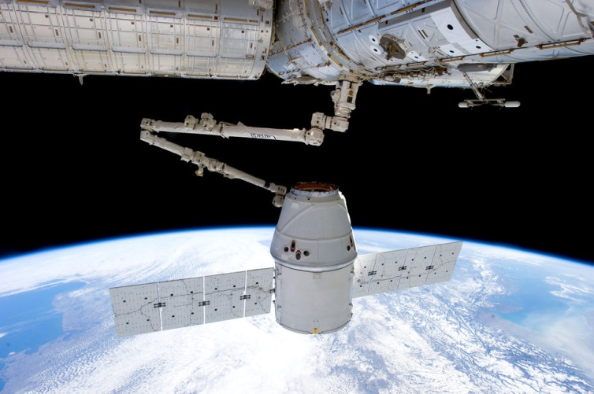
Human spaceflight has become a dynamic international and commercial activity that promises to exceed even the 50-year old transformational space vision of President John F. Kennedy, which led to the first humans on the Moon in 1969. Engineers, scientists, and managers need to stay abreast of this arena as global needs and aspirations surge to new heights.
For example, the International Space Station has won approval from the White House and the International Partners (Russia, Japan, ESA, Canada) to extend operations to 2024. In 2012, the Dragon spacecraft (SpaceX) made history when it became the first commercial spacecraft to deliver cargo to ISS; Dragon is also designed to deliver crew. In 2018 SpaceX plans to send commercial tourists to the Moon.
In 2014, China became the first country in the 21st century to soft-land a spacecraft on the Moon. Human missions to its space station (Tiangong-1) since 2011 are well-known, and China has recently begun talks with ESA about a joint lunar base. NASA continues with development of the Space Launch System, a heavy-lift vehicle that could support human spaceflight to the Moon and Mars, as could SpaceX’s Falcon Heavy.
At USC in Fall Semester 2017, ASTE 524 Human Spaceflight will explore a variety of attractive systems and technologies used in current and future human space missions. This includes environmental control and life support, human factors and space environments, and crew accommodations. For missions to Earth orbit and beyond we’ll examine orbit selection and astrodynamics, as well as mission operations and safety, and communications. Applications will include launch vehicles and transfer vehicles, space stations, and surface bases.

