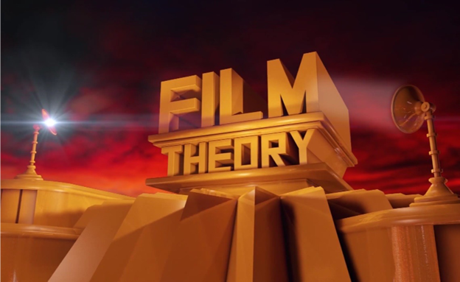

**Location:**

**SCA 112**

**Time:**

**Monday 10-1:50**

**Professor**

**Aniko Imre**

**Film and Media Theory**

**This course provides an introduction to the major theories of media, from the earliest writings about film to contemporary approaches to digital media. Even more important, the class gives you the conceptual and analytical tools to map and navigate aesthetic and technological forms as well as industrial and reception practices across historical periods. You will learn a lot in this class!**

**periods. You will not only learn a lot in this course; you will also get smarter!artistic and cultural practice.**

**CTCS 473**